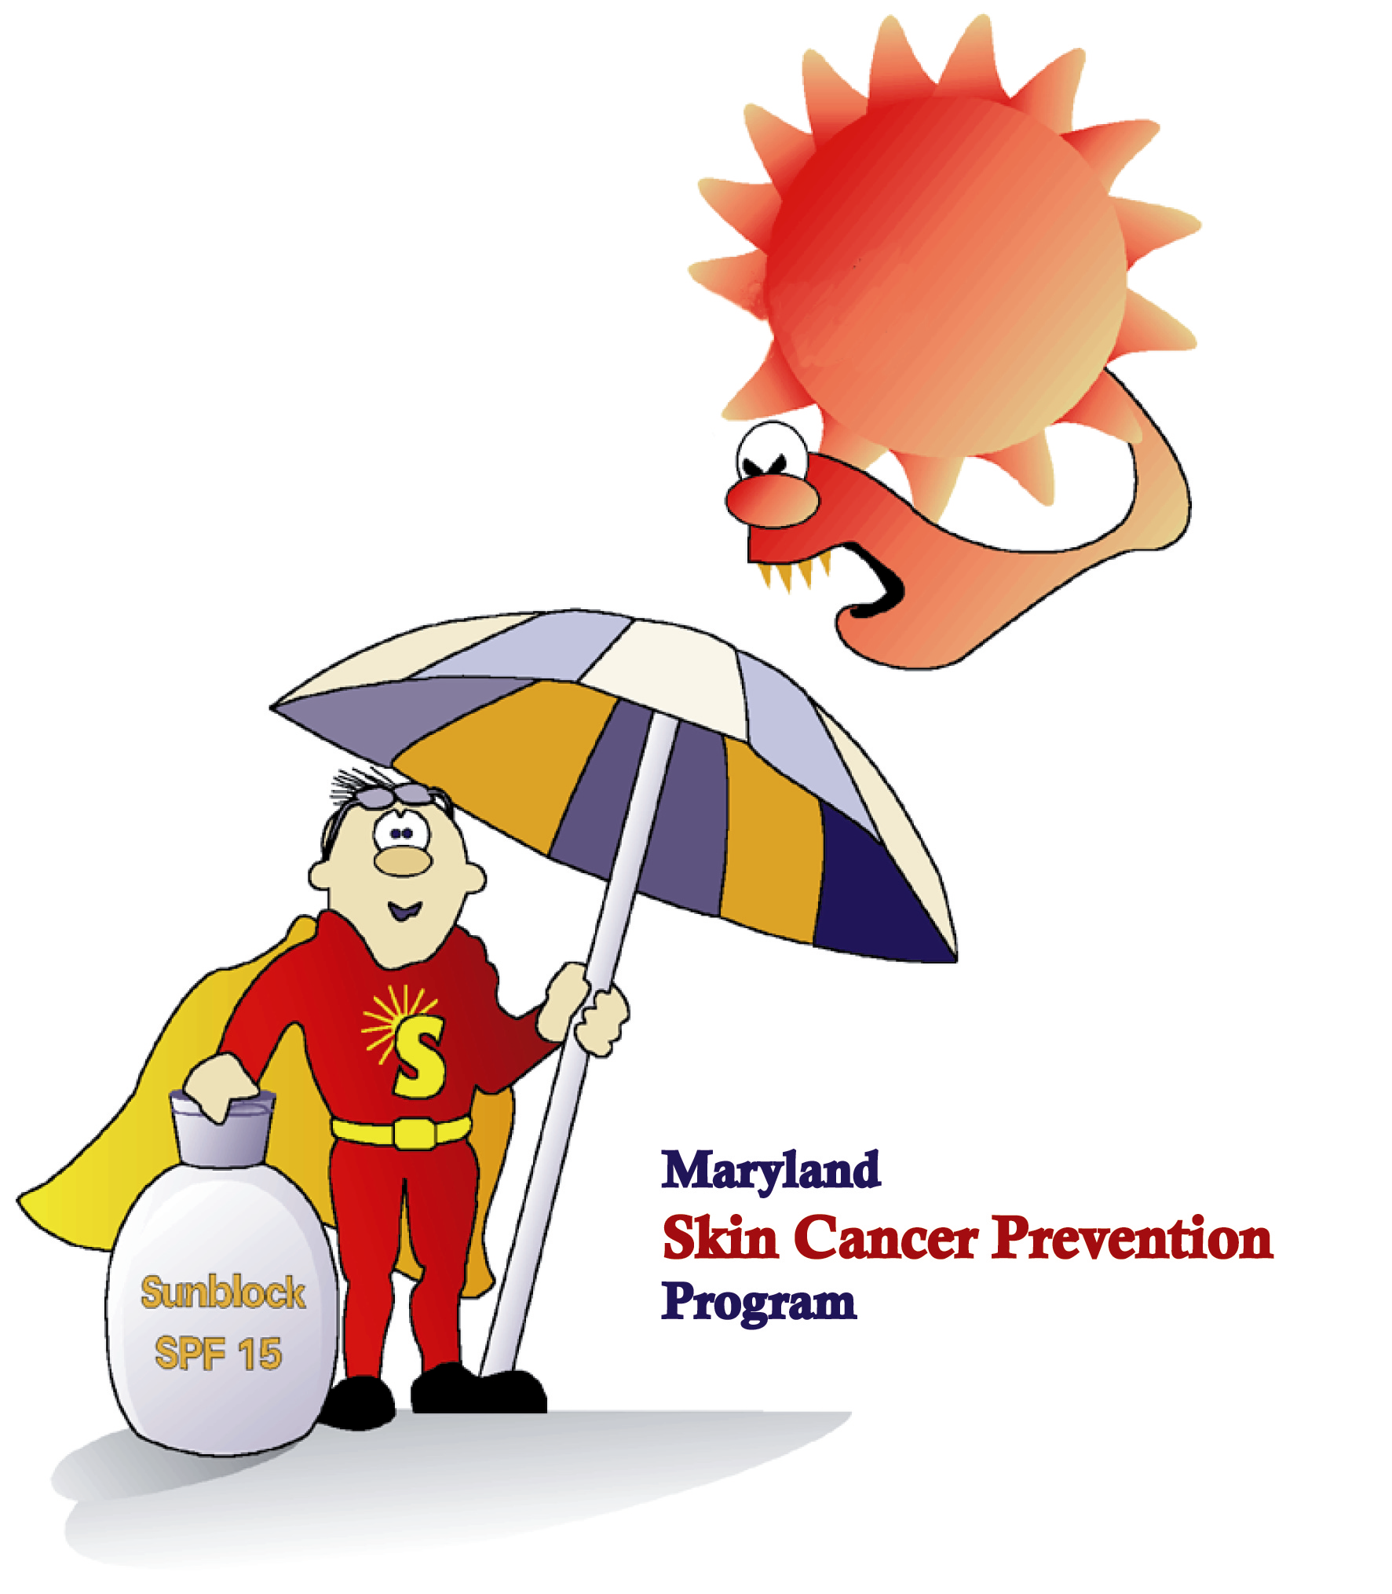
10 Ways to SunGuard Your Skin

- Limit sun exposure between 10 a.m. and 4 p.m.
- Avoid sun tanning and tanning beds.
- Generously apply a broad-spectrum (UVA/UVB) sunscreen with a minimum SPF of 30. Re-apply every two hours and after swimming or sweating.
- Wear sun protective clothing such as a wide-brimmed hat and a long sleeved, dark colored shirt.
- Wear UV protective sunglasses.
- Seek shade of umbrellas, trees, and awnings.
- Use extra caution when near water, sand, snow, and concrete, as they reflect the UV rays.
- Get vitamin D safely through a healthy diet; don’t seek the sun!
- Send sunscreen to school and camp with your children and encourage them to use it.
- Remember to Slip, Slop, Slap, Wrap!

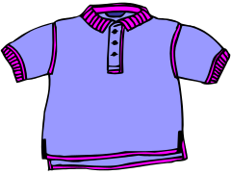


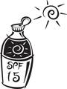

Maryland Skin Cancer Prevention Program

www.sunguardman.org
Slip on a shirt!
Slop on sunscreen!
Slap on a wide-brimmed hat!
Wrap on sunglasses!

