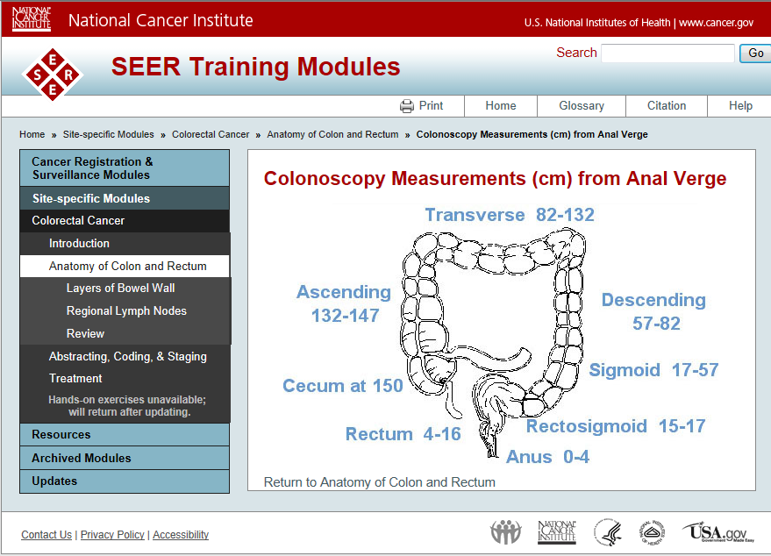
Source: http://training.seer.cancer.gov/colorectal/anatomy/figure/figure1.html

Parts of Colon and Rectum- http://training.seer.cancer.gov/colorectal/anatomy/
- Cecum (proximal right colon)
6 x 9 cm pouch covered with peritoneum
- Appendix
A vermiform (wormlike) diverticulum located in the lower cecum
- Ascending colon
20-25 cm long, located behind the peritoneum
- Hepatic flexure
Lies under right lobe of liver
- Transverse colon
Lies anterior in abdomen, attached to gastrocolic ligament
- Splenic flexure
Near tail of pancreas and spleen
- Descending colon
10-15 cm long, located behind the peritoneum
- Sigmoid colon
Loop extending distally from border of left posterior major psoas muscle
- Rectosigmoid segment
Between 10 and 15 cm from anal verge
- Rectum
12 cm long; upper third covered by peritoneum; no peritoneum on lower third which is also called the rectal ampulla. About 10 cm of the rectum lies below the lower edge of the peritoneum (below the peritoneal reflection), outside the peritoneal cavity
- Anal canal
Most distal 4-5 cm to anal verge

http://yoursurgery.com/ProcedureDetails.cfm?Proc=17
- The large bowel is composed of:
  - Colon. The colon averages 150 cms. (60 inches) in length.
  - The ascending colon is about eight inches in length
  - The transverse colon is usually over 18 inches in length
  - The descending colon, usually less than 12 inches
  - The sigmoid colon, which is S-shaped and measures about 18 inches
http://learnhumananatomy.com/large-intestine-2/
The length of the caecum makes up about 4.66% of the whole large intestine. The ascending colon constitutes approximately 16.17%, the transverse colon – 34.55%; the descending colon is 13.72% and the sigmoid colon – 29.59%.
- the caecum length is 4-8cm
- The appendix length varies between 2 and 20 cm (on average 8cm).
- The ascending colon is 18-20cm
- The transverse colon length is on average 50cm. (ranging between 40 and 50cm).
- The descending colon average length is 25cm.
- The sigmoid colon average length is 40-45cm (ranging between 12 and 84cm).
- The rectum average length is 15cm

http://www.theodora.com/anatomy/the_large_intestine.html
Henry Gray (1825–1861). Anatomy of the Human Body. 1918. http://www.bartleby.com/107/pages/page1182.html
- Cecum on an average is 6.25 cm. in length
- Appendix varies from 2 to 20 cm. in length, average 8.3 cm
- Iliac Colon (Fig. 1076) is situated in the left iliac fossa, and is about 12 to 15 cm. long. It begins at the level of the iliac crest, where it is continuous with the descending colon, and ends in the sigmoid colon at the superior aperture of the lesser pelvis
- Sigmoid Colon (colon sigmoideum; pelvic colon; sigmoid flexure) (Fig. 1076) forms a loop which averages about 40 cm. in length
- The rectum is about 12 cm. long

