CANCER REGISTRY ADVISORY COMMITTEE

MEETING MINUTES
September 14, 2023

Attendees Affiliation
Robin Yabroff (Chairperson) | American Cancer Society
Joanne Dorgan | University of MD/School of Medicine
Mary Mesnard | Tumor Registry Association of MD
Monique E.Wilson | MDH/Vital Statistics Administration
Norma Kanarek | Johns Hopkins School of Public Health
Clifford Mitchell | MDH/Environmental Health Bureau
MDH Staff
Erica Smith | PHPA/CCPC
Tyler Adamson | MDH/PHPA/CCPC
Afaq Ahmad | MDH/PHPA/CCPC
Jennifer Hayes | MDH/PHPA/CCPC
Delores Rich | MDH/PHPA/CCPC
Myriddian Staff
Vijay Medithi | Myriddian, LLC
Jason Myers | Myriddian, LLC
Sharee McConnell | Myriddian, LLC

Call to order/Introductions:
Each attendee introduced themselves and shared their respective affiliations.

Approval of Minutes (October 20, 2022)
Minutes from the October 20, 2022, minutes were approved.

Maryland Cancer Registry (MCR) Updates
MCR Incidence & Mortality Report – The MCR is currently working on the 2020 Incidence and Mortality Report and expects to have it available some time in October. The committee will be notified when the report is posted on the MCR website.

Update KSS:
Kimberly Stern, Program Manager, has been out for an extended period of time. The MCR does not have an expected return to work date yet.

Delinquent Facilities:
A matter of concern has arisen with the MCR concerning the ongoing issues with the number of facilities that are delinquent in reporting cancer cases. Unfortunately, a viable resolution for this matter is yet to be implemented. The MCR vendor, Myriddian, has proactively initiated continuous outreach efforts, but the response from the delinquent facilities is poor. At this point the MCR would welcome any feedback on how to approach it, particularly since this problem will have a dramatic impact on the data in coming years. One issue is there are no penalties for addressing facilities that are delinquent as some other states.

How many facilities are delinquent and what geographic area are they in?
Two large facilities that are in different geographic areas.
Physicians groups that have specialties (ex: GI) have cases for specific sites are not reporting
This is of particular concern because it may see drops in rates for particular cancer sites and this may provide a false appearance that cancer is doing well for that site.

Why is this happening?
It started during COVID as staff were re-assigned or were furloughed. Once things began to return to normal, some staff in facility registries found other employment and funding. Facilities lost money and they do not see a return investment on cancer registry operation. Since there are no penalties for not reporting, not seen as a priority.

Is there a dashboard where rates of timeliness could be seen publicly?
Currently the plan is to reward those facilities that are reporting timely with a certificate. The carrot and carrot approach. Recommendation: Create a dashboard of timeliness and publish all reporting results so that the public can see it. There needs to be a place where the public can look to see any entity that is consistently failing to report.

Are there members on the Cancer Council that may be of assistance?
Robin Yabroff will bring this issue up at the next Cancer Council meeting (9/15/).

What would be involved in passing legislation that could impose penalties?
It is difficult for the MDH to impose financial penalties. It is also very difficult to get legislation through the general assembly.

As smaller practices become merged with larger practices, this may become a tremendous issue as the registry moves forward. The MCR is currently evaluating what other states are doing and trying to find solutions that do not require statutory changes.

Myriddian Updates:

There is concern that Myriddian won’t meet the requirements for “Gold” certification if the trend of delinquent reporting continues.

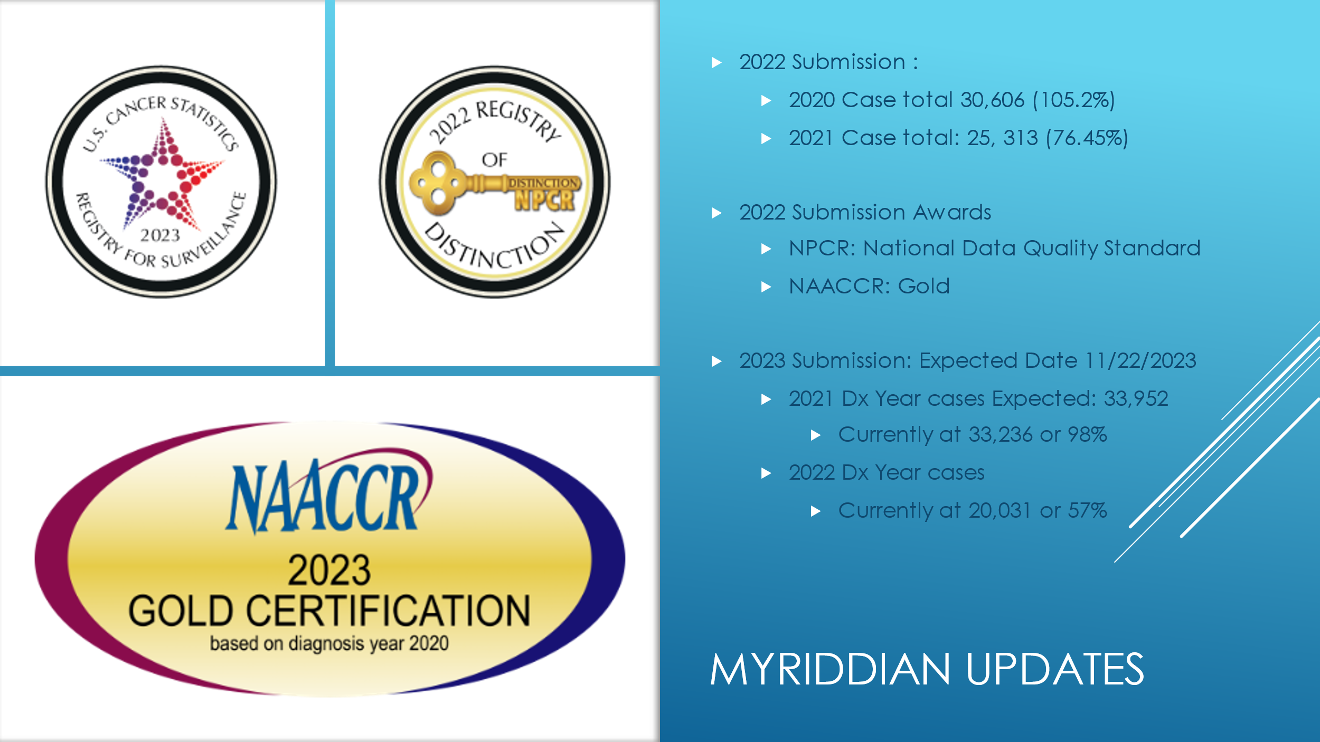
Expecting to reach 80%
Slight decrease
12 month data
24 month data
Myriddian has consistently met these certification standards.
If current trend of delinquent reporting continues, Myriddian will not be able to meet certification standards.

Other Updates
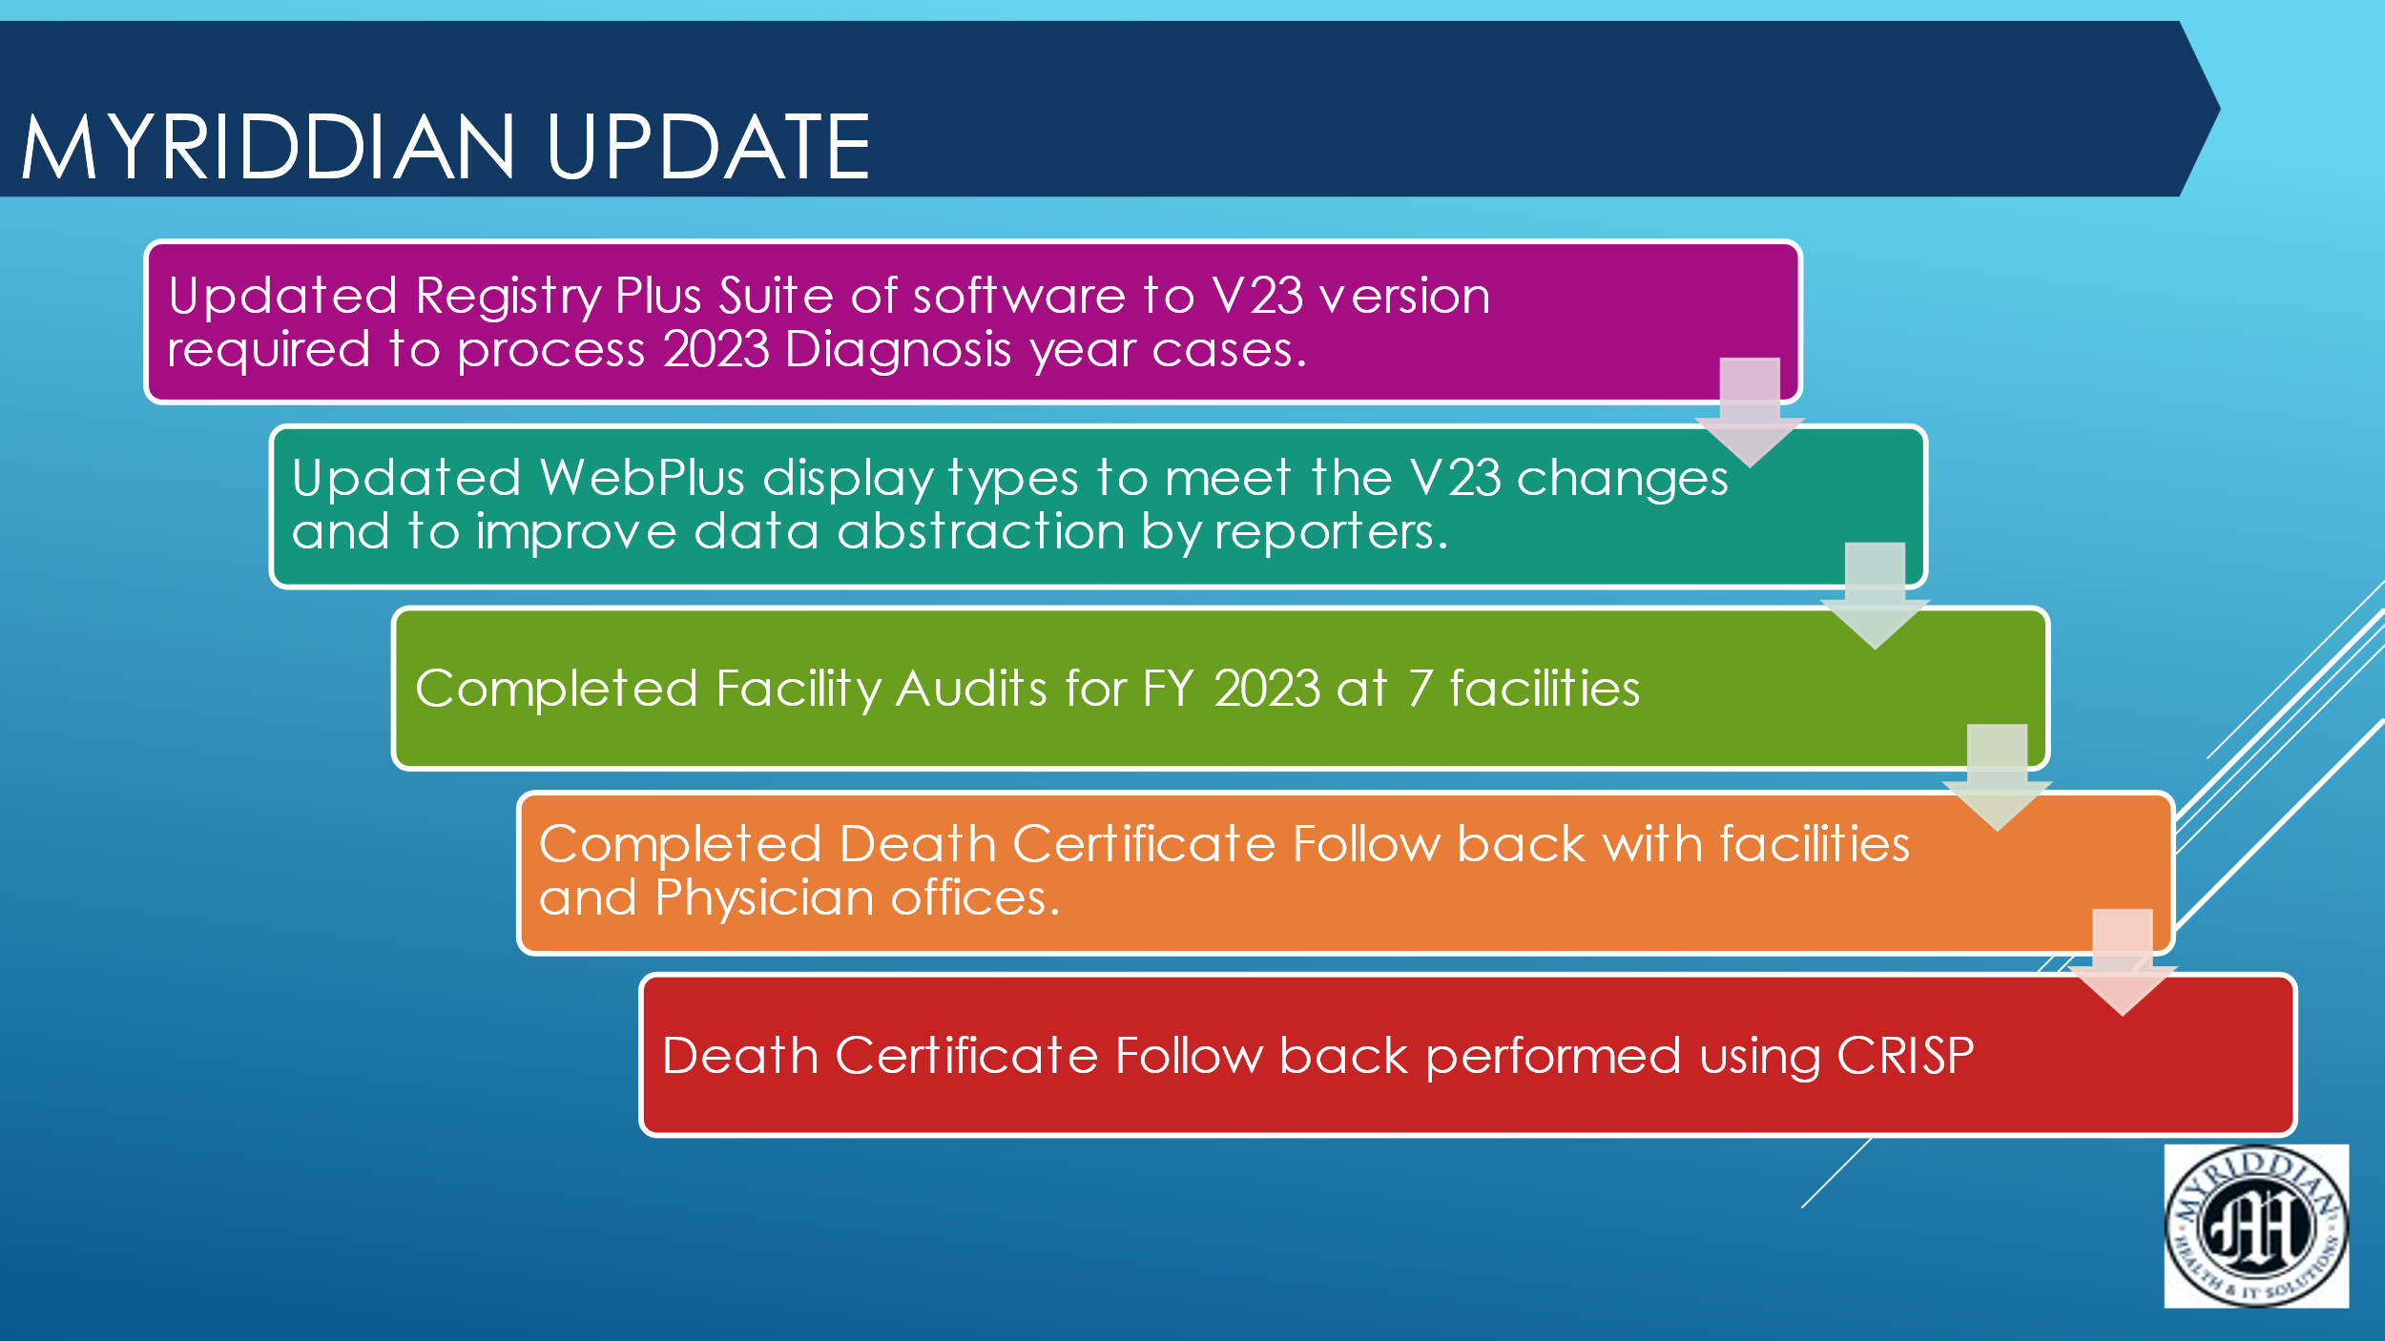
Myriddian has been able to drop DCFs to below 1% (using CRISP)

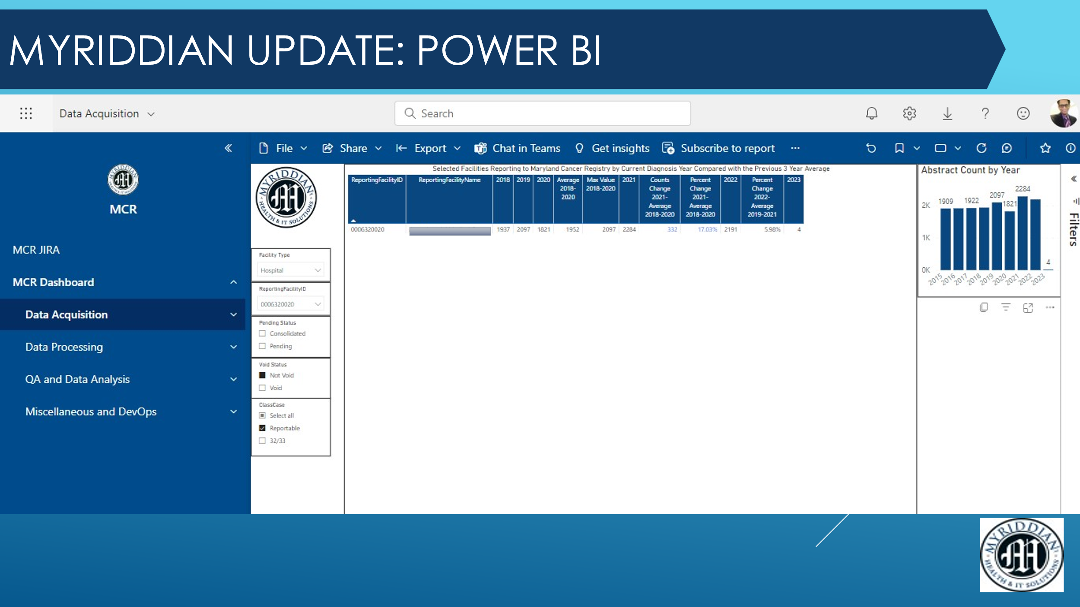
Myriddian has used Power BI and have improved it significantly to include Data Acquisition, Data Processing, QA & Data Analysis and Misc and Dev Ops.

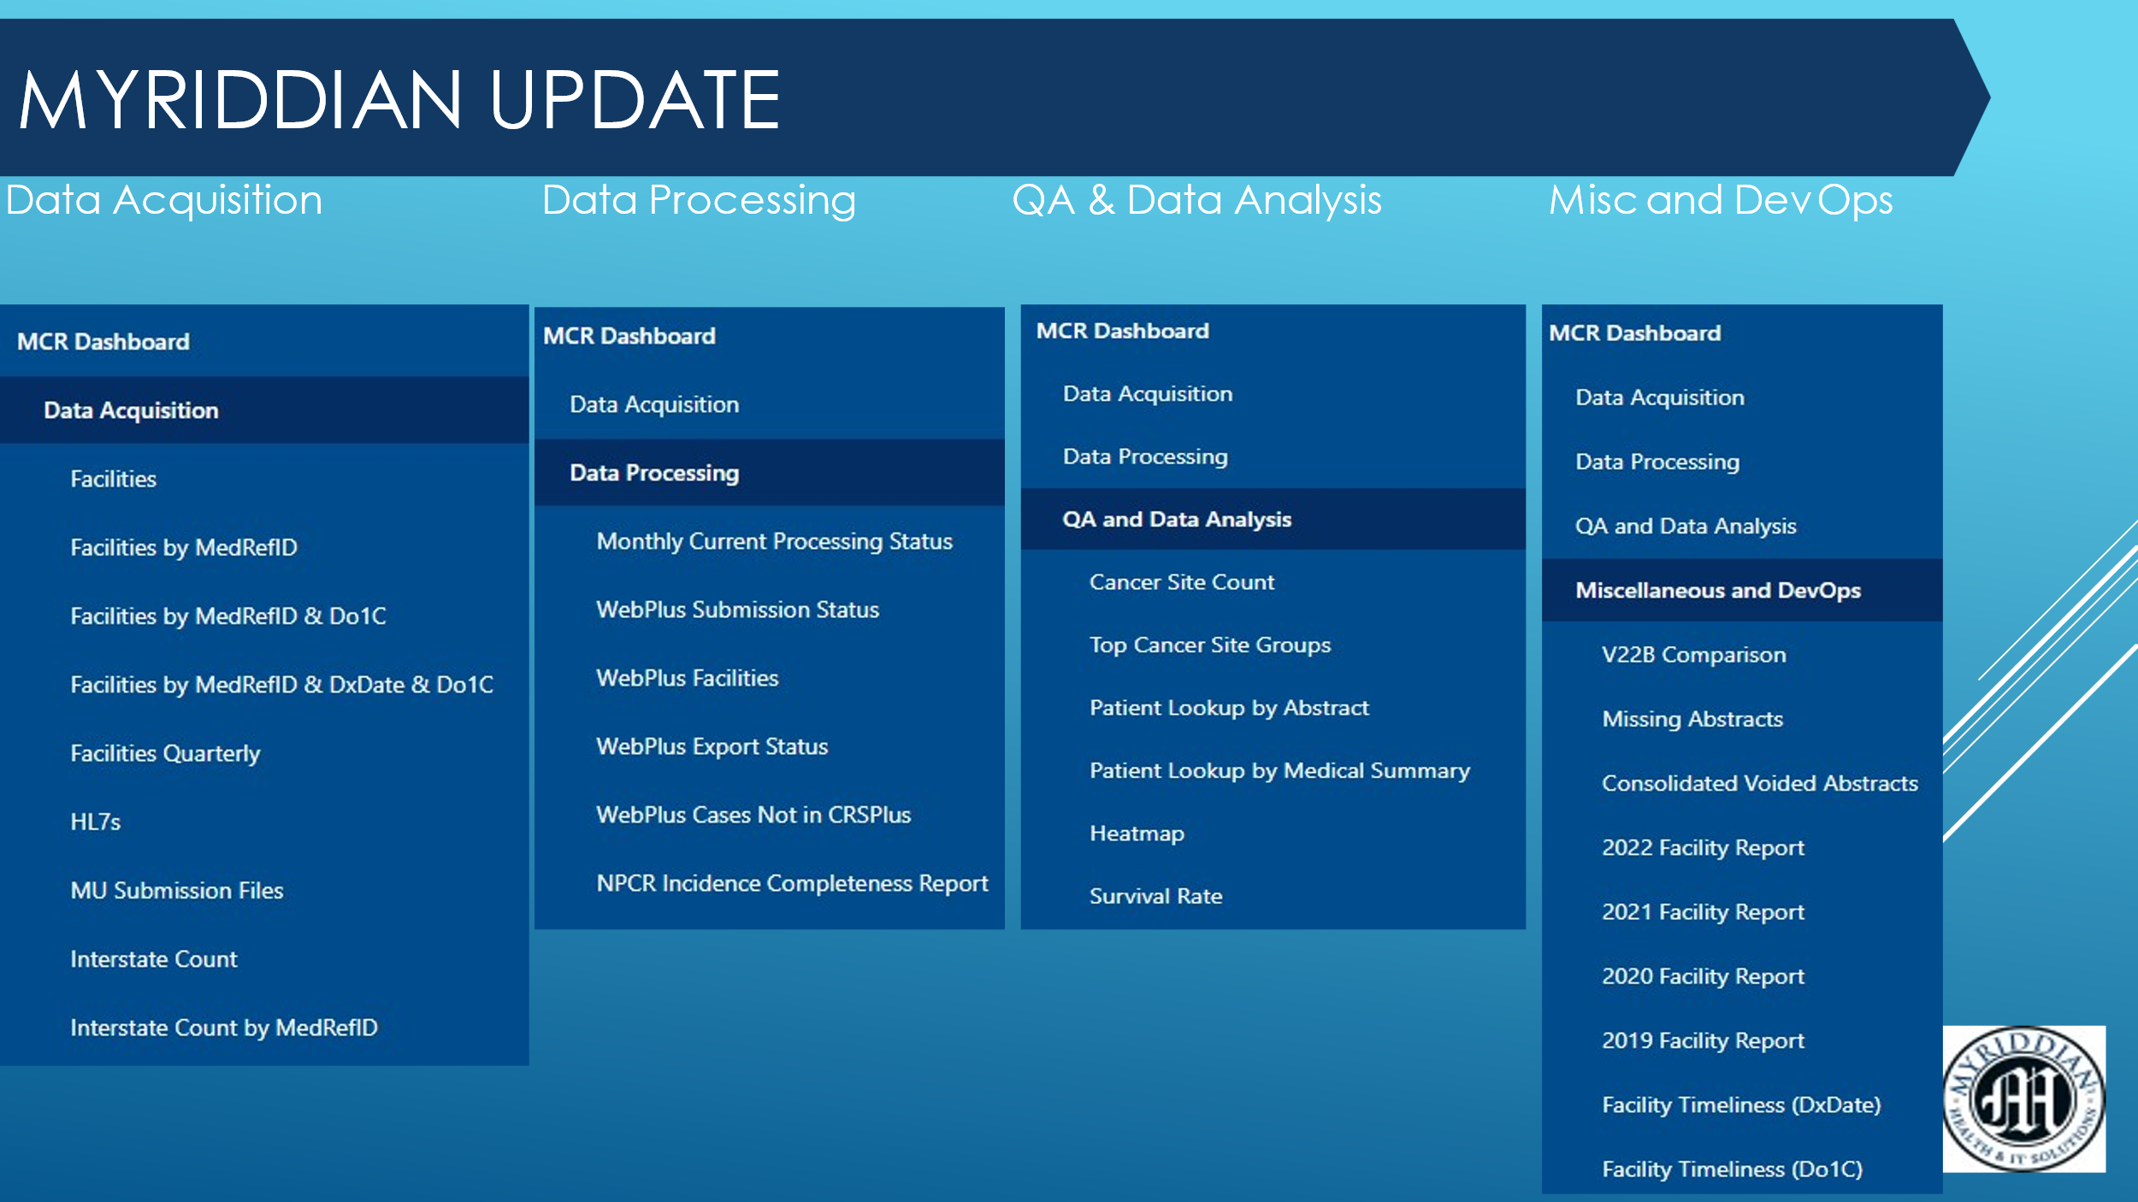

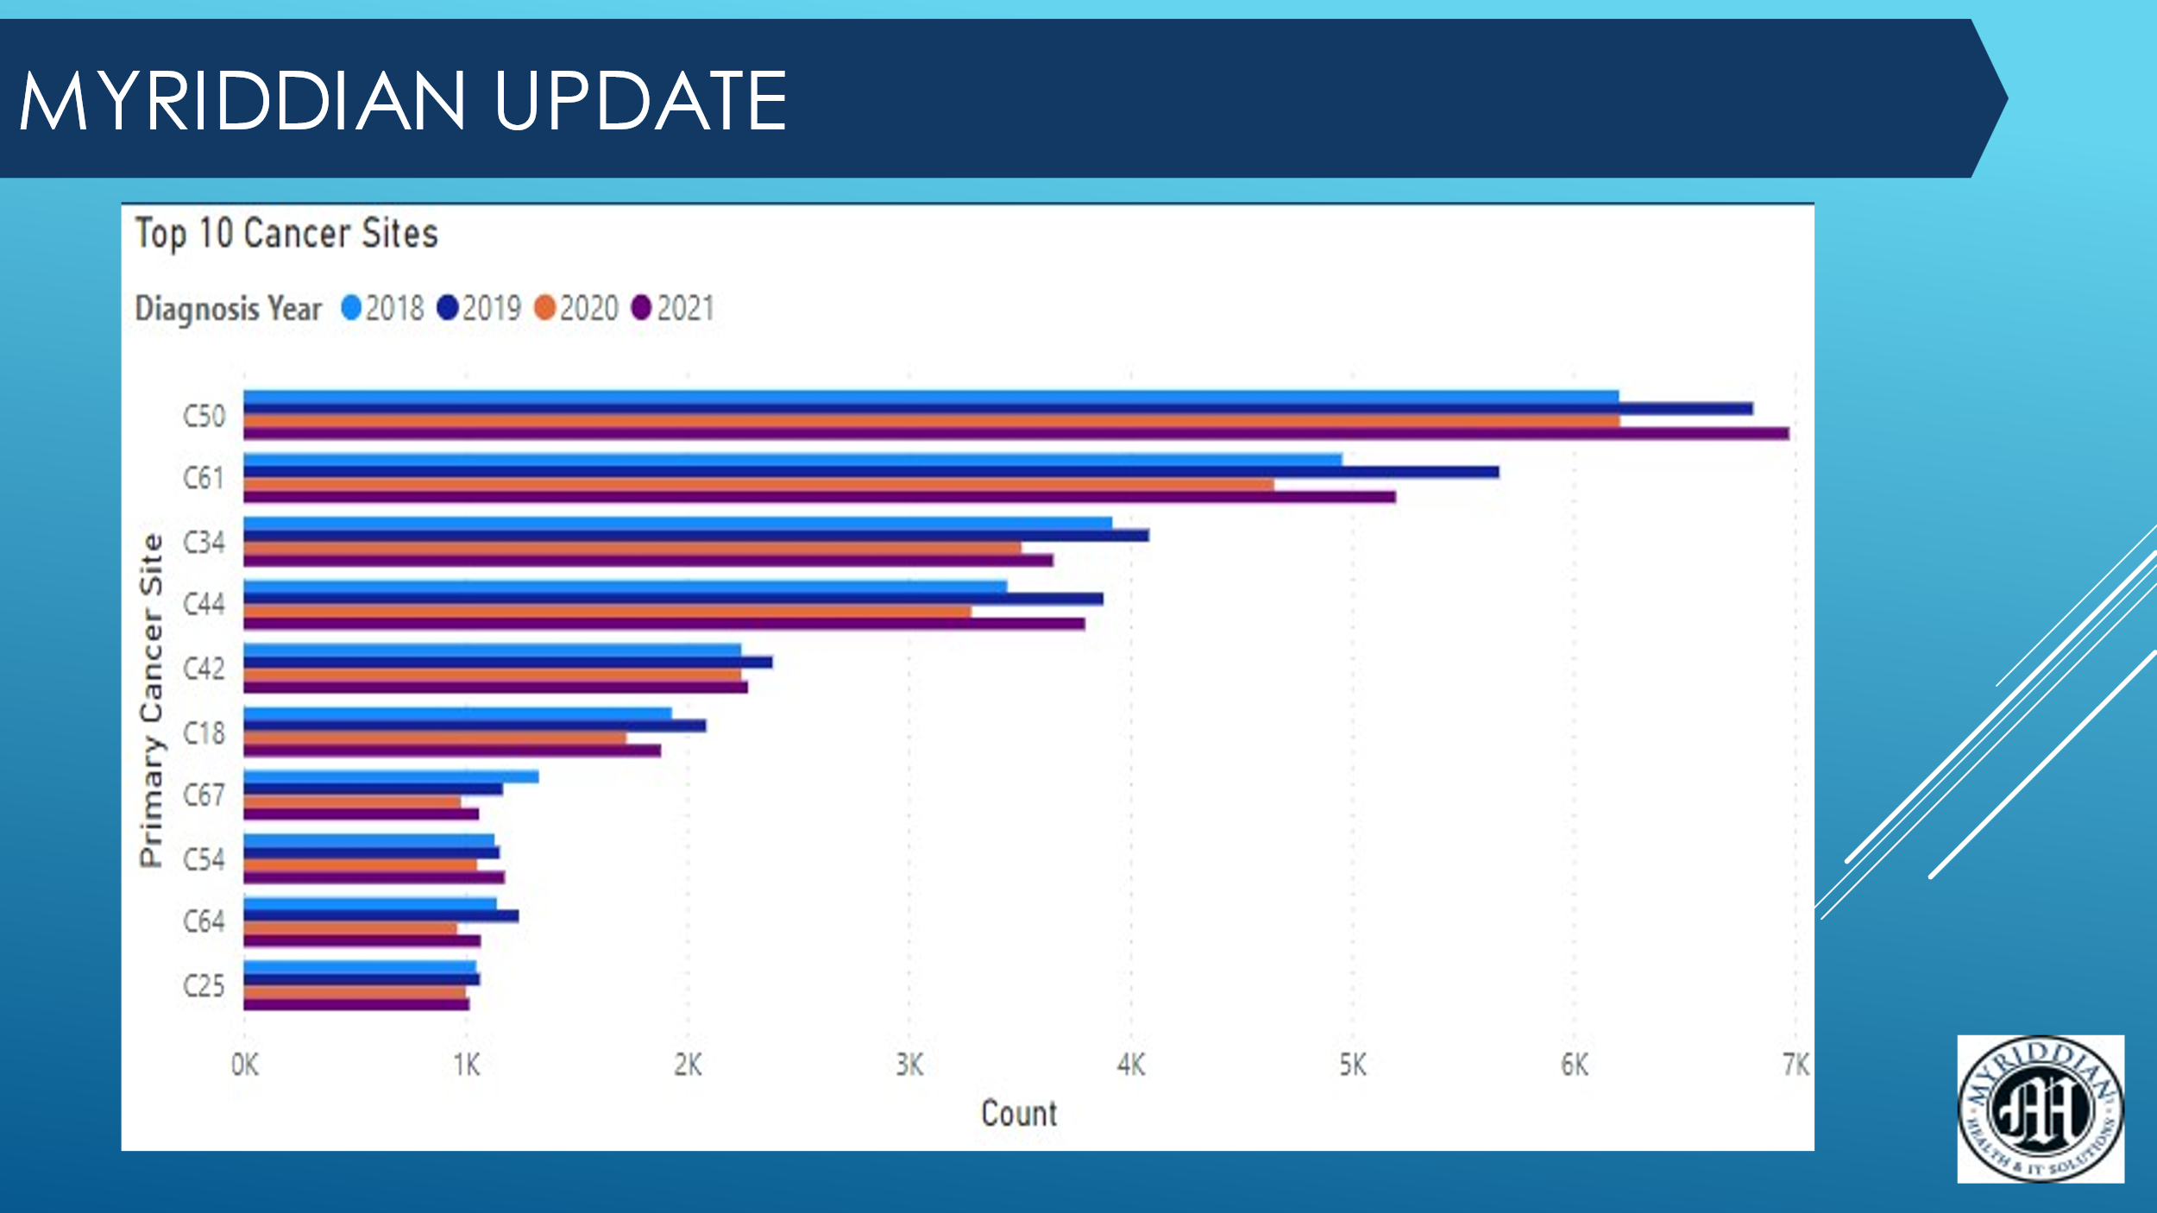

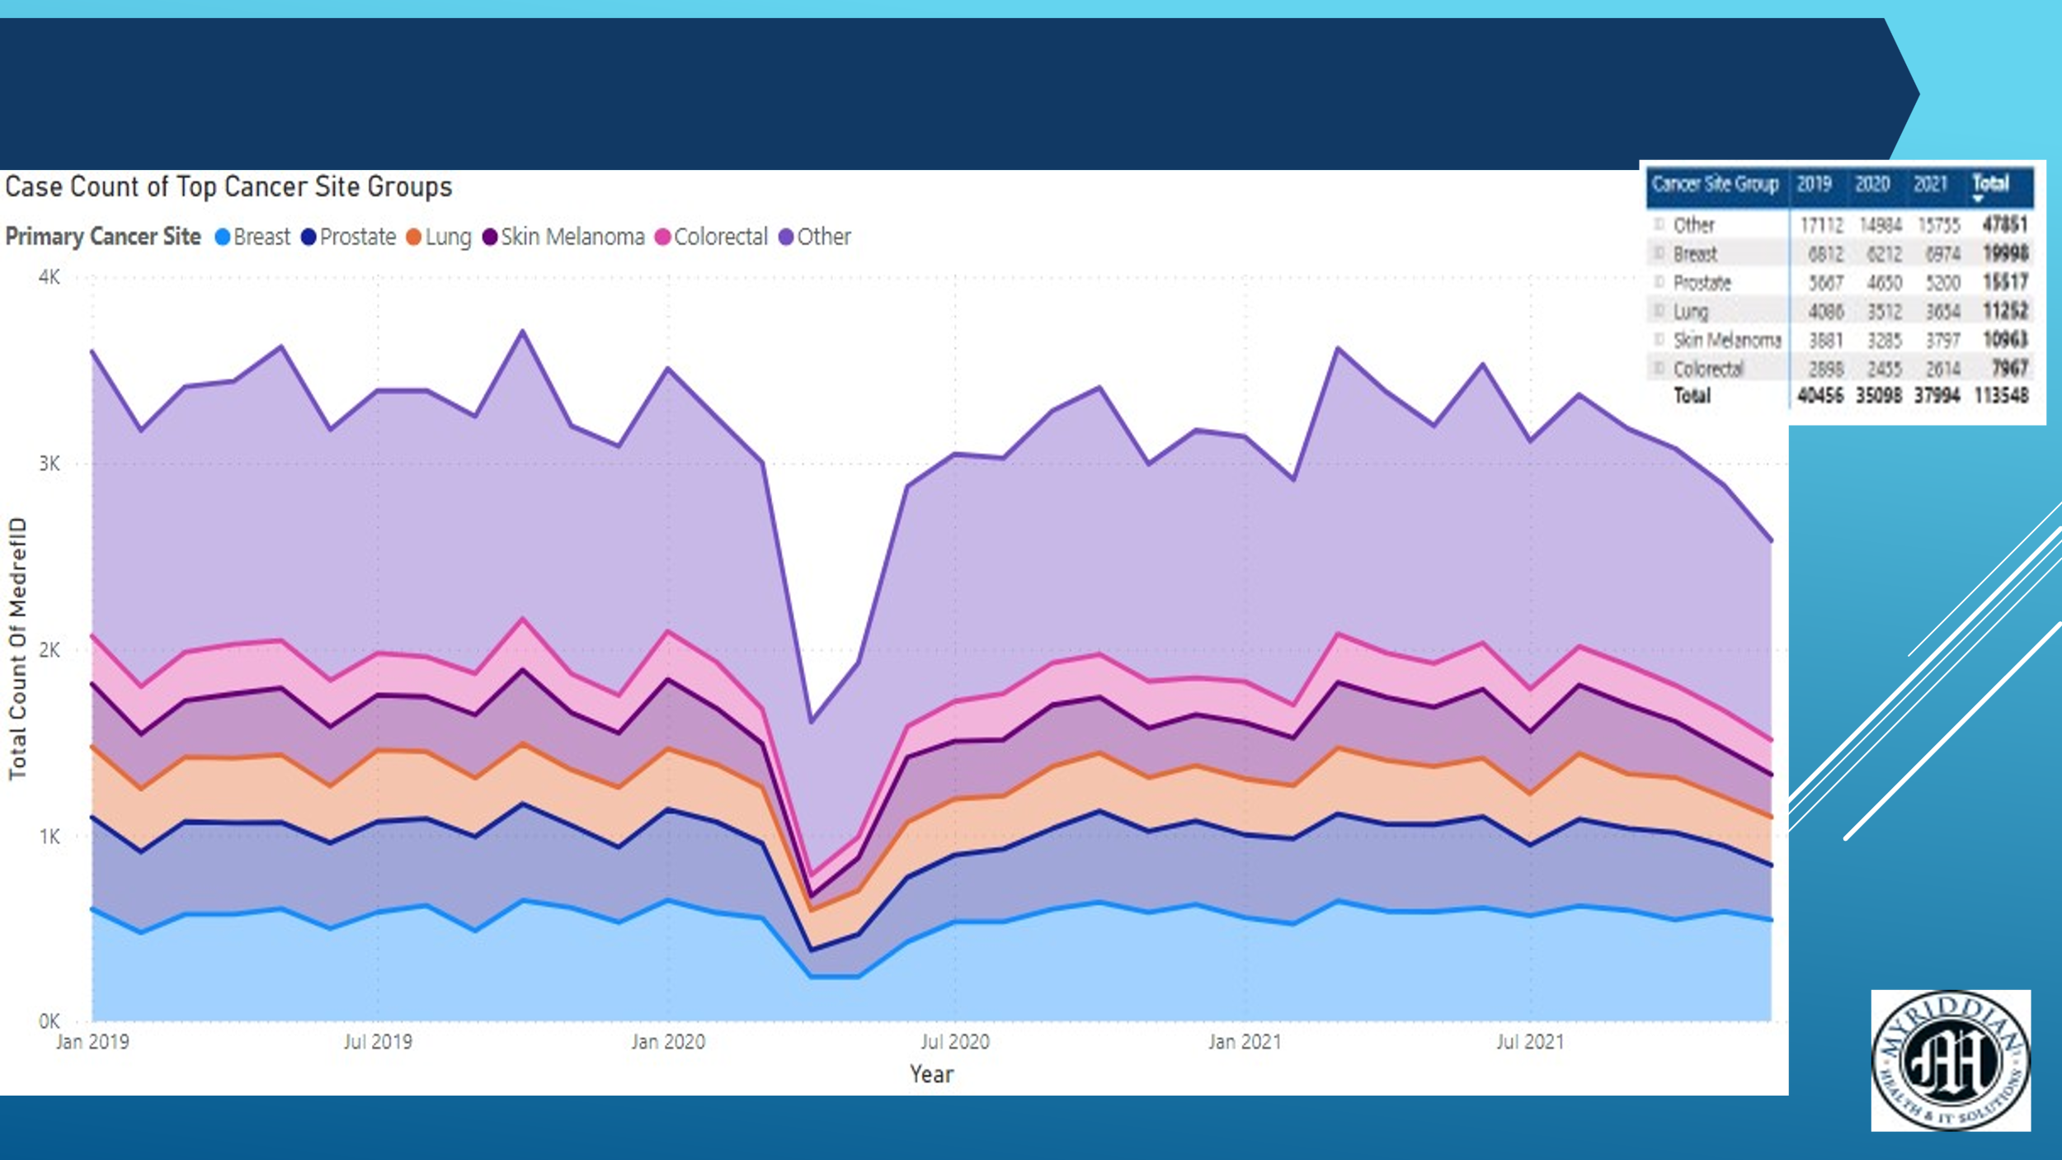

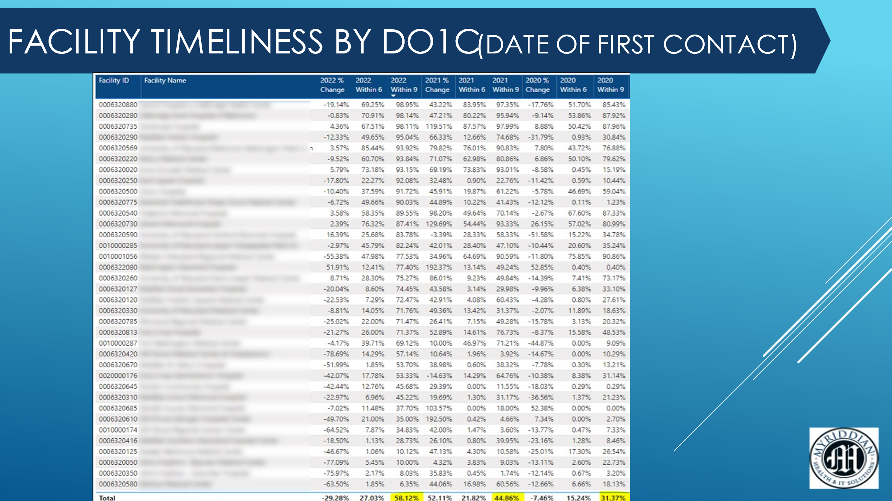
Myriddian is able to use this table to complete counts by medical summaries. If multiple cases are submitted for same patient, it will fall under one medical summary.

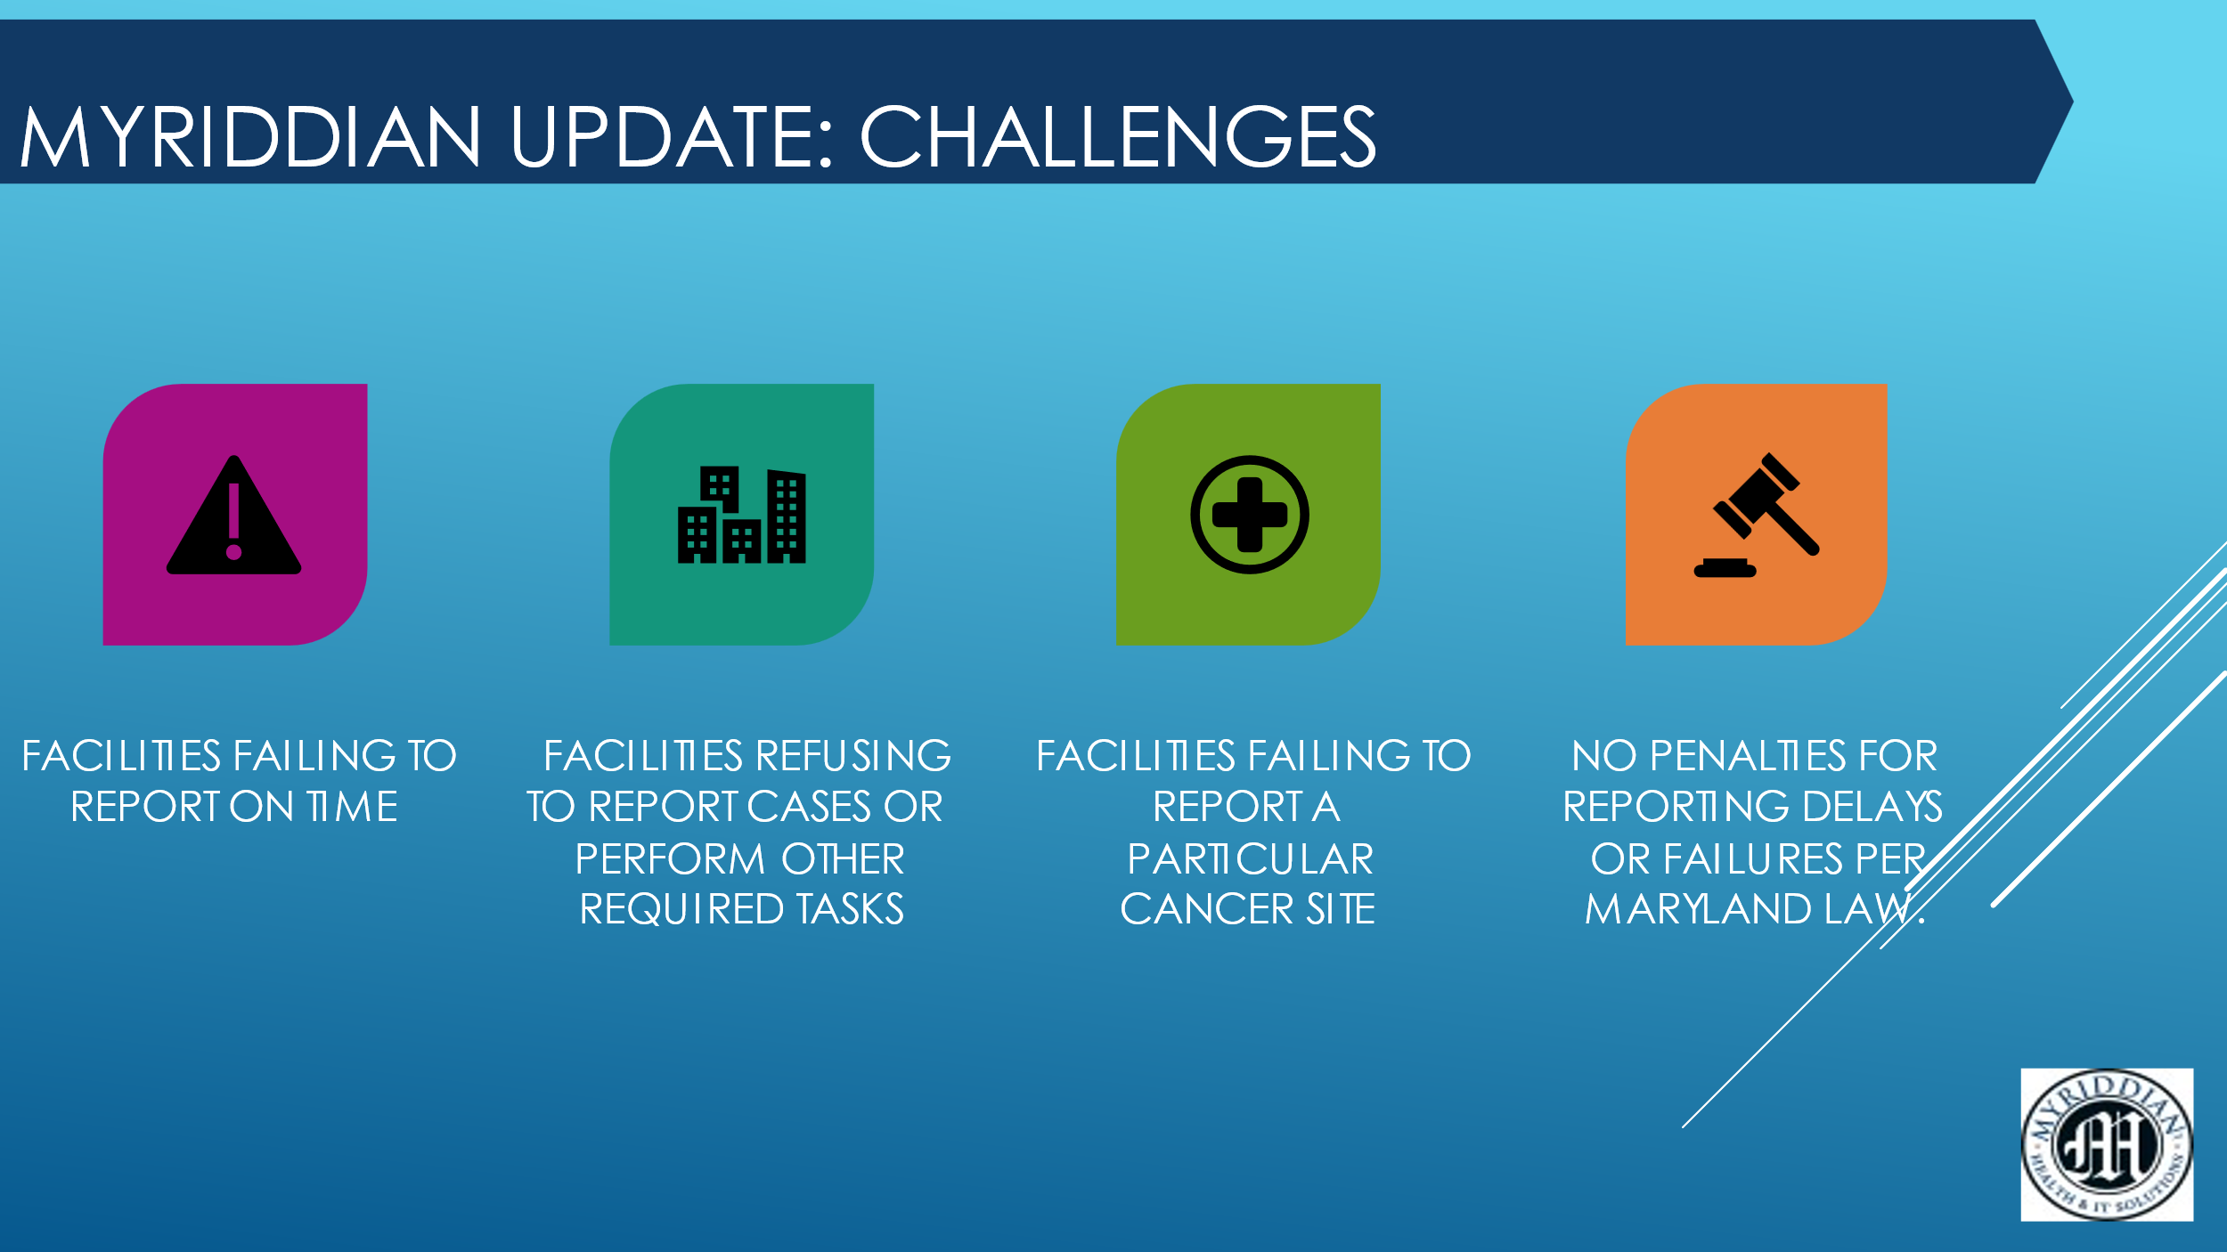

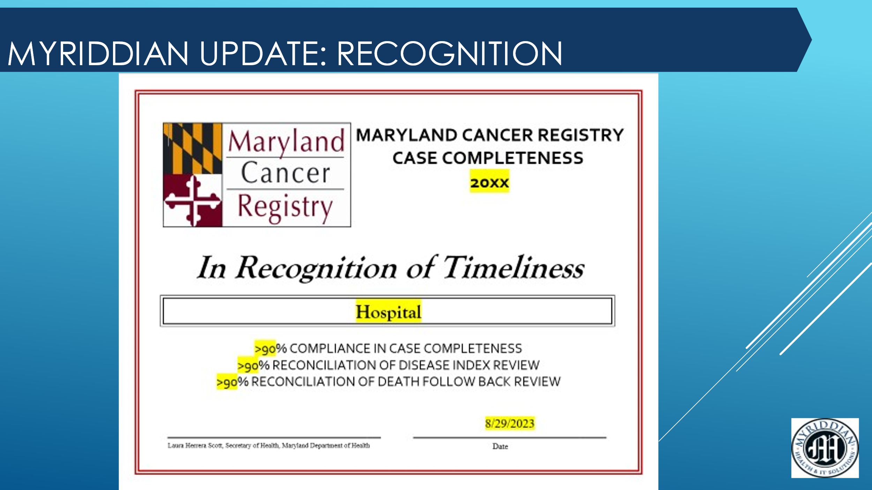

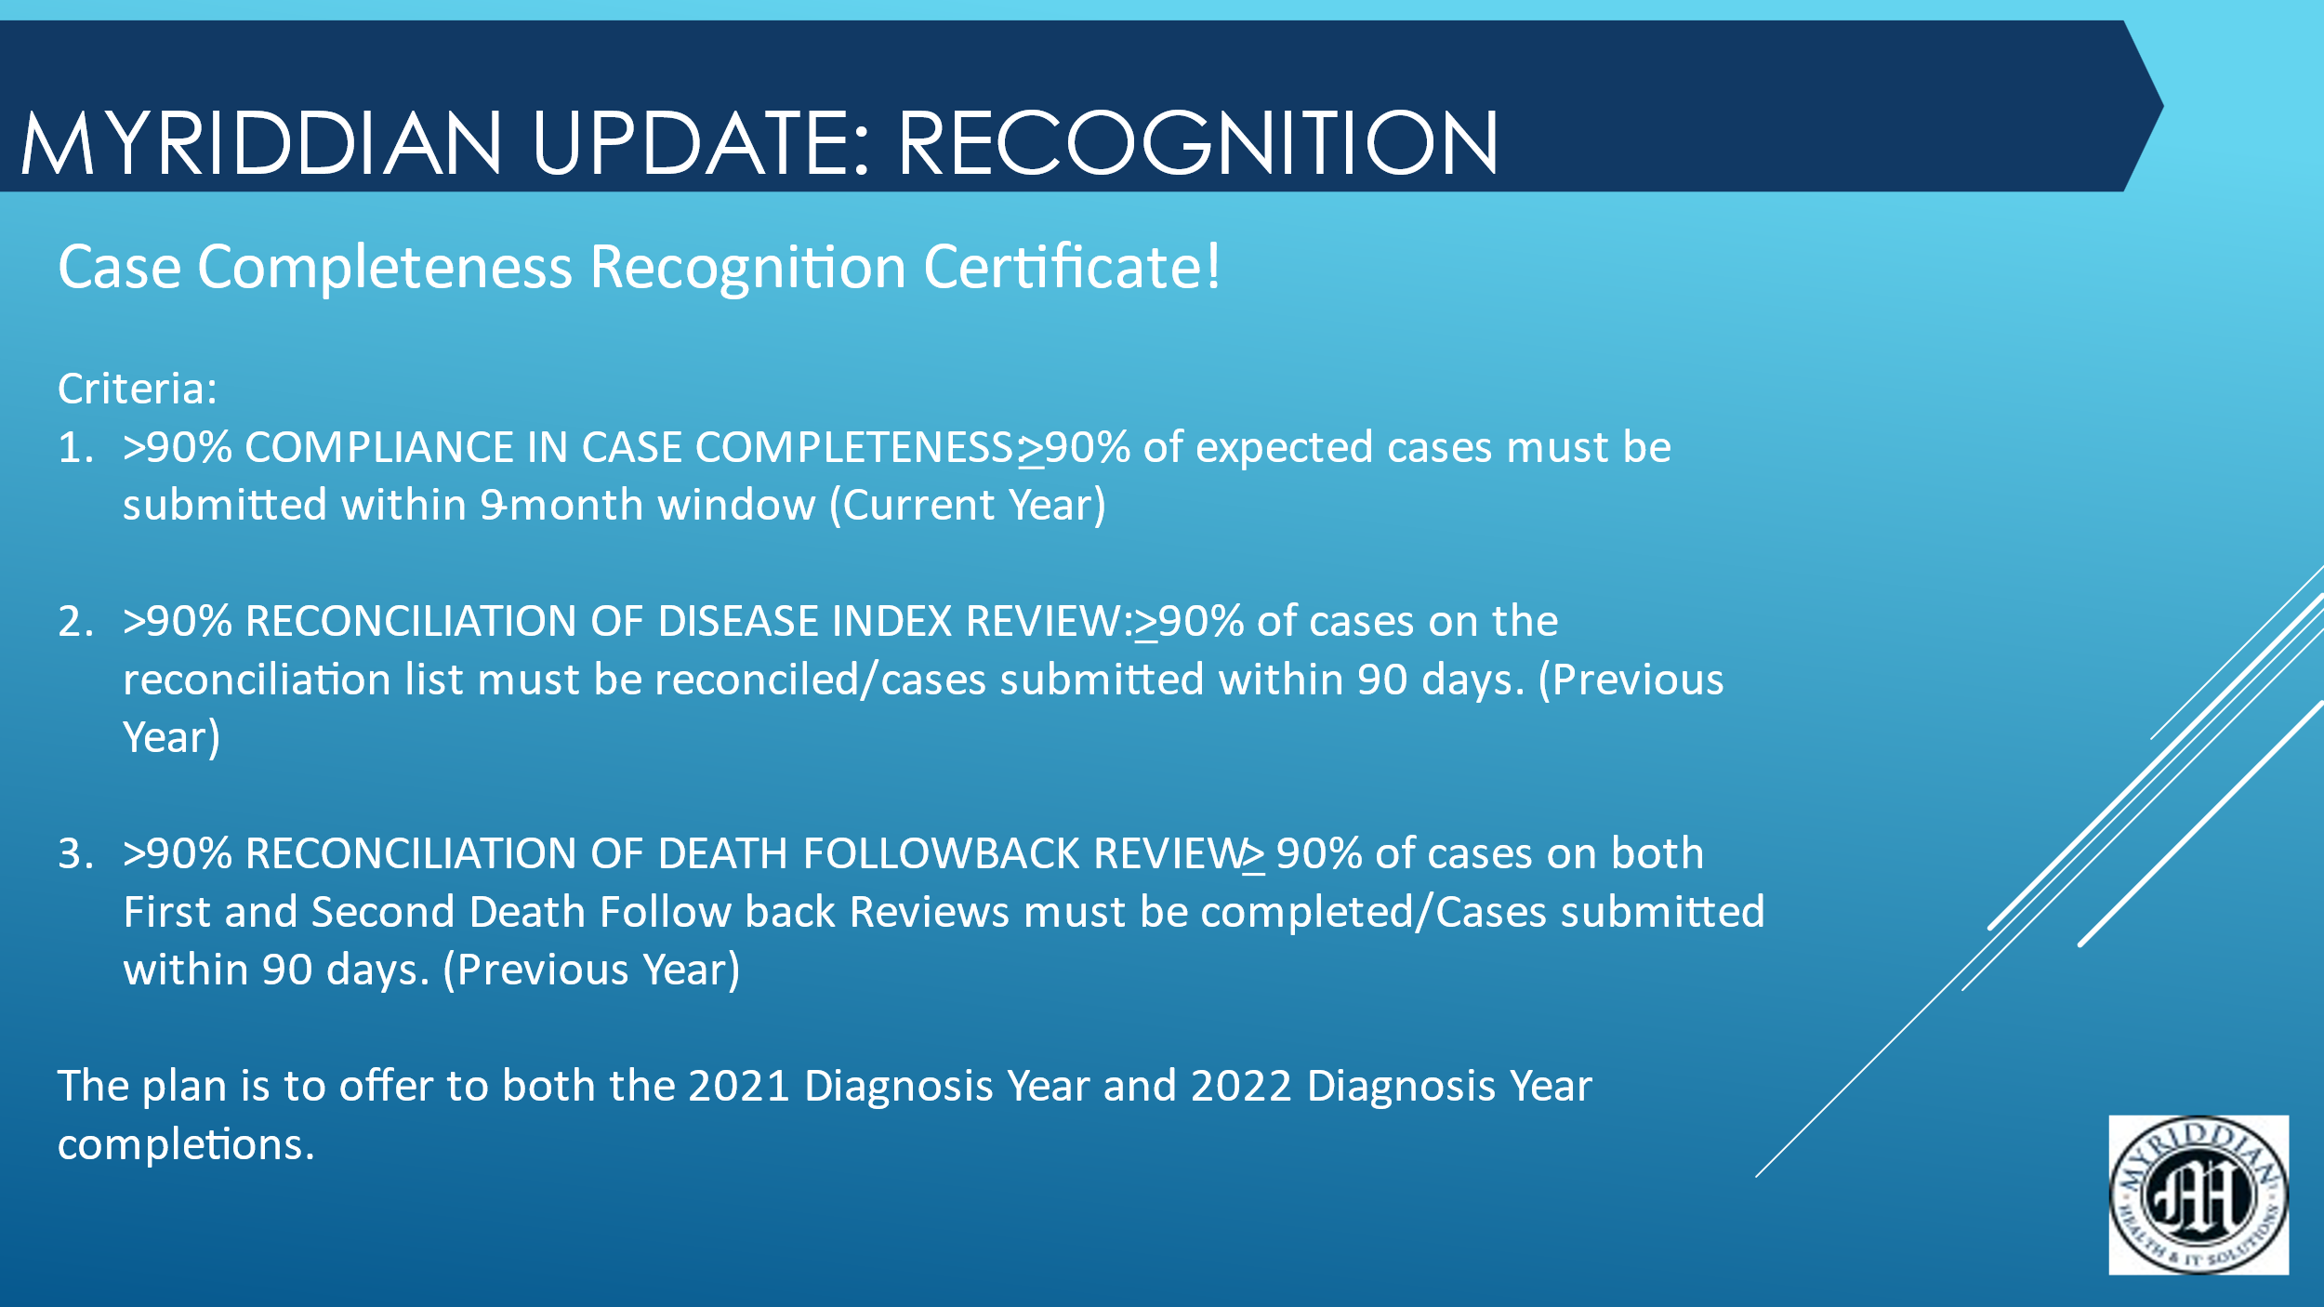

Environmental Public Health Tracking Update:

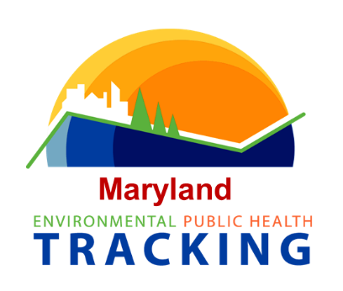

Link: https://maps.health.maryland.gov/ephtportal/

Dr. Mitchell provided an overview of the updated Environmental Public Health Tracking website.

Background: In early 2000, congress recognized that there is a large quantity of environmental and health data. A recommendation was made that environmental and health data should be viewed together so that communities could have a better idea of what they may be exposed to as well as their health status. It is a project that focuses on providing data to the public regarding environmental conditions and conditions related to the environment. The Maryland Environmental Health Bureau has been a part of the program since 2003.

An updated portal was launched in 2023.

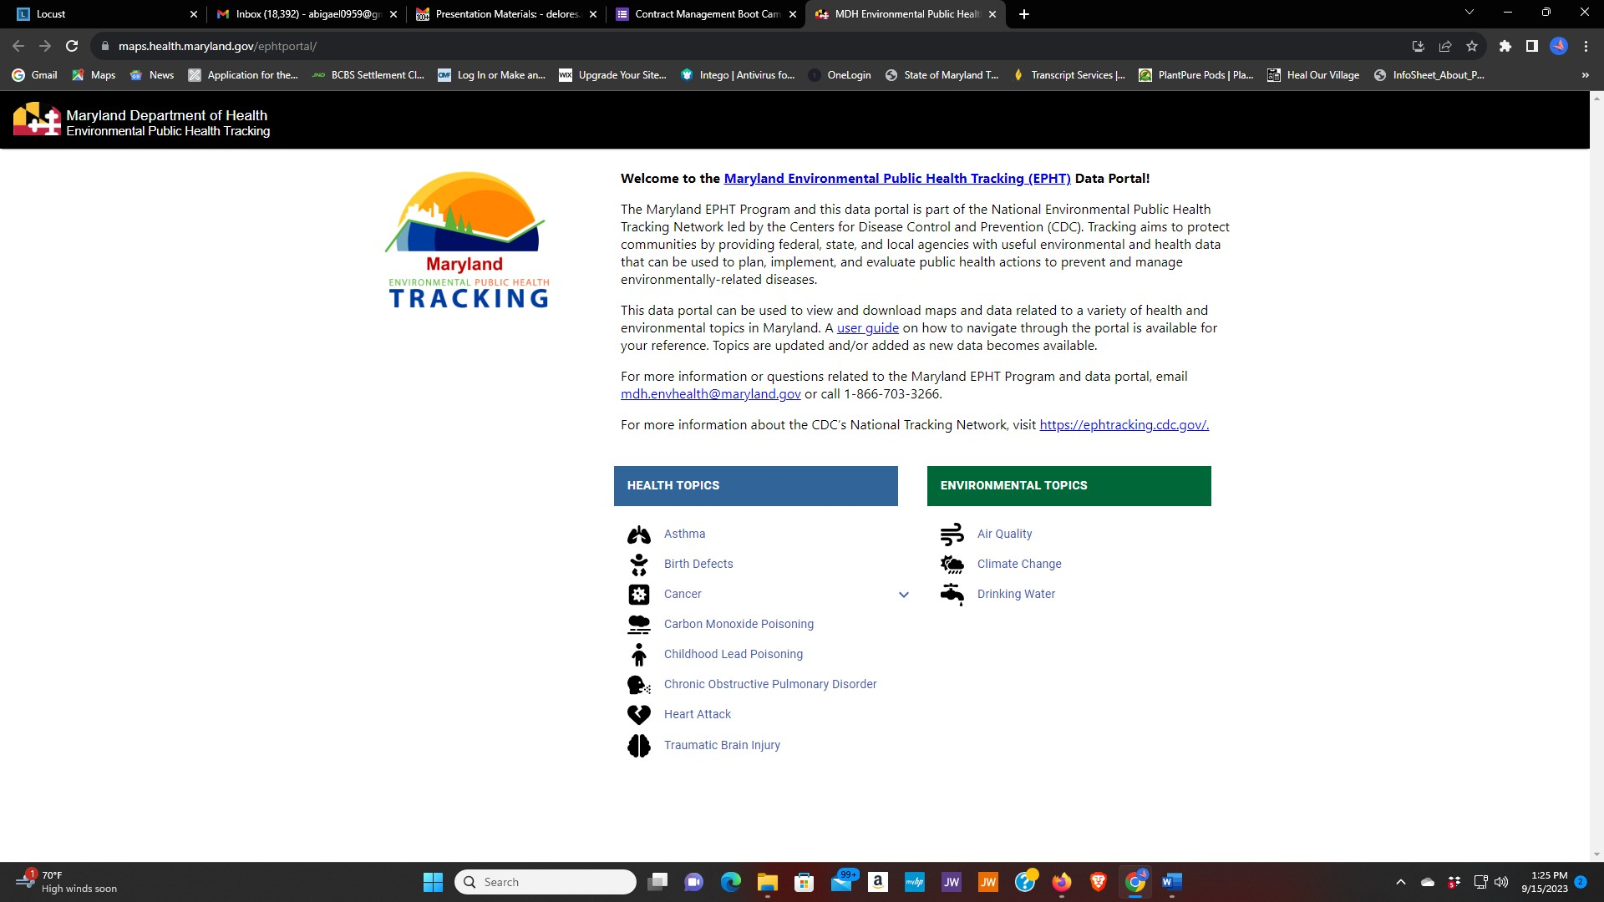

The new portal includes:

Health Topics | Environmental Topics
Asthma | Air Quality
Birth Defects | Climate Change
Cancer | Drinking Water
Carbon Monoxide Poisoning
Childhood Lead Poisoning
Chronic Obstructive Pulmonary Disorder
Heart Attack
Traumatic Brain Injury

These topics will be expanded over time.

Cliff demonstrated how the page works using “cancer”. There is text about the data to include:

- Data Facts
- Why these data are important
- Data Sources
- Years available
- Data source
- What’s reported
- How it’s reported
- Level of geographic detail
- Level of demographic detail
- Data disclaimers
- Environmental Health Helpline
- Data suppression rules

The overall goal is to provide the public with a readily accessible tool without having to contact the Maryland Cancer Registry.

2020-2022 data will be asterisks to explain what happened during COVID.

NEXT Meeting
The next CRAC meeting is scheduled for February 2, 2024.

