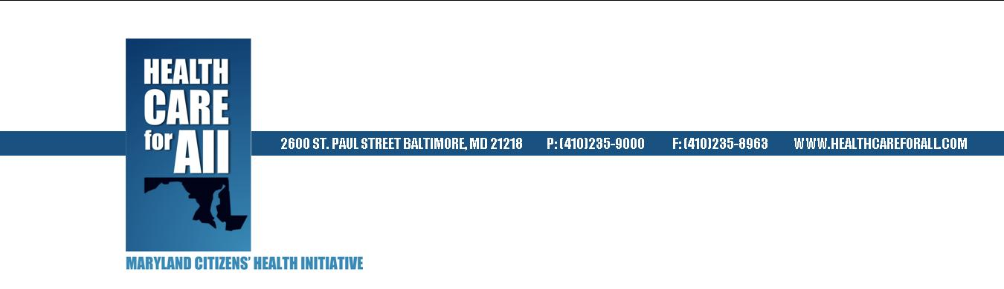

Invitation to Maryland Health Forums

Our state is pioneering a new care model that is focusing our hospitals more on prevention and strengthening their relationships with other health providers in their communities. This is producing better outcomes for patients, keeping people healthier, and making it easier for consumers to navigate the health care system.

Please come and learn about how you can take advantage of these exciting changes. We will also talk about innovative collaborations between health care institutions and faith communities and consider how to implement these models locally. These efforts are truly unique in the nation, and you should know about all of the new opportunities available.

This information is so important, I hope you will extend this invitation to your networks across the state. We are trying to get the word out about these changes in Maryland's health care system as widely as possible. Please see below for our scheduled events. We expect to schedule several more. To find relevant materials and an updated list at any time, please go to our website.

Baltimore County  Tuesday, June 2, 8:30AM-10:30AM  Sheppard Pratt Conference Center  6501 N Charles St  Towson, MD 21204 | Montgomery County  Monday, June 15, 5:00PM-7:00PM  Holy Cross Hospital  1500 Forest Glen Rd  Silver Spring, MD 20910
Anne Arundel County  Tuesday, June 23, 8:30AM-10:30AM  Rams Head Center Stage at Maryland Live  7002 Arundel Mills Circle  Hanover, MD 21076  *Free garage and surface parking. Valet available for a fee. | Baltimore City  Tuesday, July 7, 6:00PM-8:00PM  Central Baptist Church of Baltimore City  2035 West Baltimore Street  Baltimore, MD 21223  *Parking available at Bon Secours Hospital across from the church
Please RSVP to Stephanie Klapper at stephanie@healthcareforall.com or 410-575-4035. Your comfort and full participation is important to us. Please note that these facilities are handicap accessible. If you require interpretation or any special assistance, please let us know.

