Isolate Submittal Policy: Isolates That Cannot Be Ruled-Out As Select Agents

POLICY
In the event a Sentinel Laboratory is unable to “rule-out”* an isolate as a Select Agent**, it must be “referred-in” to the Maryland Department of Health (MDH) Laboratories Administration. Isolates that cannot be ruled-out as Select Agents require special consideration, and it is imperative that these procedures are followed to ensure the protection and integrity of the isolate and the safety of the personnel handling it. Consultation with the MDH Laboratories Administration (and in some cases MDH Physician-On-Call or Epidemiologist) is required.

PROCEDURE
If an isolate cannot be ruled-out as a Select Agent, contact the Laboratories Administration at the following numbers before submission:

MDH Laboratories Administration
Office of Laboratory Emergency Preparedness and Response
Monday – Friday 8:00 a.m. - 4:30 p.m. AFTER HOURS
(Dial in order) (Dial in order)

443-681-3787 - Office phone 410-925-3121 - Cell Phone
410-925-3121 - Cell Phone 410-408-7521 - Pager
443-681-3788 - Office phone 410-408-7521 - Pager

DO NOT submit isolates that cannot be ruled-out as a Select Agent without first contacting the MDH Laboratories Administration for consultation (numbers listed above, in the set order).

It is important that the Sentinel Laboratory contact the MDH Laboratories Administration EACH and EVERY time there is an isolate that cannot be ruled-out as a Select Agent. Consultation received is for the isolate in question only. It does NOT apply to future or previous isolates. If additional consultation is required, MDH Labs Administration will provide guidance at the time.

SHIPPING GUIDELINES
Refer to the attached document (Basic Triple Packaging) for packaging and shipping guidelines. If necessary, the MDH Laboratories Administration will arrange for an emergency courier, but will only do so after consultation with the patient’s physician and MDH Physician-On-Call or Epidemiologist. A completed INFECTIOUS AGENTS: CULTURE/DETECTION Request Form (MDH 4676) must accompany each isolate. Make sure to note the name of the organism to be ruled out on the Request Form. Rule-out specimens MUST be sent in a separate package from routine specimens.

This document (effective 03-21-2023) supersedes all previous documents regarding the transport and shipping of specimens that cannot be ruled-out as Select Agents.

REFERENCES
*Refer to the Laboratories Administration website for the Sentinel Level Laboratory Protocols for Suspected Biological Threat Agents and Emerging Infectious Diseases for rule-out protocols: https://asm.org/Articles/CPHMC/Laboratory-Response-Network-LRN-Sentinel-Level-C

** A “Select Agent” is defined as any of the biological agents or toxins listed in 42 CFR 73.3 and 73.4. You can visit the CDC website on select agents http://www.selectagents.gov/ for further information and a current and comprehensive list of select agents at: http://www.selectagents.gov/SelectAgentsandToxinsList.html.

BASIC TRIPLE PACKAGING

Basic triple packaging systems include a primary receptacle such screw-cap tube or plate with that has been sealed with Parafilm. The primary (1°) receptacle, along with required absorbent and cushioning material, is placed inside a secondary (2°) container. The 2° container for diagnostic specimens should be a sealed biohazard or Ziploc bag. The 2° container is then securely placed within an outer shipping container (tertiary (3°) container), generally a corrugated cardboard box with cushioning material inside to surround the 2° container. Include an itemized list of contents in a sealed plastic bag, placed between the 3° and 2° containers. This outermost container bears the name, address, and telephone number of shipper, name of person responsible with 24/7 telephone number, and the complete name, shipping address, and telephone number of the recipient, plus all the required markings.

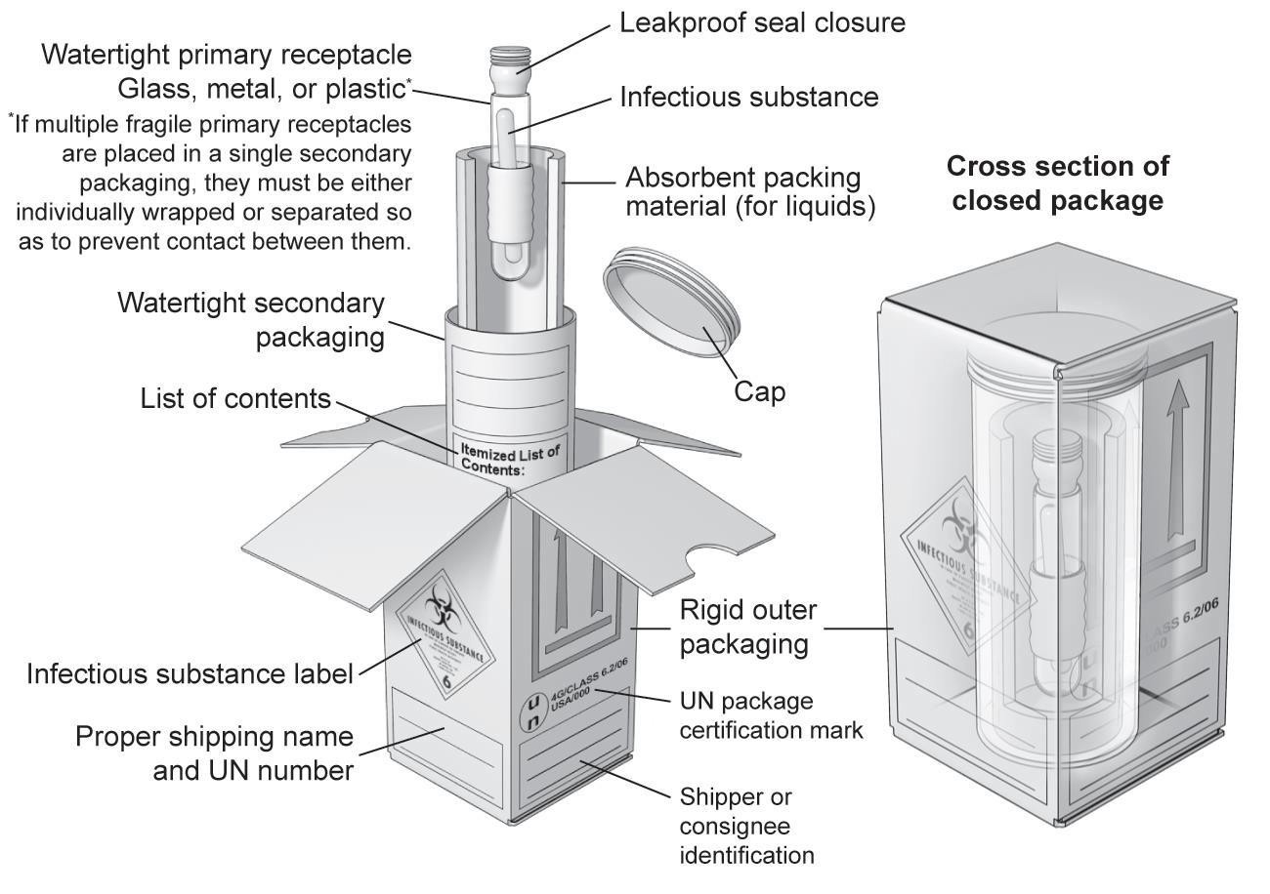

BASIC TRIPLE PACKAGING:
- A watertight primary receptacle.
- A watertight secondary receptacle.
- An outer packaging of adequate strength for its capacity, mass and intended use.
Note: For a liquid specimen, absorbent material must be placed between the primary and secondary containers and be capable of absorbing the entire contents of the primary receptacle(s).

Certified packaging systems are designed to withstand specific pressure changes and drop tests. Packaging systems that meet the packing instruction standards are currently available from vendors specializing in products certified to meet the IATA, USPS, and other carriers' requirements. Packaging systems using fiberboard or aluminum canisters, zip-lock bags, or other uncertified components may not be in compliance.

IT IS THE RESPONSIBILITY OF THE SHIPPER TO COMPLY WITH ALL LAWS AND REGULATIONS REGARDING THE SHIPPING OF INFECTIOUS SUBSTANCES.

