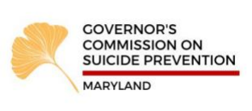Meeting Agenda
July 21, 2021
1 PM – 3 PM
1. Welcome and Introductions

2. Approval of May 19, 2021 minutes

3. Postvention Presentation
Andrea Duarte

4. Focus Area Strategy Discussion: Postvention

5. Governor’s Challenge Updates

6. BHA Update

7. Open Discussion
Next Meeting: Wednesday, September 15th, 2021

