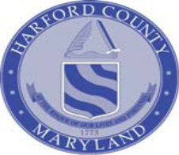 MENTAL HEALTH ADDICTIONS ADVISORY COUNCIL

FY 2016-2018 Strategic Plan, January 2016 Updates

Vision

The Mental Health and Addictions Advisory Council of Harford County envisions a comprehensive, culturally-sensitive and recovery-oriented substance use disorder and mental health system in Harford County.

Mission

The Mission of the Council is to expand, strengthen, and sustain an integrated and comprehensive prevention, intervention, and treatment services system to reduce the incidence and consequences of substance abuse and mental health problems in Harford County.

Overview

Strong partnerships and positive collaboration are the foundation for developing the substance use disorder and mental health systems in Harford County. This collaboration occurs with multiple systems, agencies, and people. To develop and improve the overall delivery of behavioral health services in Harford County, the Harford County Health Department, Harford County Department of Community Services/Office of Drug Control Policy, and Office on Mental Health/Core Service Agency work with strategic partners such as consumers of substance use disorder/mental health services, family members, providers, the Department of Health and Mental Hygiene (DHMH)’s Behavioral Health Administration, Harford County Mental Health and Addictions Advisory Council, Harford County District & Circuit Courts, Local Law Enforcement Departments, Harford County Detention Center, Harford County Board of Education, Department of Social Services, Department of Juvenile Services, Harford County Public Library, Harford County Local Management Board, and faith-based agencies.

As the foundation, the Harford County FY16-18 Strategic Plan is based on principles set forth by the Substance Abuse Mental Health Services Administration (SAMHSA) and mirrored by the State of Maryland DHMH. SAMHSA states that behavioral health is essential to the Nation’s health – for individuals, families, and communities, as well as for the Nation’s health delivery systems. Further, our country and within each community, can make a difference in its health, justice, social services, educational, and economic systems by addressing the prevention and treatment of mental and substance use disorders and related problems. To guide the country, SAMHSA has identified six strategic initiatives (http://www.samhsa.gov/about/strategyExt.aspx).

SAMSHA’s Strategic Initiatives

- Prevention of Substance Abuse and Mental Illness: Through this initiative, SAMHSA promotes and implements prevention and early intervention strategies to reduce the impact of mental and substance use disorders in America’s communities. This initiative includes a focus on several high-risk populations, including:
- Transition-age youth
- College students
- American Indian/Alaska Natives
- Ethnic minorities experiencing health and behavioral health disparities
- Service members, veterans, and their families
- Lesbian, gay, bisexual, and transgender (LGBT) individuals
- Health Care and Health Systems Integration: Health care and health systems integration aims to ensure that behavioral health care services are more accessible and connected to the broader health care system. This initiative focuses on:
- Increasing access to appropriate high quality prevention, treatment, recovery, and wellness services and supports
- Reducing disparities between the availability of services for mental illness (including serious mental illness) and substance use disorders compared with the availability of services for other medical conditions, including those for people from minority populations who experience significant health disparities
- Supporting coordinated care and services across systems
- Trauma and Justice: This initiative addresses the behavioral health needs of people involved in - or at risk of involvement in - the criminal and juvenile justice systems. Additionally, it provides a comprehensive public health approach to addressing trauma and establishing a trauma-informed approach in health, behavioral health, human services, and related systems. The intent is to reduce both the observable and less visible harmful effects of trauma and violence on:
- Children and youth
- Adults
- Families
- Communities

- Recovery Support: This initiative will promote partnering with people in recovery from mental and substance use disorders and their family members to guide the behavioral health system in:
- Promoting individual, program, and system-level approaches that foster health and resilience
- Increasing housing to support recovery
- Reduce barriers to employment, education, and other life goals
- Securing social supports in their chosen communities
- Health Information Technology: This initiative advances the use of health information technologies to support integrated behavioral health care and its potential to transform the health care system. It encourages the general health care delivery system in the adoption of Health Information Technology (HIT) and interoperable Electronic Health Records (EHR) by states, community providers. This will help practitioners across the spectrum provide:
- High-quality integrated health care
- Appropriate specialty care
- Improved patient and consumer engagement
- Effective prevention and wellness strategies

Workforce Development: This initiative will support active strategies to increase the supply of trained and culturally aware preventionists, health care practitioners, paraprofessionals and peers to address the behavioral health needs of the nation. It will also improve the behavioral health knowledge and skills of those health care workers not considered behavioral health specialists. To help meet behavioral health needs within America’s transforming health promotion and health care delivery systems, this initiative will monitor and assess the needs of:
- Youth
- Young adults
- Young adult and adult peers
- Communities
- Health professionals

Analysis of Jurisdictional Needs

Demographics
Harford County is comprised of 440 square miles, is bordered by Pennsylvania, the Chesapeake Bay, and Cecil and Baltimore Counties. Harford County has the seventh largest population in the State of Maryland, which is 4.4% of the state population. According to the Harford County Government- Planning and Zoning Department, the 2014 - 2015 estimated population is 250,105 and that number has risen the last several years. The latest figures report that Harford County can expect to increase its population by 30,000 over the next five years. The county’s growth rate over the last eight years has continued to acell while the statewide population increase has only averaged about 6%. According to the latest statistics available (estimated 2015), children ages 0-19 account for 27% of the total population, ages 20 – 54 account for 49% of the total population, ages 55 – 85+ account for 24% of the total population in Harford County.

The minority populations include approximately 12% African-American, 3% Hispanic, 2% Asian, and a total of less than 2% as other minority categories. As organizations, we respect the individual and cultural differences of our residents and make every effort to develop services that meet the needs of a diverse community.

Wealth of the county population is a major consideration for substance use disorder/mental health planning. The median household income for Harford County is slightly above the average for the State. According to the Department of Health and Mental Hygiene (FY2012), 30,050 Harford County residents were enrolled in Medical Assistance. The number of children living in single parent homes has increased steadily, which will increase the chances that a child will live in poverty. In addition, the number of families in need of public assistance has increased. Those individuals living below the poverty line in Harford County is estimated at 7.4%.

Treatment data/needs:

Based on the most recent data available through the Maryland Behavioral Health Administration (BHA):

- Based on current treatment data to date, it is estimated that about 7,500 Harford County residents have a substance abuse problem requiring treatment.

- Through May 30, 2015 (FY 15), 1,312 residents received treatment in State-supported facilities; 483 in non-state-supported facilities. These numbers are unduplicated counts meaning that if a person was admitted two or more times, they were only counted one time.
  - The demographics of these residents include:
    - 40% women
    - 5% adolescents
    - 23% African-Americans, Hispanic, or individuals of other minority groups
    - 43% with co-occurring mental health problems
    - 56% without any employment or disabled

Mental Health data/needs:

In FY 2015, the public mental health system served 6,632 people; 2,499 children/adolescents, 369 transitional aged youth, and 4,133 adults. Of these, 344 were new to the public mental health system, for an increase of 5.4%% from FY14. The Office on Mental monitored $25.8 million through the PMHS Fee-for-Service system and provided $3.28 million in grant funds for services and programs in the County. One of the key components of the Mental Health system in Harford County is the Mobile Crisis Team which handled 2,067 crisis calls and responded to 828 persons in crisis, and provided 113 medical evaluations with Harford Memorial Hospital.

On January 27, 2015, the Harford County Department of Community Services conducted a point in time study to capture data on people who are homeless in Harford County. 210 people were identified as being homeless. 50 of the 210 (24%) reported having a mental health or addiction disorder.

DATA CHARTS:

The Mental Health and Addictions Advisory Council is comprised of representatives from the consumers of addiction/mental health services, family members, substance use disorder/mental health providers, Harford County Health Department, Office on Mental Health/Core Service Agency, Judicial and Criminal Justice, etc. A workgroup has been selected to review the bylaws and discuss changing the group’s name. This workgroup plans on meeting in the summer.

The Harford County Health Department is the Local Addictions Authority for the county and is responsible for planning, managing, and monitoring publicly funded substance use disorder services.

A review of the below data was used to help gain an overall understanding of the addiction problems. As shown below, in 2014, Harford County is 6th highest in the state for total drug and alcohol related intoxication overdose deaths and 7th in the state for heroin related intoxication deaths. This continues to be a concern. Thus far in 2015, Harford County has lost 12 people to overdose deaths but potentially saved 21 persons through Harford County Health Department’s Narcan initiative, and this number does not include those lives saved from other entities such as EMS, hospital, etc.

Table 1
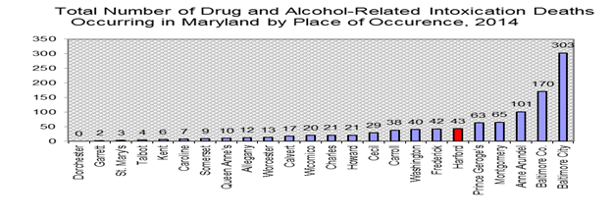
Table 2

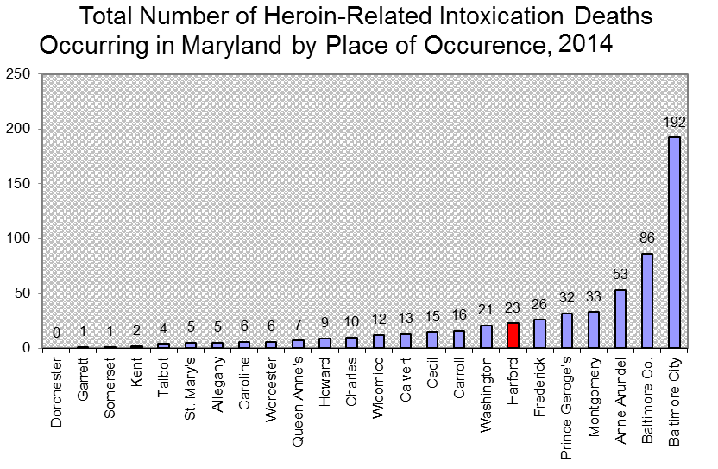
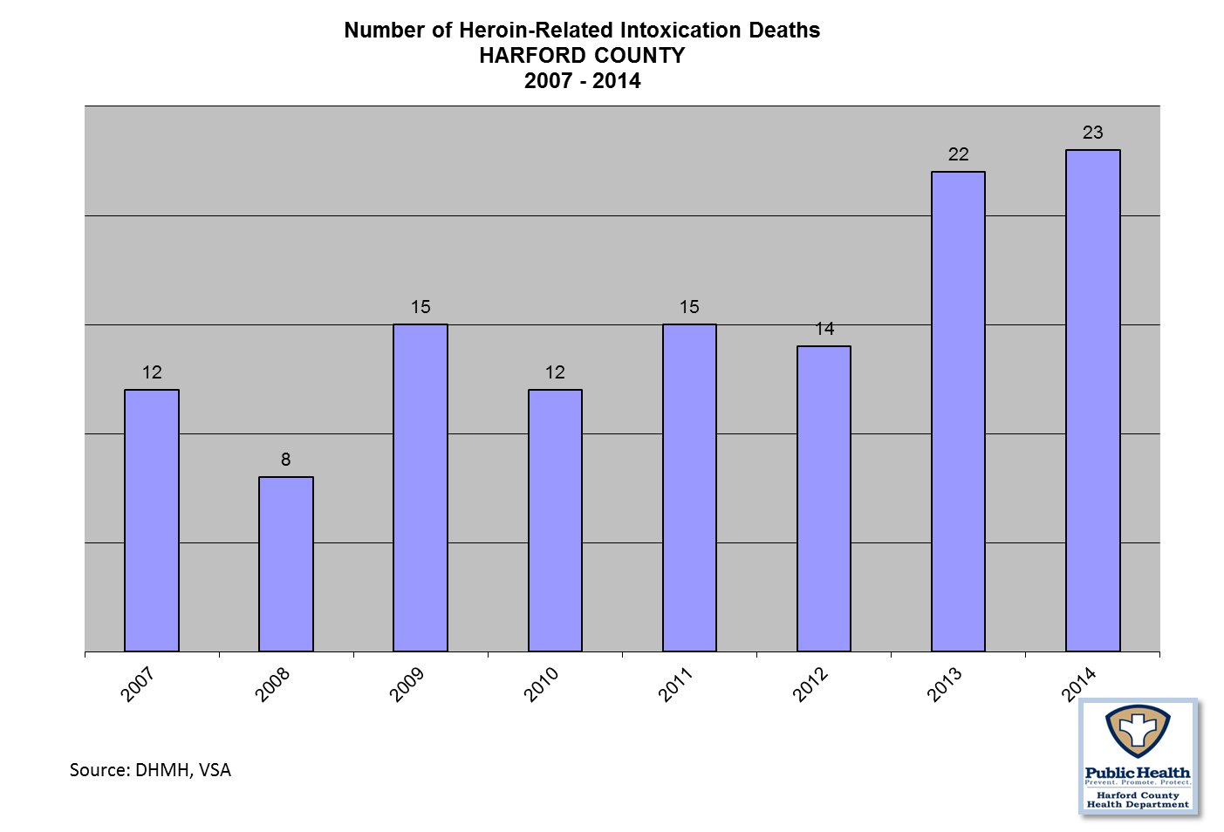
Table 3
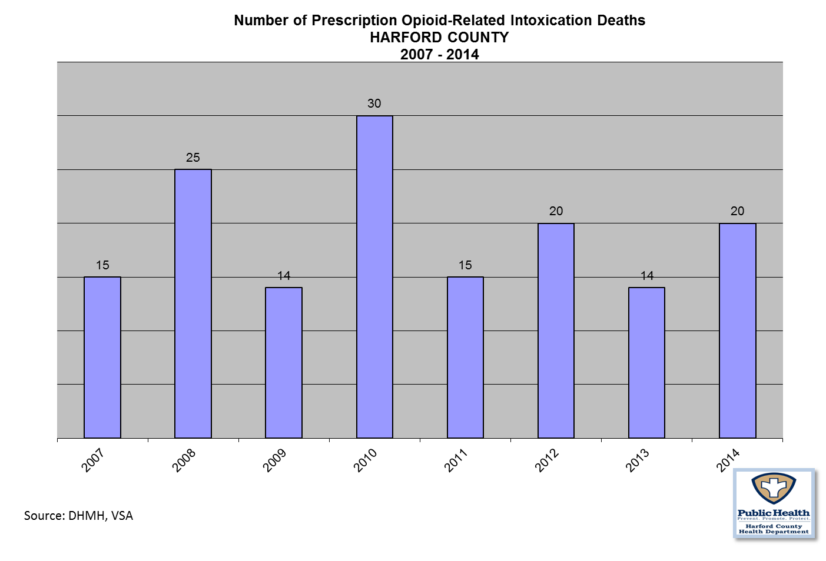
Table 4

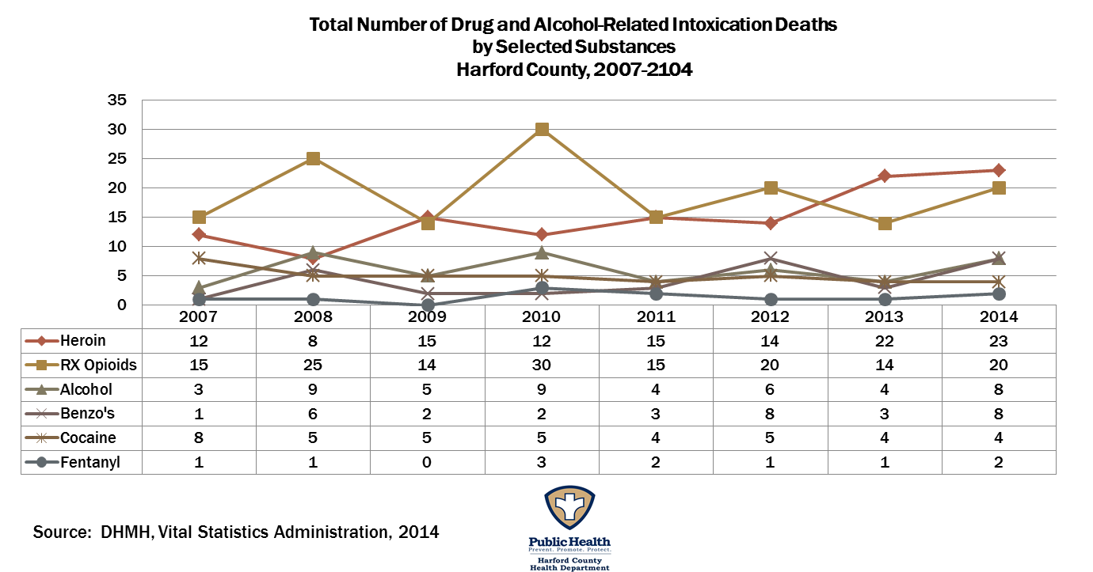

Where one death is too many, clearly heroin and prescription opioids continue to be a major concern for Harford County.
Figure 4

Patient Residence for Admissions to State-Supported
Alcohol and Drug Abuse Treatment Programs Reporting Data
Harford County Drug and Alcohol Treatment FY 10 - 14 |  |  |  |  |  |  | Total
 | FY 10 | FY11 | FY12 | FY13 | FY14 | FY15 ** | Total
Number of Admissions to State Funded  Treatment Centers | 1,091 | 1,305 | 1,372 | 1,286 | 1,697 | 1,312 | 8,063
Source BHA, 2015 ** Through 5/30/15

Figure 5

Heroin- Related Admissions to treatment providers in Harford County, FY 12 – FY 15
Heroin-Related Admissions
Harford County Providers | Fiscal Year of Admission
Harford County Providers | 2012 | 2013 | 2014 | 2015**
Emmorton Psych | 4 | 1 | 0 | 0
Harford Co Tx for Juvenile Drug Court (101004) | 1 | 2 | 3 | 0
Medication Assisted Treatment Technologies (MATT) partly supported by Harford County Health Dept | 141 | 117 | 139 | 35
Serenity Health, LLC | 55 | 93 | 29 | 15
Emmorton Psych Chartered | 5 | 0 | 0 | 0
Joppa Health Services Inc | 119 | 142 | 125 | 56
Harford Health Dept. | 87 | 138 | 186 | 130
Total | 412 | 493 | 482 | 236

Figure 6- Narcan Training Initiative FY 15

Total Individuals Trained | Total Certificates Issued | Total Prescriptions Issued | Total Naloxone Dispensed | Total Naloxone Administered from HCHD Training | Total Sheriff Office Overdose Incidents (10/1/14 – 6/30/15)
574 | 566 | 176 | 1154 | 21 | 117

Figure 7 -Persons served in the Harford County Public Mental Health System

Age | FY 2011 | FY 2012 | FY 2013 | FY 2014 | FY 2015
0 – 5 | 232 | 272 | 183 | 270
6 – 12 | 967 | 1,119 | 965 | 1,253
13 -17 | 674 | 770 | 691 | 929 | 2,499  Ages 0 to 17
18 – 21 | 305 | 364 | 288 | 358 | 369
22 – 64 | 2,185 | 2,775 | 2,444 | 3,436 | 4,133  Ages 22 and older
65 + | 29 | 33 | 39 | 42
Total | 4,392 | 5,333 | 4,610 | 6,288 | 6,632

The Harford County Office on Mental Health/Core Service Agency monitors the number of people who receive public mental health services in the county. As illustrated above, the overall number of people served in the public mental health system continues to increase each year.

Figure 8 – Drug Seizures and Drug Take Back Events

Year | Heroin | Opiate/Prescription Meds./Pills
2009 | 61 grams | 395
2010 | 138 grams | 1,076
2011 | 341 grams | 4,011
2012 | 2,336 grams | 1,628
2013 | 1,231.6 g | 775
2014 | 314 g | 1,952

Source: Harford County Sheriff’s Office/Task Force

Take Back Events

2012 | 3,472 Pounds
2013 | 4, 044 Pounds
2014 | 5,010 Pounds

Figure 9 – 2013 - Youth Risk Behavior Survey
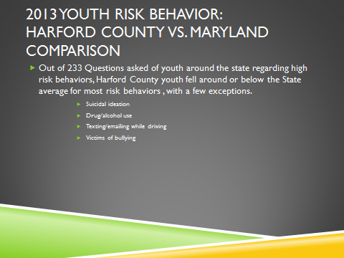
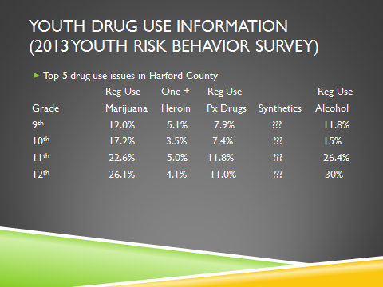
Figure 10– 2013 - Youth Drug Use

Figure 11 – Youth Risk Behaviors

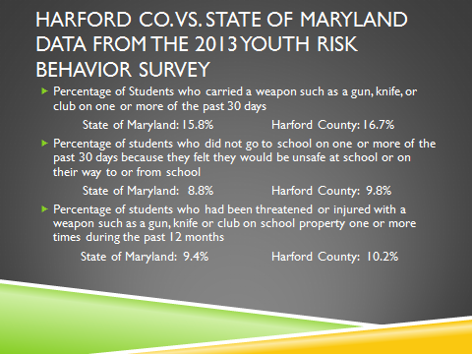

Figure 12 – Bullying, Suicidal Ideation/Attempts, Risky Behaviors

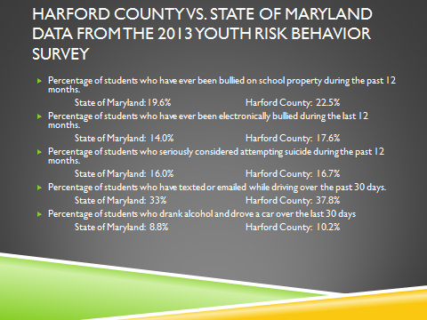

To summarize the youth data: Harford County youth rank higher in high risk behaviors such as bullying, suicide attempt/plans, substance use and texting while driving.

Analysis of the Local Continuum of Care

The Harford County Health Department’s Division of Behavioral Health oversees and administers a comprehensive continuum of care that includes the following:

- ASAM Level 0.5 Early Intervention services to adults and adolescents at Health Department site
- ASAM Level I services to adults and adolescents at Health Department site with opioid medication treatment vended out (OTP)
- Level II.1 Intensive Outpatient Program (IOP) for adults and adolescents at Health Department site
- Level III.7 care through agreements between the Health Department and intermediate care facilities, including Mountain Manor and Shoemaker, which provide detoxification and inpatient services to adults.
- Continuing Care – offered to those clients who successfully complete treatment and volunteer to stay involved via phone contact
- Peer Recovery – offered to any interested client at any time throughout treatment and continues as long as client is interested
- Halfway House or Recovery housing through a local navigation program, ACR
- Family Support Group
- Women’s Support Group

The Harford County Government also provides funding for two halfway houses in the County:

- ASAM Level III.1 care for 12 men provided by the Mann House, located in Bel Air, Maryland*
- ASAM Level III.1 care for 8 women provided by Homecoming Project, Inc, located in Bel Air, Maryland

Harford County still continues with system barriers, gaps and challenges such as:

- Lack of adequate affordable housing, particularly with people with criminal histories and poor credit histories
- Lack of comprehensive transportation system
- Lack of residential treatment for adolescents
- Insufficient number of halfway and recovery houses
- Halfway housing for opioid-dependent individuals on medication such as methadone or suboxone

JANUARY 2016 UPDATES ARE REFLECTED IN RED BENEATH EACH MEASURE

Goal 1: Reduce the number of overdose deaths by 10% by the year 2018

Objective 1: Review and monitor overdoses via Overdose Fatality Review Team and make recommendations for system change

Objective 2: Place peer counselors/recovery coaches within the hospital to meet with patients who have behavioral health needs

Objective 3: Train residents in the use of Narcan

Objective 4: Promote behavioral health screenings within primary care and urgent care practices

Objectives | Performance Measures/Targets | Target Date
Review and monitor overdoses via Overdose Fatality Review Team and make recommendations for system change | - Meet at least quarterly or as is needed to review every overdose death | 2018
 | Harford County’s Overdose Fatality Review Team met four times during calendar 2015. 16 cases were reviewed. | 1/2016 Update
Place peer counselors/recovery coaches within the hospital to meet with patients who have behavioral health needs | 1. Place a peer within each hospital (Upper Chesapeake and Harford Memorial) to work with the behavioral health patients to link them up to appropriate care for getting into recovery | 10/2015
 | The Division of Behavioral Health secured a grant with the CHRC in May 2015 to place peers within the two area hospital as needed. During calendar year 2015, DBH peers met with and referred as appropriate 46 persons. | 1/2016 Update

Train community in the use of Narcan | 1. Hold Narcan trainings at least quarterly or as needed to accommodate community need | ongoing
 | During calendar year 2015, the Harford County Health Department trained and certified a total of 1066 persons to carry and administer Narcan, encompassing 291 law enforcement and 775 from either family members, volunteers, occupation, or social experience. From these specific trainings, Narcan was reported to be used on 37 occasions.  Furthermore, the DBH contacted a total of 160 Near Overdose victims or their families to discuss treatment options and/or give referrals. | 1/2016 Update
Promote behavioral health screenings within primary care and urgent care practices | 1. Meet with docs and urgent care practices quarterly to make them aware of behavioral health needs and resources | ongoing
 | A physician liaison was hired to meet with all primary care doctors and pediatricians to train them on behavioral health screening to include suicide. This was concluded in 6/2015  In March 2015 interested pediatric doctors were trained to learn how to identify suicide signs and what to do in the case an adolescent/child screened positive. | Completed 6/15

Goal 2: Improve delivery and awareness of behavioral health services

Objective 1: Reduce hospital admissions from the Emergency Department due to behavioral health conditions.

Objective 2: Raise community awareness around drug use/misuse and treatment

NEW Objectives added, 1/2016
Objective 3: Increase community education on behavioral health on suicide prevention, treatment options and promoting wellness.

Objective 4: Educate obstetricians and substance use providers about treating pregnant women who use substances.

Objective 5: Increase education on drugs and behavioral health within schools

Objective 6: Promote recovery and support through peers, families, and faith based community

Objectives | Performance Measures/Targets | Target Date
Reduce hospital admissions from the Emergency Department for behavioral health conditions | 1. Implement peer specialists in the Emergency Rooms to meet with behavioral health patients to link them to appropriate care | October 2015
 | DBH Peers are “on-call” with the two area emergency rooms when a behavioral health patient presents to the ER. During calendar year 2015, 46 patients were seen and given treatment options and/or referrals. | 1/2016 Update
Raise community awareness around drug use/misuse and treatment | - Use social media, print media, billboards (if funding allows) around community with signage to include places to call for help | August 2015
 | Harford County placed 2 billboards around the county for a total of 6 months.  Harford County placed banners around the Harford County Mall  Harford County had 2 radio ads, 20 paper ads, and 2 ads in the county e-newsletter | 1/2016 Update
 | Added new performance measures: (1/2016)  - Meet with dentists to raise awareness about Rx monitoring program, safe disposal of medications and be more aware when prescribing opiates medications, i.e. number of pills dispensed, refill ability, etc. | August 2016
New Objective added 1/2016:  Increase community education on behavioral health on suicide prevention, treatment options and promoting wellness. | - Conduct mental health first aid trainings in the community.  - Develop a team of instructors for QPR (Question, Persuade and Refer)  - Conduct QPR trainings in the community | June 2016 and ongoing
New Objective added 1/2016:  Educate obstetricians and substance use providers about treating pregnant women who use substances. | - Identify obstetricians and medication assisted treatment providers in the community.  - Provide education to physicians about treating pregnant women who use substances.  - Develop referral pathways for obstetricians and addiction/medication assisted treatment providers. | June 2016 and ongoing
Increase education on drugs and behavioral health within schools. | 1. Provide prevention services to include behavioral health education in middle and elementary schools | October 2016
 | A total of 73 events were conducted within the Harford County School system regarding behavioral health issues: 61 were presentations and 12 were health fairs
Promote recovery and support through peers, families, and faith based community | 1. Use existing certified peers to train interested community member in recovery coaching | December 2015
 | The Health Dept’s Certified Peers conducted two trainings in calendar year 2015. They provided training to Father Martin Ashley staff as well as interested members of the community. These trainings resulted in 26 persons became certified in the CCAR Recovery Coach Academy.

Goal 3: Enhance resources and programs to address the consumers in the behavioral health and criminal justice system.

Objective 1: Enhance the operations of the mental health and specialty court programs.

Objective 2: Provide a Vivitrol Program to the detention center population

Objective 3: Train inmates and their families on the use of Narcan

Objective 4: Develop a working partnership with community stakeholders utilizing local Sheriff’s Office as leadership (HOPE)

Objectives | Performance Measures/Targets | Target Date
Enhance the operations of the mental health and specialty court programs | 1. Revamp the eligibility requirements for the specialty courts  2. The Coordinator will work with the mental health court program to lead a strategic planning session and continue to develop the diversion program through Mental Health Diversion Program. | January 2016  Ongoing
 | Due to new budget constraints, this goal is being put on hold for the time being. The entire landscape of specialty courts needs to be revamped to mirror the budgetary limitations. We are looking into expanding the scope to include the larger community.
Provide a Vivitrol Program to the detention center population | 1. Increase program enrollment to 25 | January 2016
 | A CAC-AD counselor visits the detention center a few times a week to meet individually with inmates who are interested in Vivitrol. The counselor also provides weekly group education about Vivitrol and SUD in general. Currently we have a total of 34 clients who are on our Vivitrol program. Not all of them received their first shot at the detention center.
Train inmates and their families on the use of Narcan | 1. Train every interested alcohol and opioid dependent inmate prior to release | January 2016
 | This did not take place due to budgetary concerns. At this time and to my knowledge this is no longer an option.
Develop a working partnership with community stakeholders utilizing local Sheriff’s Office as leadership  Information sharing by the Sheriff Office of those resident who overdose but survive | 1. Meet monthly and promote in order to have broad representation from community members  2. Distribute Need Help cards to every overdose survivor that outlines a number to call to speak with a peer specialist  1. HCHD receives monthly from the Sheriff Office, the names of those residents who overdosed but survived. HCHD calls every name on the list and tries to get the victim and/or family into treatment, or at least directed to appropriate resources. | Ongoing  Ongoing  Ongoing
The HOPE Workgroup met monthly from April 2015 until December 2015. The workgroup members were professionals and members of the community. Subcommittees were formed to discuss issues such as Treatment, Policy and Education, and Legislative concerns.
Some of the larger accomplishments of the HOPE workgroup include: A town hall meeting was held regarding heroin and over 300 community members showed up; from the HOPE workgroup; presentations were held by treatment providers, the school system was invited to discuss more education in schools, judges and state’s attorney was invited to discuss legal matters, etc.

Every overdose survivor that the Sheriff Dept was involved in was given a Need Help Care.

179 calls and/or letters were sent by HCHD DBH staff to every overdose survivor in an attempt to impart information on treatment, recovery and to make referrals, if appropriate.

