Zoom tutorial:
Home screen:
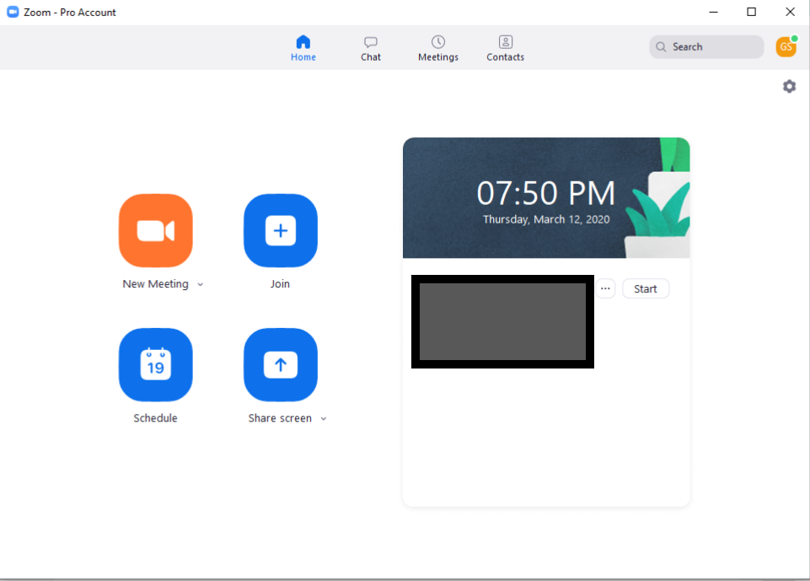

Start a Meeting:
Click New Meeting. Join with computer audio.
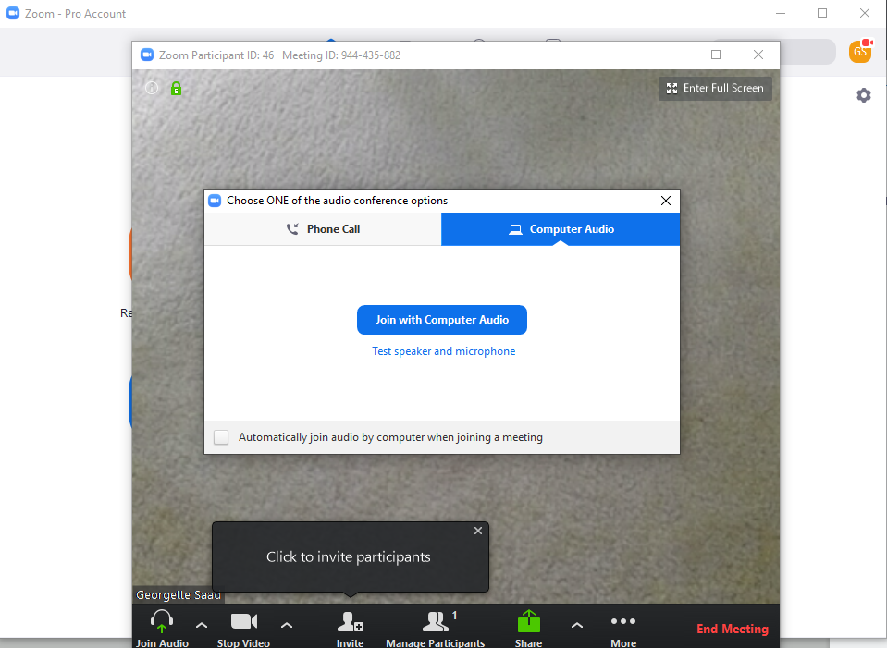

Invite a participant:
If you haven’t scheduled the meeting, open a meeting, click Invite, copy the invitation and email it to the participant.

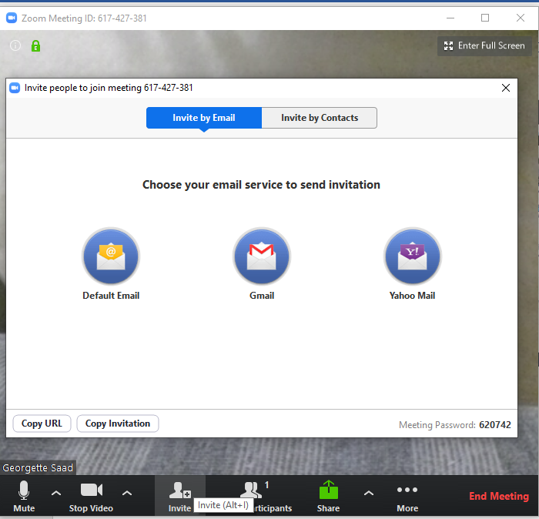

Schedule a meeting:
To schedule, click Schedule and you will see the image below. Complete all fields and choose the calendar where the meeting should be linked. An email will come up, address it to the person with whom you will meet, and send the invitation. It will show up on your calendar as well as your Zoom home. Be sure to rename the meeting as well as click that both videos come on and choose Outlook under calendar.

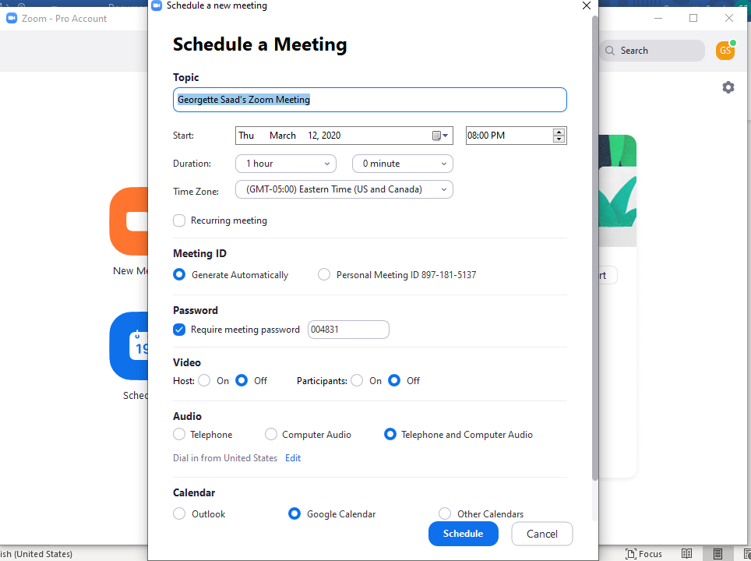

Share screen:
In order to share what is on your screen, select Share Screen on the bottom of the meeting once it is started. Select the window you would like to share. Click the small box on the bottom left stating “Share computer audio” if you are planning on sharing a video clip or music.

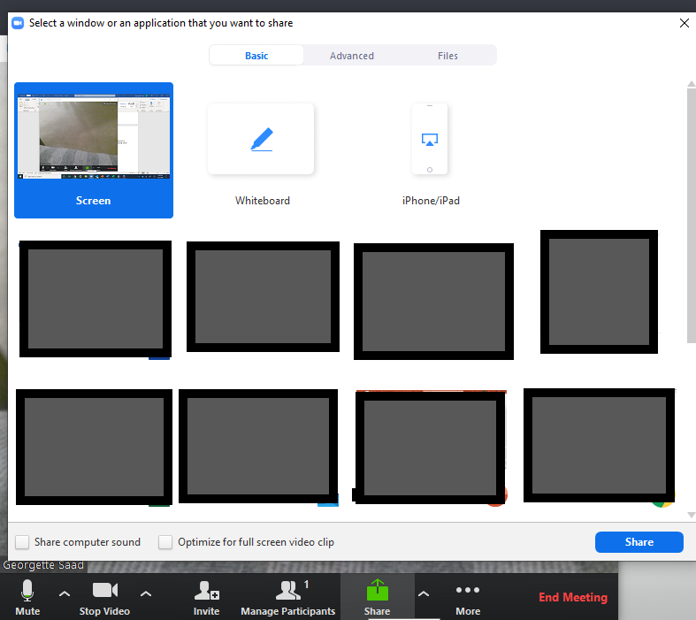

To stop share, click stop share:
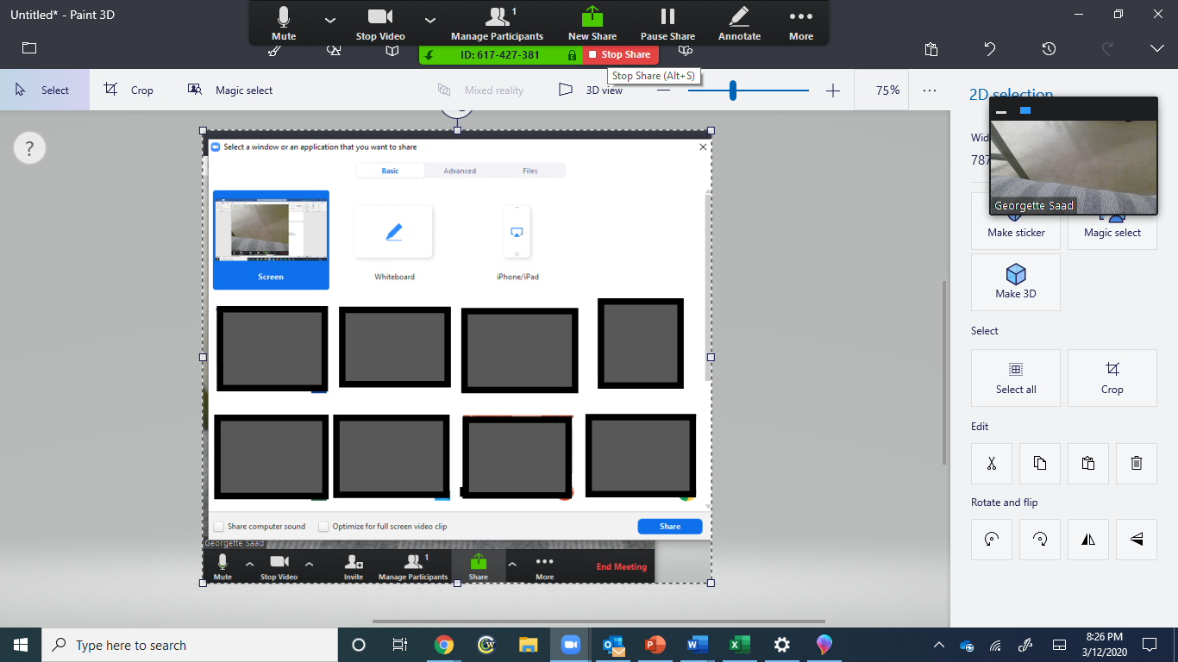

General controls:
Use the microphone and camera buttons to activate or deactivate each control.
