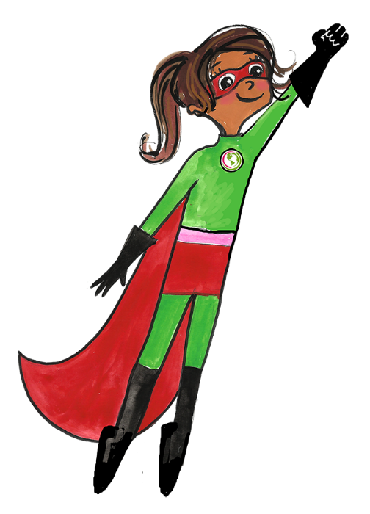

**When germs are spreading around,**

**there’s a few things we can do to TAKE THEM DOWN!!**

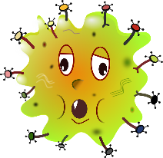

1. **Wash, wash**

**WASH YOUR HANDS**

**(for at least 20 secs)**





**3. Avoid touching**

**your FACE**

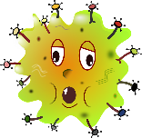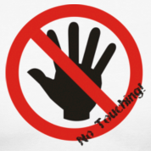

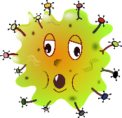





**2. Sneeze / cough**

**Into a tissue**

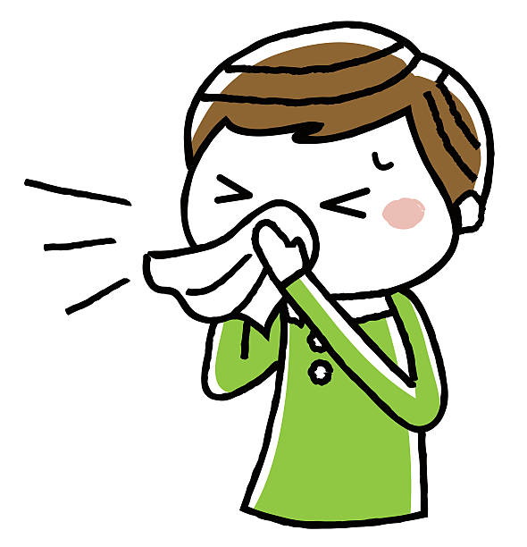

**There’s a new virus in town: Coronavirus.**

**But, there are steps you and your family can take to stay safe and healthy.**

**If you or a family member has a fever or is experiencing fever,**

**runny nose, coughing, shortness of breath, headaches or sore throat…**

**CALL YOUR DOCTOR!**