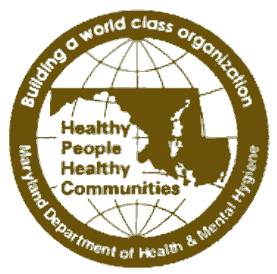
STATE OF MARYLAND

DHMH

Maryland Department of Health and Mental Hygiene

201 W. Preston Street • Baltimore, Maryland 21201
Martin O’Malley, Governor – Anthony G. Brown, Lt. Governor – Joshua M. Sharfstein, M.D., Secretary

Family Health Administration
Russell W. Moy, M.D., M.P.H., Director

CCSC HOM # 11-10

MEMORANDUM

Date: February 14, 2011

To: Health Officers
CRF and Colorectal Cancer Coordinators

Through: Barbara Andrews, Program Manager

Diane Dwyer, M.D., Medical Director

From: Ahmed Elmi, MPH, CHES, Community Health Educator
CRF Programs Unit

Re: March 2011 Colorectal Cancer Awareness Month Toolkit

March 2011 is the 12th annual Colorectal Cancer Awareness Month, and it provides us another opportunity to scale up our colorectal cancer outreach and education to providers, general public, minority groups, and medically underserved populations. To assist you with your outreach and education activities, I am sending you the 13 attached colorectal cancer awareness month information files. As noted in the last attachment, Friday March 4, 2010, is Dress in Blue Day! for colon cancer awareness.

ATTACHMENTS WITH THIS CORRESPONDENCE:

Document | Document Name
1. Colorectal Cancer Fact Sheet | ccsc11-10--att1_colorectal_cancer_factsheet2.doc
- Local Public Health Program’s Proclamation Template | ccsc11-10--att2_local_proclamation2.doc
- News Release Templates (2) | ccsc11-10--att3_news_release_templates2.doc
- Tips for Writing and Placing an Article on Local Newspapers | ccsc11-10--att4_tips_for_writing_newspaper_article2.doc
- Colorectal Cancer Public Service Announcements of 10, 15, 20, and 30 seconds | ccsc11-10--att5_public_service_announcements2.doc
- Template letter to radio and TV station managers | ccsc11-10--att6_letter_to_radio_and_tv_managers2.doc
- Talking Points | ccsc11-10—att7_talking_points2.doc
- Poster (11”x8.5”legal size) – doctor recommendation for colorectal cancer screening | ccsc11-10—att8_poster_doctor_recommendation2.doc
- Poster (11”x8.5”legal size) – Ask your doctor if you should have colorectal cancer screening | ccsc11-10—att9_poster_ ask_your_doctor2.doc
- Poster (11”x8.5”legal size) - Colorectal cancer screening saves lives | ccsc11-10--att10_poster_ screening_saves_lives2.doc
- Poster (11”x8.5”legal size) - Who should be screened for colorectal cancer? | ccsc11-10--att11_poster_ who_should_be_screened2.doc
- Resource  - The Colon Cancer Puzzle: A video on the colorectal cancer screening. You can order a copy at no cost or view it online at http://ecog.dfci.harvard.edu/general/videoinfo_col.html  - How to Increase Colorectal Cancer Screening in Practice: A Primary Care Clinician’s Evidence-Based Toolbox and Guide http://www.cancer.org/acs/groups/content/documents/document/acspc-024588.pdf  - The Impact of Cancer Coalitions on the Dissemination of Colorectal Cancer Materials to Community Organizations in Rural Appalachia http://www.ncbi.nlm.nih.gov/pmc/articles/PMC1563978/pdf/PCD32A55.pdf | ccsc11-10--att12_resource2.doc
- Second Annual National Dress In Blue Day for Colorectal Cancer Screening Awareness (flier) | ccsc11-10--att13_Dress_in_blue_day.pdf

More information will be coming soon regarding the Governor’s Colorectal Cancer Awareness Month proclamation. We have ordered one copy for each program.

If you have any questions about any of the above referenced materials, please feel free to contact me at 410-767-0786 or by e-mail at aelmi@dhmh.state.md.us.

Attachments (e-mailed to Health Officers and Program Coordinators)

cc: Russell Moy, M.D., M.P.H.
Donna Gugel, M.H.S.
Kelly Sage, M.S.

