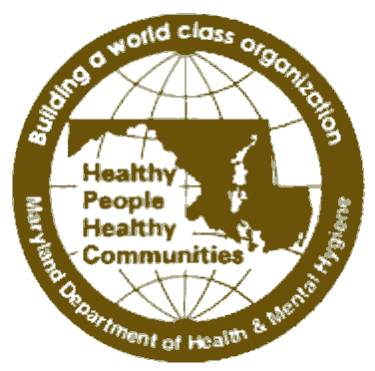
STATE OF MARYLAND

DHMH

Maryland Department of Health and Mental Hygiene

201 W. Preston Street • Baltimore, Maryland 21201
Martin O’Malley, Governor – Anthony G. Brown, Lt. Governor – John M. Colmers, Secretary

Family Health Administration
Russell W. Moy, M.D., M.P.H., Director – Joan H. Salim, Deputy Director

CCSC HOM #09-18

MEMORANDUM

Date: March 26, 2009

To: Health Officers
CRFP-CPEST Cancer Coordinators
SAHC CRF Coordinators

From: Carmela Groves, RN, MS, Chief
Surveillance and Evaluation Unit, Center for Cancer Surveillance and Control

Re: Updated Web Links: Health Officer Memos and Education Database (EDB) Web-based Training
_____________________________________________________________________________
Our cancer web site has undergone some recent changes. Please take note of the following:

Health Officer Memos: The Health Officer memos can now be found at the SAME web address as before: http://www.fha.state.md.us/cancer/homemos/
However, we have removed the need for a User Name and the Password because these memos do not contain any confidential data. Just go to the http address to get to the site; there is no link to it from the CCSC Home Page. You will be able directly to access the memoranda.

Education Database (EDB): This memo updates HO Memo #09-16. The link to the web-based training has been changed to the following:
http://www.fha.state.md.us/pdf/cancer/Web_EDB_Training_Presentation_06-19-07.ppt

Should you have any questions, please let me know (cgroves@dhmh.state.md.us or 410.767.2616).
cc: Carlessia Hussein, DrPH
Russell Moy, MD, MPH
Joan Salim
Donna Gugel, MHS
Diane Dwyer, MD

