Maryland Department of Health and Mental Hygiene

Colorectal Cancer Fact Sheet

Most colorectal cancer can be prevented or cured
Screening (or testing) for colorectal cancer (that is, cancer of the colon or rectum) can save lives. When colorectal cancer is found at an early stage, it can be cured. Some polyps can turn into colorectal cancer. Polyps can be taken out before they grow into cancer.

People who should be screened for colorectal cancer include:
- Anyone 50 years old and older; and
- Anyone under 50 years old who:
- has had any of the following: colorectal cancer in the past, an “adenomatous polyp,” inflammatory bowel disease (ulcerative colitis or Crohn’s colitis), or cancer of the ovary or uterus;
- has a mother, father, brother, sister, or child who had colorectal cancer or an adenomatous polyp before age 60 years; or
- has a family history of genetic forms of colorectal cancer or polyps.

Screening for colorectal cancer
These are the main ways to be screened (tested) if you have an average risk of colorectal cancer:
- Colonoscopy;
- Fecal occult blood test along with a sigmoidoscopy;
- Fecal occult blood test; or
- Sigmoidoscopy.

Colonoscopy and sigmoidoscopy are special tests where a doctor uses a long, flexible tube with a light to look inside the large intestines (colon). Colonoscopy looks at the whole colon. Sigmoidoscopy looks at the last third of the colon.

Fecal occult blood test (FOBT) checks for blood in the stool or feces--even when you cannot see the blood. Blood can be in the stool because of cancer, but also because of other problems. Sometimes the test does not show blood even when a person has a cancer. That is why an FOBT is best done along with a sigmoidoscopy. The stool samples are taken at home. The test kit is then mailed in for results. Medicines and foods may affect test results of some types of tests.

Colorectal cancer in Maryland
There were 2,269 new cases and 986 deaths in Maryland in 2009 due to colorectal cancer. Colorectal cancer deaths accounted for about 9.5% of all cancer deaths in Maryland in 2009. (Source: Maryland Cancer Registry and Maryland Vital Statistics).

People with colorectal cancer usually do not have symptoms, but sometimes they have:
- blood in the stool;
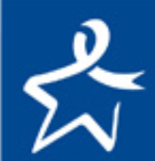
- a mass or lump in the abdomen;
- cramps or pain in the abdomen;
- change in the size of the stool (for example, the stool is thinner) or constipation.

Call your doctor to find out more about being screened.
Call your doctor if you have symptoms of colorectal cancer.

Web sites of interest:
Centers for Disease Control and Prevention (CDC): http://www.cdc.gov/cancer/screenforlife
National Cancer Institute: http://www.cancer.gov
American College of Gastroenterology: http://www.acg.gi.org
American Cancer Society: http://www.cancer.org
National Colorectal Cancer Roundtable: http://www.nccrt.org
Maryland Department of Health and Mental Hygiene. Center for Cancer Prevention and Control
Cigarette Restitution Fund -- March 2013
DEFINITIONS FOR COMMON CONDITIONS FOUND DURING A ROUTINE COLONOSCOPY PROCEDURE

Condition | Definition | Other Information
Polyp | A polyp is a small growth. Polyps can grow in the colon and rectum (also known as the large intestines or “gut”). Under the microscope, a doctor can tell the type of polyp. | 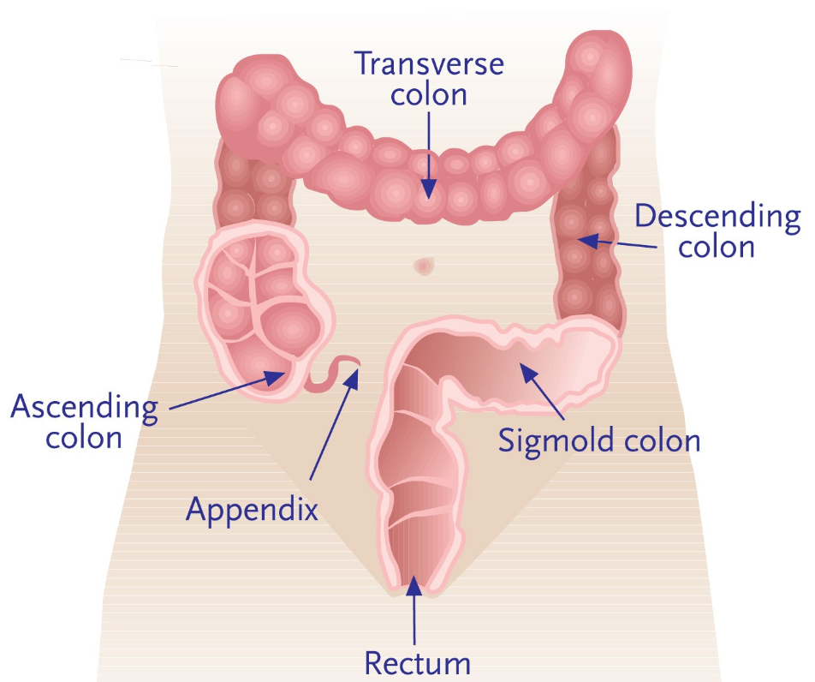  The colon (large intestine), and rectum
Adenomatous polyp | An adenomatous polyp or “adenoma” is a type of polyp found in the colon or rectum. Adenomatous polyps are non-cancerous but can turn into cancer in the future. They are removed during colonoscopy in order to prevent colorectal cancer. About 20% of older adults have adenomas.
Serrated polyp | Sessile serrated polyps and other similar polyps (sessile serrated adenomas, serrated adenomas, and traditional serrated adenomas or polyps) are benign (non-cancerous) polyps found in the colon or rectum. They are removed during colonoscopy in order to prevent colorectal cancer.
Hyperplastic polyp | A hyperplastic polyp is a type of polyp. Hyperplastic polyps do not usually turn into colorectal cancer. They are common in the colon or rectum of older adults. They are usually removed during colonoscopy.
Inflammatory bowel disease | Inflammatory bowel disease (IBD) is inflammation (redness and/or swelling, ulcers) of the lining of the small or large intestines or both. Ulcerative colitis and Crohn’s disease are the two types of inflammatory bowel disease. IBD can cause pain, diarrhea, bleeding, weight loss, and other symptoms. | 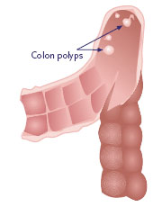  Polyps in the colon  Used with permission  ColonCheck CancerCare Manitoba
Ulcerative colitis | Ulcerative colitis is a type of inflammatory bowel disease. It is inflammation (redness and/or swelling, ulcers) in the colon or rectum. Ulcerative colitis can increase the chance of getting colorectal cancer.
Crohn’s colitis | Crohn’s disease is a type of inflammatory bowel disease. It is inflammation (redness and/or swelling, ulcers) of any part of the digestive track—from mouth to anus—but usually is in the last part of the small intestines. Crohn’s colitis is Crohn’s disease in the colon. It can increase the chance of getting colorectal cancer.
Diverticula | Diverticula are tiny pouches or sacs of intestines that bulge out from the side of the colon. When a pouch becomes infected, it is called “diverticulitis” and can cause severe pain, bleeding, fever, etc. Diverticula are very common in older adults and do not lead to cancer.
Hemorrhoids | Hemorrhoids are swollen blood vessels in and around the anus. Hemorrhoids can cause pain and can bleed but are not associated with colon cancer.
For more information, please contact your physician. You may also contact the National Institute of Diabetes, Digestive, and Kidney Diseases of the National Institute of Health at 301.496.3583 or visit http://www2.niddk.nih.gov

