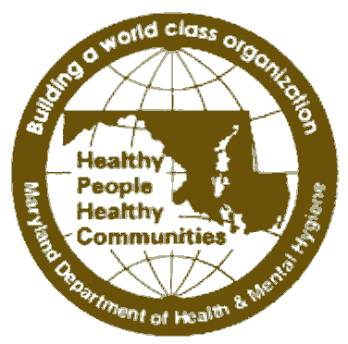
STATE OF MARYLAND

DHMH

Maryland Department of Health and Mental Hygiene
Martin O’Malley, Governor – Anthony G. Brown, Lt. Governor – Joshua M. Sharfstein, M.D., Secretary

Prevention and Health Promotion Administration
Michelle Spencer, MS, Director
Donna Gugel, MHS, Deputy Director

Ilise D. Marrazzo, RN, BSN, MPH, Acting Director, Maternal and Child Health Bureau
Deborah B. McGruder, MPH, PMP, Director, Infectious Disease Bureau
Clifford S. Mitchell, MS, MD, MPH, Director, Environmental Health Bureau
Donald Shell, MD, MA, Director, Cancer and Chronic Disease Bureau

CCPC HOM # 13-07
MEMORANDUM

Date: February 8, 2013

To: Health Officers
CRFP and Colorectal Cancer Contacts
CRF Program Directors

From: Barbara Andrews, Program Manager, CRFP Unit
Center for Cancer Prevention and Control

Re: Federal Poverty Guidelines, 2013 by Annual Household Income and Family Size

Attached is a table of the Federal HHS Poverty Guidelines (FPG) for 2013 as determined by size of a family. Provided in the table are the FPG (i.e., 100%) and the amounts at 115%, 150%, 200%, and 250% ABOVE the FPG.

The Federal HHS Poverty Guidelines are online at http://aspe.hhs.gov/poverty/13poverty.cfm
and also published in the Federal Register, Vol. 78, No. 16, January 24, 2013 pp. 5182-5183.

Please don’t hesitate to contact us if you have any questions regarding this matter.
Attachment (E-mailed to Health Officers and CRF Coordinators)

cc: Michelle Spencer/Donna Gugel/Donald Shell, M.D
Courtney Lewis/Sarah Hokenmaier
Diane Dwyer, M.D.
File

201 W. Preston Street, Baltimore, Maryland 21 201 500 N. Calvert Street, 5th Fl, Baltimore, Maryland 21202
410-767-6742 Fax 410-333-5995 410-767-5227 • Fax 410-333-6333 • TDD for Disabled 410-333-4800
Toll Free 1-877-4MD-DHMH TTY for Disabled Toll Free 1-800-358-9001 • TTY for Disabled
Maryland Relay Service 1-800-735-2258 Maryland Relay Service 1-800-735-2258
Web Site: http://fha.dhmh.maryland.gov/

Attachment

FEDERAL HHS POVERTY GUIDELINES, 2013
and Percentages ABOVE the FPG
that Cigarette Restitution Fund (CRF) Programs May Be Using for Eligibility

Annual Household Income by Persons in Family

Persons in Family | Federal Poverty Guideline 2013 | Percent ABOVE Federal Poverty Guideline that may be used for eligibility to CRF Programs
Persons in Family | 100% | 115% | 150% | 200% | 250%
1 | $11,490 | $13,213.50 | $17,235 | $22,980 | $28,725
2 | $15,510 | $17,836.50 | $23,265 | $31,020 | $38,775
3 | $19,530 | $22,459.50 | $29,295 | $39,060 | $48,825
4 | $23,550 | $27,082.50 | $35,325 | $47,100 | $58,875
5 | $27,570 | $31,705.50 | $41,355 | $55,140 | $68,925
6 | $31,590 | $36,328.50 | $47,385 | $63,180 | $78,975
7 | $35,610 | $40,951.50 | $53,415 | $71,220 | $89,025
8 | $39,630 | $45,574.50 | $59,445 | $79,260 | $99,075
Each Additional Person | $4,020 | $4,623 | $6,030 | $8,040 | $10,050

Federal Poverty Guidelines:

Federal Register, Vol. 87, No.16, January 24, 2013 pp. 5182-5183. http://aspe.hhs.gov/poverty/13poverty.cfm

These guidelines apply to the 48 contiguous states and the District of Columbia.

