
STATE OF MARYLAND

DHMH

Maryland Department of Health and Mental Hygiene

201 W. Preston Street • Baltimore, Maryland 21201
Martin O’Malley, Governor – Anthony G. Brown, Lt. Governor -- Joshua M. Sharfstein, M.D., Secretary

Family Health Administration
Donna Gugel, Acting Director

CCSC HO Memo #12-07
MEMORANDUM

To: Health Officers
CRF/CPEST Program Directors, Coordinators, and Staff
SAHC Program Directors, Coordinators, and Staff
CDB Users

From: Carmela Groves, R.N., M.S.
Program Manager, Surveillance and Evaluation Unit, CCSC

Date: March 5, 2012

Re: Testing Connections to the Intranet Client Database (CDB) – CDB Guidance #61

As we prepare to move the Client Database (CDB) to the Intranet, I want to assure that local programs have access to the database. Please verify your ability to connect to the system; disregard if you are a non-health department entity.

Contained in this memo on pages 2 and 3, are instructions for connecting. I would like each person who is a user of the CDB to follow these instructions to see if you can connect to the CDB. I am asking one person to be the contact person to notify me of the status for your local program to represent all users’ ability to connect.

Please notify me by Monday, March 12, 2012, at cgroves@dhmh.state.md.us.

Please DO NOT LOGIN/use this Intranet version of the database until you are further notified as this version of the application is not yet fully functional. If you have any questions regarding this memo, please contact me at 410-767-2616 or cgroves@dhmh.state.md.us. Thank you for assistance!

cc: Donna Gugel, M.H.S.
Kelly Sage, M.S.
Courtney Lewis, M.P.H.
Sarah Conolly Hokenmaier, M.P.A.
Diane Dwyer, M.D.
Instructions for Testing Connection to FHA Server

Introduction: Please follow Instruction 1 below; if not successful, please follow Instruction 2.

Instruction 1:
Open a browser (Internet Explorer, Netscape)
Type https://cpestweb into the address field of your browser; you should see the page below
Click Continue to this website (not recommended)
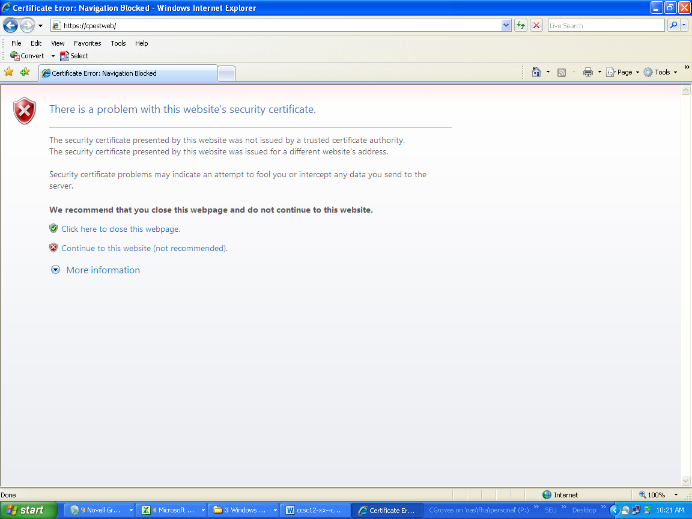

You should then see this page:

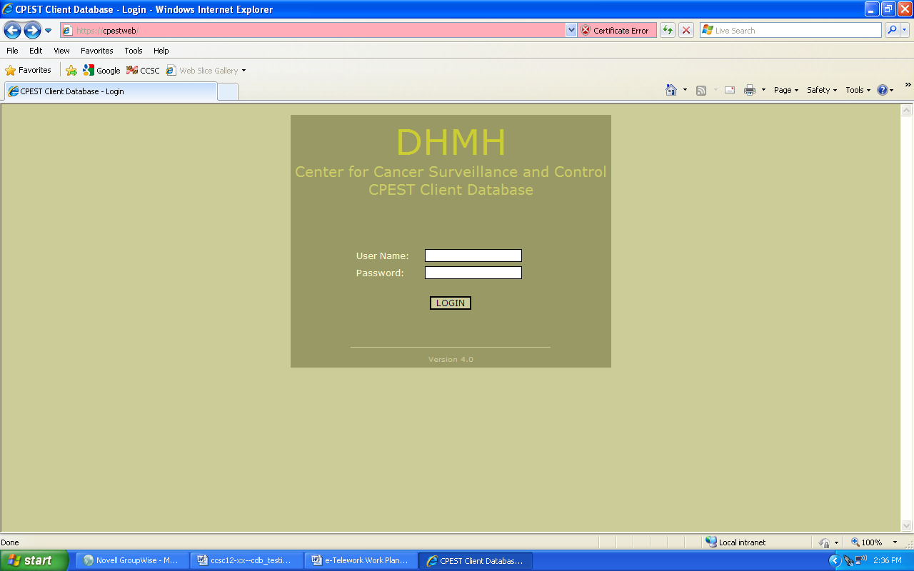

If you do not see this screen, please try the Instruction 2 (you will need the assistance of your IT staff).
DO NOT LOGIN!!

Instruction 2:

Contact your IT staff to help with the following:
“Ping” to the following IP address: 10.150.98.63

You should see the following:
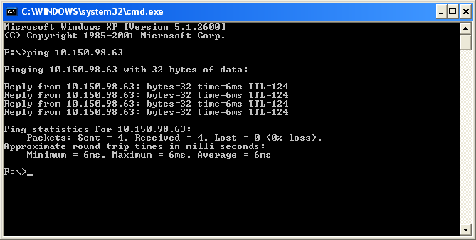

If you do not see this screen, please call Carmela Groves at 410-767-2616 or e-mail Carmela at cgroves@dhmh.state.md.us so that we can try to determine the problem.

Thanks for Testing!

