TB Update
By: Maryland Department of Health’s Center for Tuberculosis Control and Prevention

Recently, the Centers for Disease Control and Prevention (CDC) released a Morbidity and Mortality Weekly Report (MMWR) with updated guidance for the screening and testing of healthcare personnel (HCP) for tuberculosis (TB) infection. The updated recommendations come after a systematic review found that a very small proportion of HCP have positive TB test results at baseline and upon serial testing.

In summary, the update recommends: 1) adding an individual TB risk assessment to baseline/pre-employment TB testing and symptom screening, 2) not conducting yearly/routine serial testing in the absence of exposure or ongoing transmission, 3) treatment for HCP diagnosed with latent tuberculosis infection (LTBI) unless medically contraindicated (with emphasis on shorter course treatment regimens), 4) continuing annual symptom screening for persons with untreated LTBI, and 5) continuing to provide annual TB education and exposure risk to all HCP. It is important to keep in mind that outside of the changes, all other aspects of the MMWR’s “Guidelines for Preventing the Transmission of Mycobacterium tuberculosis in Health-Care Settings, 2005” remain unchanged, including recommendations for annual facility risk assessments to help guide infection control policies and procedures.

The symptom evaluation and individual risk assessment evaluation help guide decisions when interpreting test results. A LOW RISK, asymptomatic HCP with a positive test should receive a second test. The HCP should be considered infected with M. tuberculosis ONLY if both the first and second tests are positive as recommended in the 2017 TB diagnostic guidelines of the American Thoracic Society, Infectious Diseases Society of America, and CDC.

Feel free to reach out to the Maryland Department of Health’s Center for Tuberculosis Control and Prevention with questions or concerns regarding the updates at 410-767-6698.
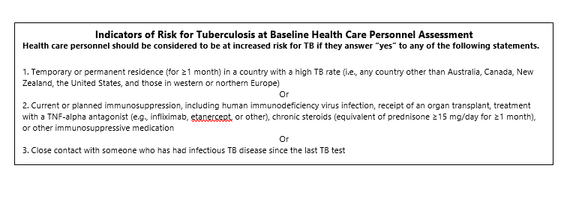
Reference:
Jensen PA, Lambert LA, Iademarco MF, Ridzon R. Guidelines for Preventing the Transmission of Mycobacterium Tuberculosis in Health-care Settings, 2005. MMWR Recomm Rep 2005;54(No. RR-17). https://www.cdc.gov/mmwr/preview/mmwrhtml/rr5417a1.htm.

Sosa LE, Njie GJ, Lobato MN, et al. Tuberculosis Screening, Testing, and Treatment of U.S. Health Care Personnel: Recommendations from the National Tuberculosis Controllers Association and CDC, 2019. MMWR Morb Mortal Wkly Rep 2019;68:439–443. DOI: http://dx.doi.org/10.15585/mmwr.mm6819

