Welcome to Maryland’s Special (Regulated) Medical Waste Program - Infectious Medical Waste.

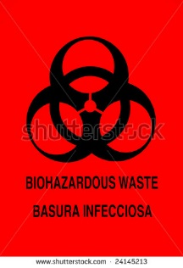

What is Special Medical Waste?
Special medical waste is sometimes known as hazardous medical waste or infectious medical waste (waste which has been or is likely to have been contaminated by an organism capable of causing disease in healthy humans).
In Maryland, the Department of Health and Mental Hygiene (DHMH) is responsible for the definition of special (regulated) medical waste and the criteria by which treatment methods are evaluated (as to whether the treatment creates a regulated or non-regulated waste product).
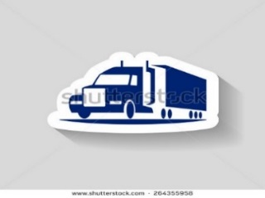

The Department of the Environment (MDE) is responsible for permitting and regulation of all aspects of special (regulated) medical waste transportation and also requires medical waste handlers to notify MDE of medical waste activity.
NOTE: (Generators are only required to file a notification if they generate 50 pounds or more special medical waste in a calendar month or have more than 50 pounds of special medical waste on site at any time).

Regulations
Both the DHMH and the MDE, are responsible for the regulation of special medical waste:
- DHMH is responsible for defining special medical waste and evaluating whether specific treatment methods are or are not acceptable means of treating special medical waste.
- MDE has regulations that govern all aspects of the transport and disposal of special medical waste.

DHMH Regulations
10.06.06.01: Scope and Purpose
10.06.06.02: Definitions (including definitions of special medical waste and treatment technologies)
10.06.06.03: Handling of Special Medical Waste (references to federal and MDE requirements)
10.06.06.04: Treatment of Special Medical Waste, Excluding Sharps, Before Disposal
10.06.06.05: Treatment of Sharps before Disposal
10.06.06.06: Alternative Treatment Systems (including criteria for treatment)
10.06.06.07: Disposal of Special Medical Waste
10.06.06.08: Enforcement

MDE Regulations
26.13.11.01: Special Medical Wastes
26.13.12.01: Standards Applicable to Generators of Special Medical Waste
26.13.13: Standards Applicable to Transporters of Special Medical Waste

MDE Resources for Special (Regulated) Medical Wastes

Medical Waste transportation:
- Guidelines for Transportation of Special Medical Wastes
- Application for Certification as a Special Medical Waste Hauler*
- Application for Special Medical Waste Vehicle Certification*
- Application for Special Medical Waste Haulers Certification Bond*
- Notification of Special Medical Waste Activity
*This form is available upon request from the Hazardous Waste Program. To request a complete application package or individual application forms, please contact Rose Peay at 410-537-3344.

