Maryland Office of Minority Health and Health Disparities

Health Equity Internship Program Application
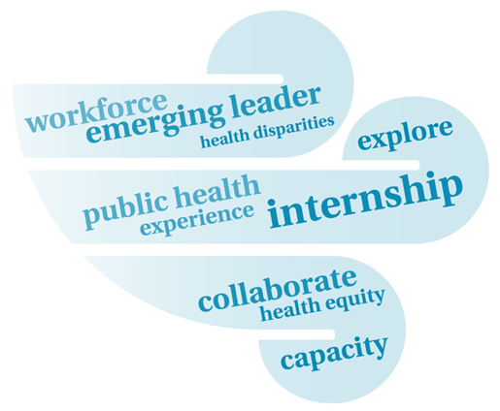
Introduction

The Office of Minority Health and Health Disparities (MHHD) within the Maryland Department of Health and Mental Hygiene welcomes interns, volunteers, fellows, those seeking job shadowing experience, and other interested parties to participate in MHHD’s Health Equity Internship Program.

MHHD internship opportunities support the goal of MHHD’s Workforce Development and Training Initiative, to build the capacity of the public health workforce to effectively advance health equity. MHHD is committed to providing interns with a meaningful learning experience within our Office, as well as with our partners. Interns will have the opportunity to apply the practice of public health in a professional state government setting and to better understand how health equity is being addressed in the state.

Internship projects will be mutually decided upon with the intern, MHHD Health Equity Team, and other involved parties. Projects are intended to challenge the intern while providing the opportunity to strengthen technical skills and gain valuable hands-on experience. At the conclusion of the internship period, the intern will provide a professional presentation to the MHHD Health Equity Team and other partners, on the results of their project.

In addition to working with the MHHD Health Equity Team, interns will be provided the opportunity to collaborate with a variety of public health and other professionals that are engaged in health equity initiatives. Interns will be provided the opportunity to form connections with a diverse group of professionals while building their professional network.

Application Process

Prospective interns will be asked to complete the following application, including a statement of intent that summarizes the internship request, and provide a resume. If a university affiliated internship (for course credit), official placement guidance, as provided by the academic institution, should be submitted. Prospective interns will be contacted for an interview with the MHHD Health Equity Team and asked to discuss his/her background, areas of interest, and other related information to the placement. Understanding that this is a competitive process and placement space is limited, MHHD will work with prospective interns to provide suggestions and guidance on alternate placement locations.

Submitting an Application

Completed applications and accompanying attachments should be e-mailed to DHMH.HealthDisparities@Maryland.gov at least 2 months prior to internship start date.

Health Equity Internship Application

Personal Information
Name:
Phone: |  | E-mail Address:
Mailing Address: |  | City:
State: |  | ZIP Code:
Do you have regular access to a car or other form of reliable transportation? Please specify.
If out of state applicant, will you have housing during your internship period?
Age
Gender |  | ☐ Male ☐ Female
Are you Hispanic or Latino? (Yes or No) |  | ☐ Yes ☐ No
If yes, please specify Hispanic/Latino origin, for example, Argentinean, Colombian, Dominican, Nicaraguan, Salvadoran, Mexican, Chicano, Puerto Rican, Cuban, Spaniard, and so on.
Please specify your race (choose all that apply) |  | ☐ American Indian or Alaska Native  ☐ Asian  ☐ Black or African American  ☐ Native Hawaiian or other Pacific Islander  ☐ White  ☐ Some other race
If some other race, please specify
What is your ancestry or ethnic origin? (For example: Italian, Jamaican, Cambodian, Cape Verdean, Norwegian, Dominican, French, Canadian, Haitian, Korean, Lebanese, Polish, Nigerian, Mexican, Taiwanese, Ukrainian, and so on.)

Application Category
☐ Independent (Internship hours will NOT count towards course credit)
☐ University affiliated (Internship hours will count toward course credit)
If University affiliated:

University Name: |  | University Department:
University Supervisor / Advisor Name: |  | E-mail Address:
Phone: |  | Total time requirement (hours):
* If University-affiliated (internship hours will count toward course credit), include university approved / published internship placement site requirements and agreement forms with your application.

Academic Information
College / University Name: |  | City, State:
Dates Attended: |  | Graduation Date:
Major:
GPA:

Degree Level (check one): ☐ Bachelors ☐ Master ☐ Doctoral ☐ Other
Anticipated Internship Start Date: Anticipated Internship End Date:

Informational Questions
- Statement of intent. Please describe your interest in and goals of an internship placement within the Maryland Office of Minority Health and Health Disparities.

- What days, times, and number of hours per week are you available to work on-site?

- If you speak and/or write in any languages other than English, please indicate.

For each language indicated, please specify what level: beginner, comprehender, fluent, native speaker, certified translator, other

- Please indicate your level of experience (Proficient, Limited Experience, or No experience) for each of the following software applications.

SAS
SPSS
MS Access
MS Excel
MS PowerPoint
MS Word
GIS Software
Other

- Please indicate any other computer or relevant skills.

- Please select all of the areas of interest that you would be willing to accept internship placement and project assignments in. More information on MHHD focus areas can be found at the MHHD Website.

☐ Grants management
☐ Technical assistance
☐ Community-based organizations
☐ Racial / ethnic data
☐ Health equity trainings
☐ Cultural, linguistic, and health literacy competency
☐ Health policy
☐ Workforce development and training
☐ Other

- How did you hear about the MHHD Office and Health Equity Internship Program?

Application Checklist Review

☐ Completed and Signed Application Form
☐ Resume/Curriculum Vitae
☐ College/University Internship Placement Guidelines (if applicable)

I attest that the information in this application is true and accurate to the best of my knowledge.

Applicant Signature: Date:

