ATTACHMENT D – Work Plan Gantt Chart Template

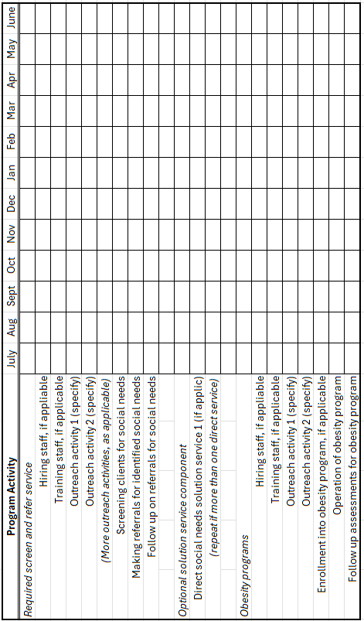

Applicants may download fillable forms from the MHHD website at MHHD Grant Documents Use the Excel spreadsheet version on our website for submissions

