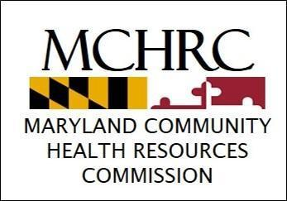
STATE OF MARYLAND
Community Health Resources Commission
45 Calvert Street, Room 336 • Annapolis, Maryland 21401

Larry Hogan, Governor – Boyd Rutherford, Lt. Governor
Edward J. Kasemeyer, Chair – Mark Luckner, Executive Director

Maryland Community Health Resources Commission
Grant Modification Request Form

Date of Grant Modification Request: | Contact Information of the Grant:
Grant # & Project Title: | Grant Modification Request #:  (To be filled out by CHRC Staff)
Original Dates of this Grant: | Revised Dates of the Grant:  (Grantee will fill this out where applicable)
Total Award: | Amount Paid (Awarded) to Date
Project Description:

Date of Last M&D Report Submitted to Commission:

Purpose of this Grant Modification Request: Explain circumstances influencing this request. When required, include a detailed narrative explanation of all budget changes that indicates which line items are affected. Fringe cannot exceed 25% of personnel costs; if fringe exceeds 25% of personnel costs explanation/justification must be provided.
activities to increase awareness of and participation in Howard County LHIC and partner initiatives to advance the priories of the Coalition.
CHRC Staff Recommendation:
(To be filled out by CHRC Staff)

