HIC: Click or tap here to enter text.
Person(s) completing the form: Click or tap here to enter text.
Date completed: Click or tap here to enter text.

Community Engagement Status
We are asking LHIC leaders to complete this form. You can use the information as part of your Local Health Improvement Plan. We will use the information to create training materials and resources for LHIC members.
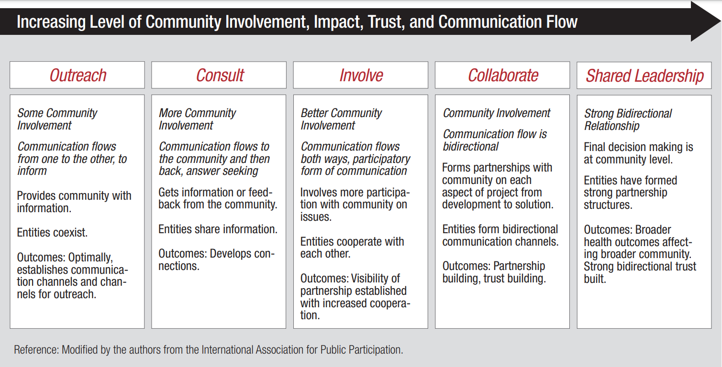
Write “2020” in the column box where your LHIC is now and “2021” where you want to be by Sept. 2021.

Corresponding CHRC Deliverables:
Outreach | Consult | Involve | Collaborate | Shared Leadership
- Charter, by-laws, membership (#1)  - Schedule (#1)  - How to participate (#1)  - Reach new partners (#2)  - Roster (#2)  - Website (#3)  - Public announcements, meetings (#3) | - Presentation on diabetes strategy (#6)  - Channels and methods for feedback (#2 and #3) | - | - | -

Community Engagement Working Definitions
These working definitions can help you develop a shared understanding of community engagement work for discussion and planning. Each LHIC may be at a different stage in a community engagement process as modeled by the chart above. All LHICs can benefit from having an explicit community engagement strategy. These are not the only definitions for these terms, and the examples provided under each are not exhaustive.
Community
What is a community?
Groups of people affiliated by geo-political boundaries, interests, culture or other common factors.¹
What is a community member?
A community member is anyone living or working in a county or area covered by the department’s and LHICs’ activities for the Maryland Diabetes Action Plan.

Examples of community members impacted/served by LHICs:
- Employers (examples: small/medium/large for-profit businesses, self-employed persons, nonprofits)
- Residents (examples: children, adolescents, adults in the workforce, retired older adults)
- Employees (examples: people who work in manufacturing plants, grocery stores, fitness studios, restaurants, hotels, retail stores)
What is community engagement?
Process of working collaboratively with and through individuals and groups of people to address diabetes and the well-being of those groups.²
The CDC’s Community Engagement Continuum illustrates how relationships with community members or partner organization can be developed over time to include more community involvement, trust, impact and communication.²
Examples of LHIC community engagement efforts at each phase of the continuum:
- Outreach: Posting LHIC information on a website, open invitations to attend meetings
- Consult: Invite community members to participate in focus groups or surveys
- Involve: Bring community organizations with similar goals together to form regularly meeting workgroups
- Collaborate: Community members or partner organizations participate in all aspects of the LHIC process (data collection, LHIP creation, workgroup development, initiative implementation, and evaluation efforts)
- Shared Leadership: LHIC community members make final decisions

Stakeholder
What is a stakeholder?
Stakeholders are people or organizations invested in taking action on diabetes, interested in how the actions affect diabetes in their communities, or with a stake in what will be done to reduce diabetes and implement the Maryland Diabetes Action Plan.³ “Stakeholders” is a term that can be used to describe community members, community organizations, and other entities. Ideally, LHICs will try to bring as many stakeholders as possible into their LHIC activities, but if even if a stakeholder isn’t an active LHIC member, you should at least share information and communicate with stakeholders about LHIC activities. You can also solicit their input at key stages, such as community health assessments.
Examples of LHIC stakeholders:
- Any community member or organization
- County Departments (Health Department, Parks and Recreation Department, Transportation Department, Department of Planning, Department of Social Services, etc.)
- State Affiliated Organizations (MDH, CHRC, insurers, MedChi, Maryland Hospital Association, UMD)
What is stakeholder engagement?
Process of working collaboratively with and through stakeholders to reduce diabetes’ effects in Maryland’s communities and implement the Maryland Diabetes Action Plan.^{2,3}

LHIC Member
Defined by each LHIC in their charter or by-laws document.

References
1. Centers for Disease Control and Prevention. Healthy Places Terminology. Healthy Places. Published December 11, 2017. Accessed October 21, 2020. https://www.cdc.gov/healthyplaces/terminology.htm
2. Centers for Disease Control and Prevention, Agency for Toxic Substances and Disease Registry. Principles of Community Engagement. Second Edition. Published online June 2011. https://www.atsdr.cdc.gov/communityengagement/pdf/PCE_Report_508_FINAL.pdf
3. Centers for Disease Control and Prevention. Step 1: Engage Stakeholders. Program Performance and Evaluation Office (PPEO). Published May 11, 2012. Accessed October 21, 2020. https://www.cdc.gov/eval/guide/step1/index.htm

