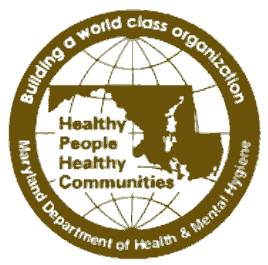
STATE OF MARYLAND

Community Health Resources Commission

45 Calvert Street, Annapolis, MD 21401, Room 336

Martin O’Malley, Governor – Anthony G. Brown, Lt. Governor
John A. Hurson, Chairman – Mark Luckner, Executive Director

February 24, 2012
FOR IMMEDIATE RELEASE Contact: Mark Luckner
Executive Director, CHRC
(410) 260-7046 office/(410) 299-2170 cell

COMMUNITY HEALTH RESOURCES COMMISSION SUBMITS REPORT TO GOVERNOR AND GENERAL ASSEMBLY OUTLINING OPTIONS TO ASSIST SAFETY NET PROVIDERS AS MARYLAND IMPLEMENTS AFFORDABLE CARE ACT
(Annapolis, MD)—The Maryland Community Health Resources Commission (CHRC) today submitted its report to the Governor and Maryland General Assembly outlining how the state could provide technical assistance and support to safety net providers as Maryland prepares to implement the Affordable Care Act (ACA). The CHRC was directed to develop this business plan by legislation (HB 450/SB 514) approved by the legislature and signed into law last year. An estimated 350,000 Marylanders will gain access to health insurance coverage in 2014, and the CHRC’s business plan offers recommendations how the state could build the capacity of the safety net provider community, Federally Qualified Health Centers (FQHCS), local health departments, free clinics and other organizations, to help meet the expected growing need for health care in the community. A copy of the full CHRC business plan can be viewed online at www.dhmh.maryland.gov/mchrc.
“This business plan provides a blueprint for how Maryland can provide ongoing support of the safety net infrastructure,” commented John A. Hurson, Chairman, Maryland Community Health Resources Commission. “We are looking forward to implementing these actions in the coming weeks and months.”

The mission of the CHRC, a quasi-independent agency operating within the Department of Health & Mental Hygiene (DHMH), is to expand access to affordable, high-quality health care services for low-income and uninsured Marylanders. Over the last six years, the Commission has awarded 93 grants, totaling $22.6 million. The grants have supported programs in all 24 jurisdictions of the state, and the grants have collectively provided access to health care for nearly 100,000 Marylanders.

“Maryland has become a national leader in implementing health care reform because we understand that these measures will reduce costs, increase access, and improve the quality of health care for all Marylanders,” commented Lt. Governor Anthony G. Brown, co-chair, Health Care Reform Coordinating Council (HCRCC). “The CHRC business plan will help us take steps to meet the expected growing need for health care services.”

The HCRCC tapped the Commission to develop the business plan outlining how the state could provide technical assistance and support to safety net providers as they respond to the challenges and opportunities brought by the Affordable Care Act.

“This roadmap provides a number of helpful steps for Maryland to build capacity to deliver health care services,” commented Frances B. Phillips, DHMH Deputy Secretary for Public Health Services. “We look forward to working with the Commission to help implement these strategies.”

In developing its business plan, the CHRC implemented three surveys, of FQHCS, local health departments, and free clinics, and conducted approximately 50 follow-up interviews. Following are the five key recommendations that reflect and summarize the feedback received during this process:
1. Provide technical assistance and support around the “mechanics” of health reform implementation;
2. Address workforce shortage issues;
3. Facilitate access and interpretation of key public health data;
4. Support the state’s efforts around outreach, eligibility, and enrollment into health insurance; and
5. Utilize CHRC grant funding to leverage additional private/non-profit resources to expand access.

####

