Table of Contents
MDMEDI 7
MDMEDI Weekly Reports 7
1. Weekly Claims Data Entry Summary 7
2. Weekly PA Drug Detail by Status Code 7
3. Weekly Prior Authorization Requests 7
4. Negative Determinations Report 8
5. Positive Determinations Report 8
MDMEDI Monthly reports 9
1. Drug Audit Report Refill Too Soon Overrides 9
2. Drug Audit Report Duplicate Claim Overrides 10
3. Drug Audit Report Maintenance Drugs with Less Than 10 Days Supply 10
4. Drug Audit Report DAW 1 10
5. Controlled Substance (NH Recipient) 11
6. Controlled Substance (Pharmacy Providers) 11
7. Controlled Substance (Prescribers) 12
8. Carved Out Drugs Paid Claims Only 12
9. Adjudicated Claims Analysis 13
10. Claims with Payment Amount Greater than $400 13
11. Maryland Medicaid Pharmacies Ranked By Total Payment for Health Choice MCO-AIDS Drugs 14
12. Top Pharmacies Ranked by Amount Paid 15
13. Top Pharmacies Ranked by Number of Prescriptions 15
14. Top Pharmacies Ranked by BWGA Number of Prescriptions 15
15. Top Prescribers of Controlled Substances Ranked by Amount Paid 16
16. Top Prescribers of Controlled Substances Ranked by Number of Prescriptions 16
17. Top Prescribers Ranked by Amount Paid 16
18. Top Prescribers Ranked by Number of Prescriptions 17
19. Top Prescribers Ranked by Average Prescription Cost 17
20. Top Prescribers Ranked by Brand with Generic Available Number of Prescriptions 17
21. Top Prescribed Drugs Ranked by Amount Paid 18
22. Top Prescribed Drugs Ranked by Number of Prescriptions 18
23. Top Prescribed Injectable Ranked by Amount Paid 18
24. Top Prescribed OTC Drugs Ranked by Amount Paid 18
25. Top Therapeutic Classes Ranked by Amount Paid 19
26. Top Therapeutic Classes Ranked by Number of Prescriptions 19
27. Claims Payment Summary 20
28. Top Utilizers Ranked by Amount Paid 20
29. Top Utilizers Ranked by Number of Prescriptions 20
30. Top Utilizers of Controlled Substances Ranked by Amount Paid 21
31. Top Utilizers of Controlled Substances Ranked by Number of Prescriptions 21
32. Age-Sex Utilization Summary 22
33. Monthly Prior Authorization Status 23
34. Top Prescribers Ranked by Ingredient Cost Allowed 24
35. Denied Exceptions Ranked by Number of Edits Posted 24
36. Paper Claims Summary 25
37. Paper Claims Submissions 25
38. Monthly Payment Summary 26
39. Cost Sharing Savings 26
40. Plan Sponsor Cost Summary 27
41. Executive summary 27
42. Denied Claims Analysis 28
43. Monthly Denied claims 29
Prescriber Reports 29
1. Prescriber Activity Reports 29
2. Prescriber sanction Report 30
3. Invalid Prescribers as per Source data (Pass Check digit logic only) 30
FDB Report 30
1. POS NDC MDSPAN UPDT RPRT - MediSpan Price change 30
2. POS NDC UPDT RPRT - FDB Price change report 31
Interface file load/update/Reconciliation Reports 31
1. Eligibility Update report 32
2. Eligibility Update report – Deletes 33
4. Reject Analysis Report 34
5. OOEP/Encounter Claims Extract Reconciliation Report 35
6. OOEP/Encounter Claims Extract Produced Errors 37
7. OOEP/Encounter Claims Error Reconciliation Report 38
8. STATE PRESCRIBER SANCTIONS LOG Report 40
9. STATE PRESCRIBER SANCTIONS LOG Error Report 40
Miscellaneous Reports 40
1. Operational Performance Report 40
2. MONTHLY INJECTABLE FFS TOTAL REPORT 40
3. MONTHLY INJECTABLE ENCOUNTERS TOTAL REPORT 40
4. J-Code Claims load report 41
5. J-Code Claims Error report 41
DUR Board Meeting Quarterly Reports 42
1. Top 20 Drugs by DUR Conflict 42
2. Prospective DUR Cost Avoidance by Amount Paid 42
3. Summary Report by DUR Conflict, Intervention, and Outcome Codes 43
4. Preferred Drug List (PDL) Prior Authorization (PA) Report 43
5. Call Center Report 44
Annual CMS Reports 44
1. Top 20 Drugs by DUR Conflict 44
2. Prospective DUR Cost Avoidance by Amount Paid 45
3. Summary Report by DUR Conflict, Intervention, and Outcome Codes 45
4. Summary report which includes, top 10 PA Requests by Drug Name, top 10 PA Requests by Drug Class, top 5 Denial Reasons, top 10 Drug Names by Amount Paid and % of Total Spent by Amount Paid, top 10 Drug Names By Claim Count and % of Total Claims. 45
P&T Committee Quarterly Report 46
1. Preferred Drug List (PDL) Prior Authorization (PA) Report 46
2. Top 10 PDL PAs by Therapeutic Classes 46
MDBCCDT 47
MDBCCDT Weekly Reports 47
1. Weekly PA Drug Detail by Status Code 47
2. Weekly Prior Authorization Requests 47
3. Weekly Claims Data Entry Summary 47
MDBCCDT Monthly Reports 48
1. Drug Audit Report Refill Too Soon Overrides 48
2. Drug Audit Report Duplicate Claim Overrides 48
3. COB Claims Where Other Amount Paid is <$3 48
4. Adjudicated Claims Analysis 49
5. Claims with payment Amount >$400 49
6. BCCDT Active Insurance Report 50
7. BCCDT Monthly Drug Costs Report 51
8. BCCDT Override Report 51
9. BCCDT PBM Override Report 51
10. Top Pharmacies Ranked by Amount Paid 52
11. Top Pharmacies Ranked by Number of prescriptions 52
12. Top Prescribers of Controlled Substances Ranked by Number of Prescriptions 53
13. Top Utilizers Ranked by Amount Paid 53
14. Top Utilizers Ranked by Number of Prescriptions 53
15. Top Utilizers of Controlled Substances Ranked by Number of Prescriptions 54
16. Top Prescribed Drugs Ranked by Amount Paid 54
17. Top Prescribed Drugs Ranked by Number of Prescriptions 54
18. Top Prescribed Injectable Drugs Ranked by Amount Paid 55
19. Top Therapeutic Classes Ranked by Amount Paid 55
20. Top Therapeutic Classes Ranked by Number of Prescriptions 55
21. Claims Payment Summary 56
22. Monthly Prior Authorization Status 56
MDBCCDT Interface file load/update/Reconciliation Reports 57
1. Eligibility update report 57
2. BCCDT Claims Extract Reconciliation Report 58
3. BCCDT Claims Error Reconciliation Report 58
4. Reject Analysis Report 59
MDKDP 60
MDKDP Weekly Reports 60
1. Weekly Claims Data Entry Summary 60
2. Weekly PA Drug Detail by Status Code 60
MDKDP Monthly Reports 61
1. Drug Audit Report Refill Too Soon Overrides 61
2. Drug Audit Report Duplicate Claim Overrides 61
3. Drug Audit Report Maintenance Drugs with Less Than 10 Days Supply 61
4. Drug Audit Report DAW 1 and DAW 4 Utilization 62
5. Claims Level Detail 62
6. Controlled Substance (Provider) 62
MDKDP COB Quarterly Report 63
1. COB_2_3_4_KDP Monthly 63
MDKDP Interface file load/update/Reconciliation Reports 63
1. Eligibility update report 63
2. KDP Claims Extract Reconciliation Report 64
3. KDP Claims Extract Produced Errors 65
4. KDP Claims Error Reconciliation Report 65
5. Reject Analysis Report 66
MADAP 67
MADAP Monthly Reports 67
1. MADAP MEDICAID Eligible Report 67
2. MADAP Active Insurance Report 67
3. MADAP Override Report 68
4. MADAP PBM Override Report 68
5. MADAP Insurance Problem Report 68
6. MADAP Monthly Drug Costs Report 69
MADAP Interface file load/update/Reconciliation Reports 70
1. Eligibility update report 70
2. MDADAP Claims Extract Reconciliation Report 71
3. MDADAP Claims Error Reconciliation Report 71
4. Reject analysis 72
Call Center Reports 73
Call Center Monthly Reports 73
1. Call Center Stats 73
2. Busy Hour Report 74
3. Fax SLA Report 75

MDMEDI

MDMEDI Weekly Reports

Weekly Claims Data Entry Summary
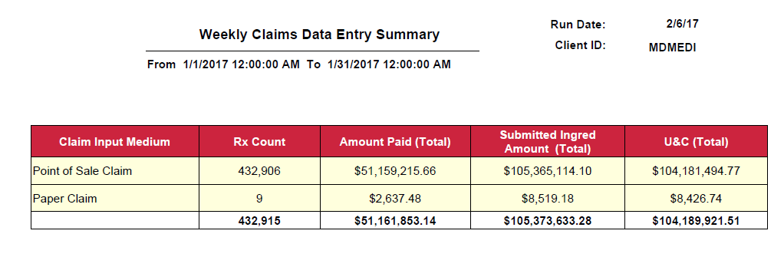

Weekly PA Drug Detail by Status Code

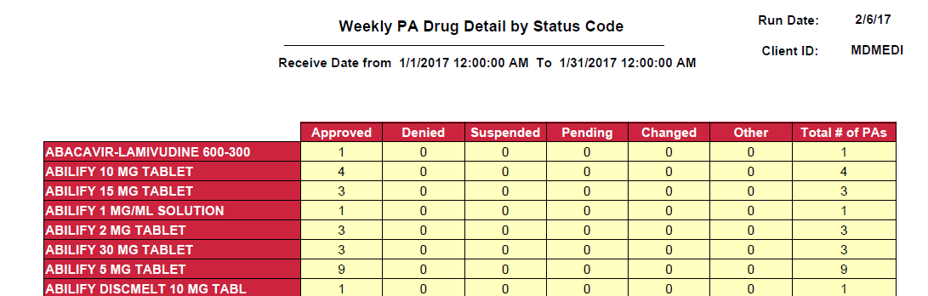

Weekly Prior Authorization Requests

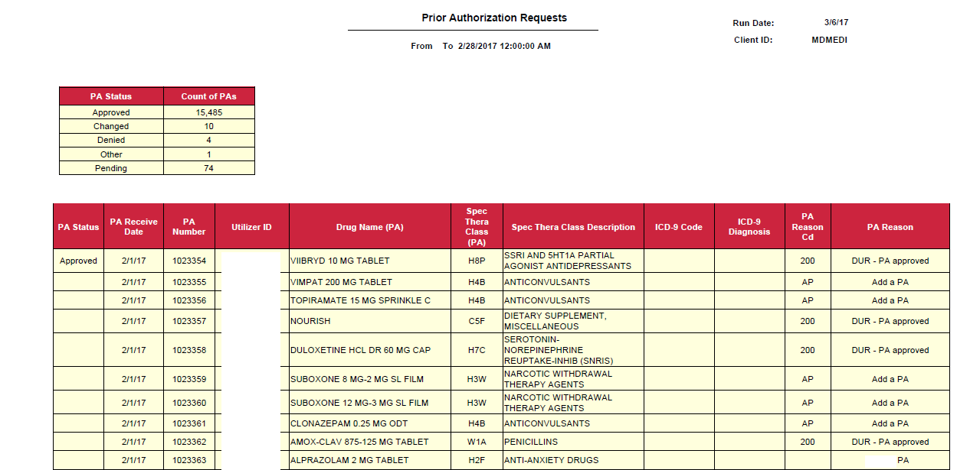

Negative Determinations Report

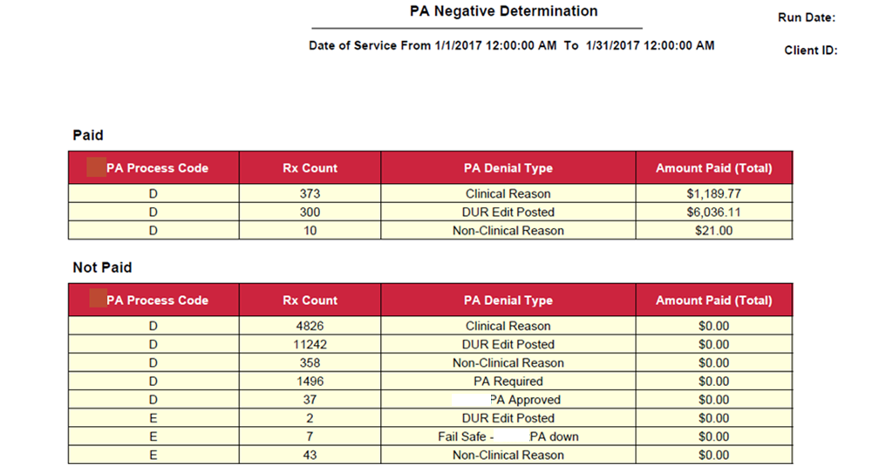

Positive Determinations Report

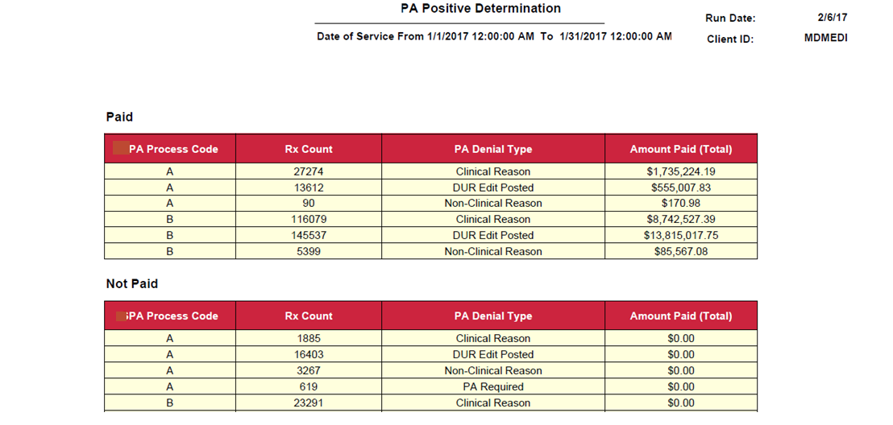

MDMEDI Monthly reports

Drug Audit Report Refill Too Soon Overrides

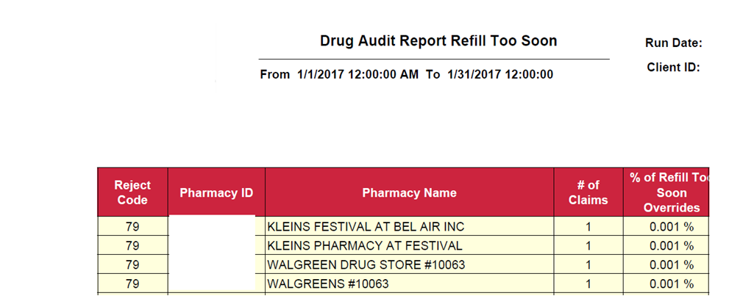

Drug Audit Report Duplicate Claim Overrides
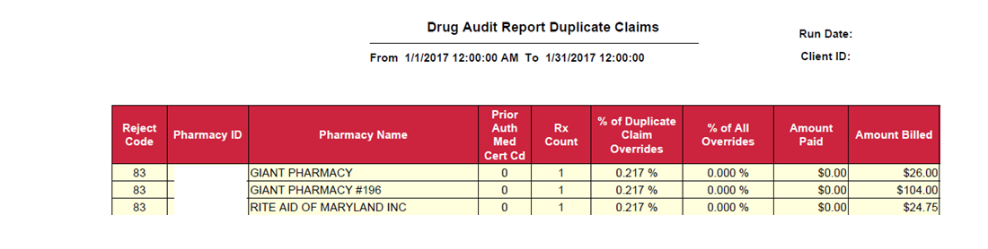

Drug Audit Report Maintenance Drugs with Less Than 10 Days Supply
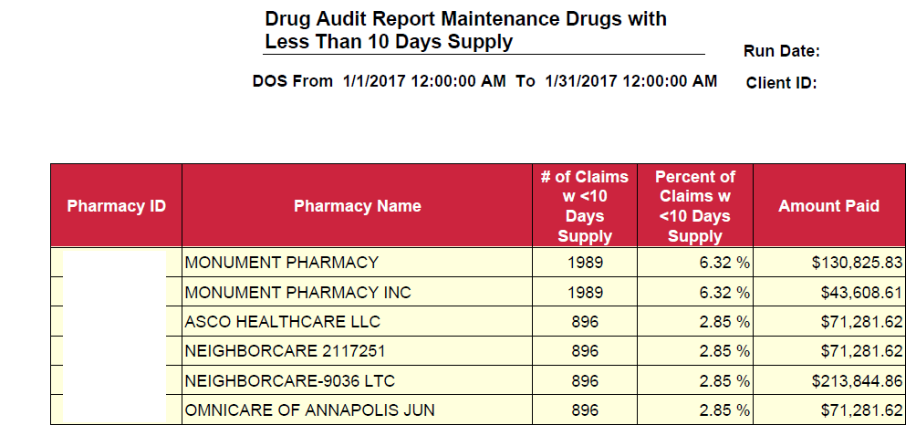

Drug Audit Report DAW 1

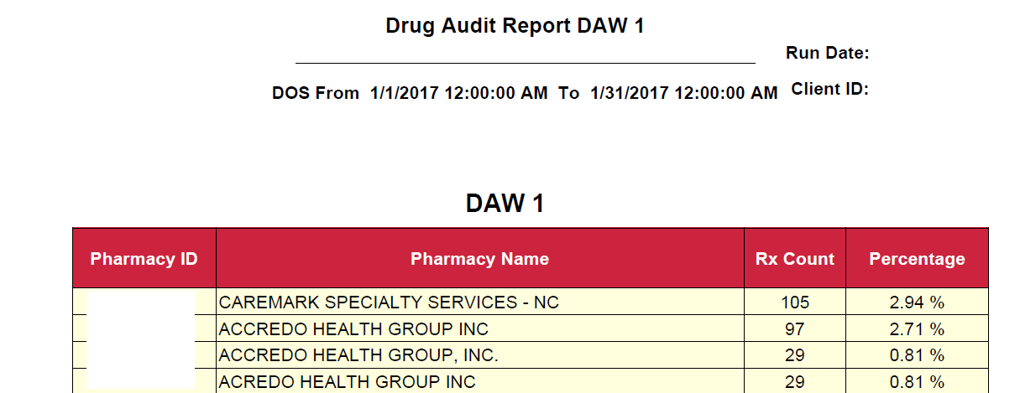

Controlled Substance (NH Recipient)

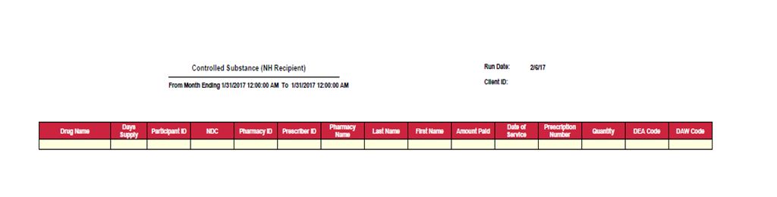

Controlled Substance (Pharmacy Providers)
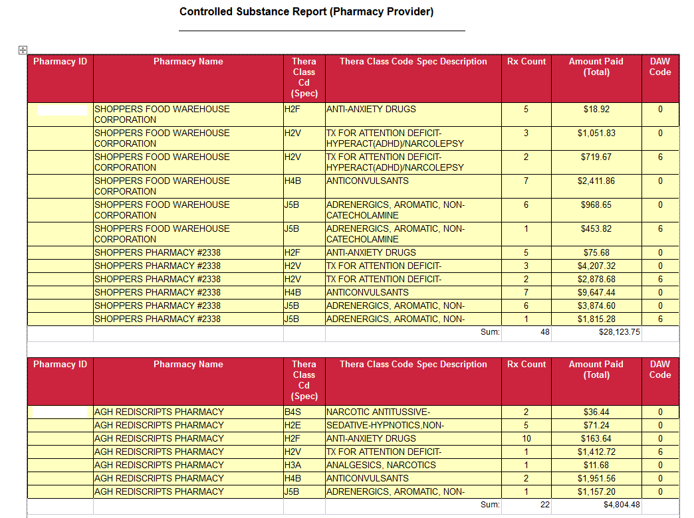

Controlled Substance (Prescribers)
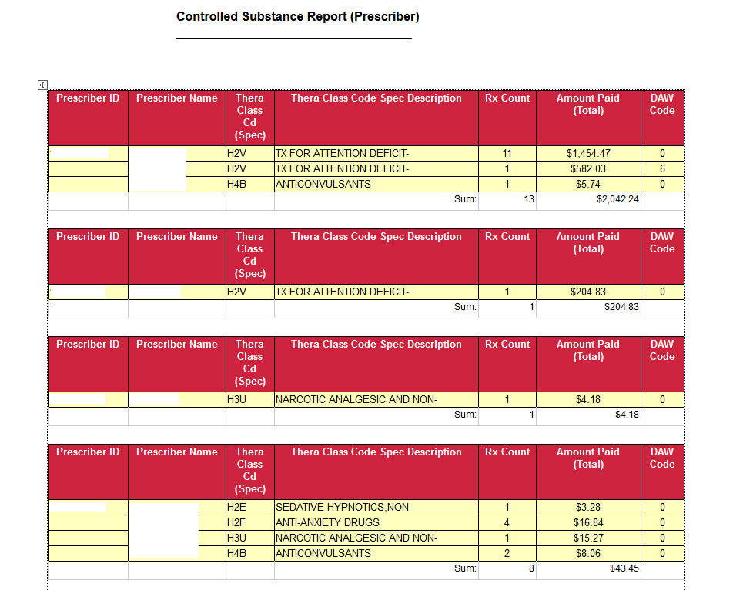

Carved Out Drugs Paid Claims Only

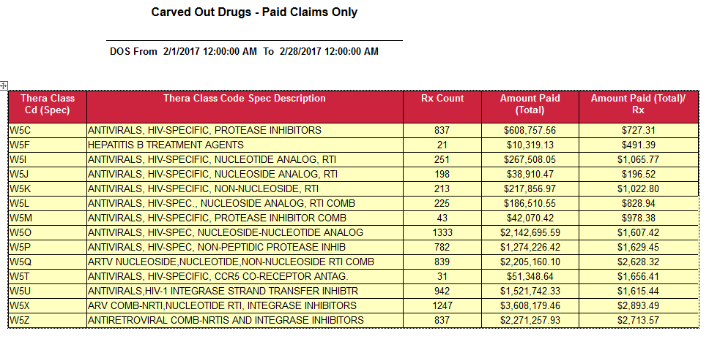

Adjudicated Claims Analysis
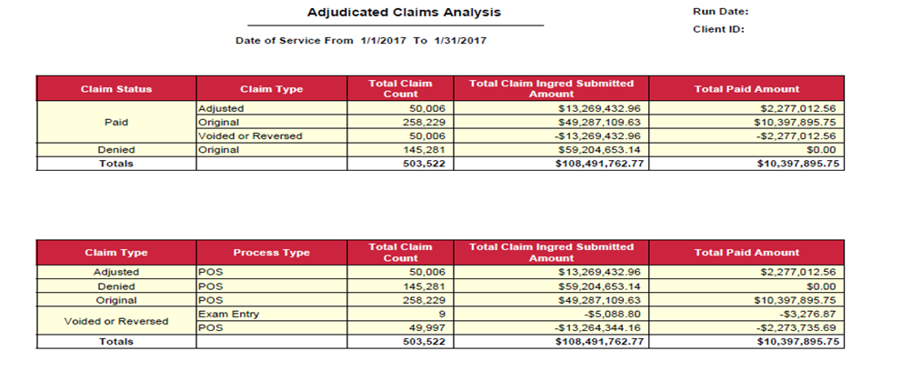

Claims with Payment Amount Greater than $400

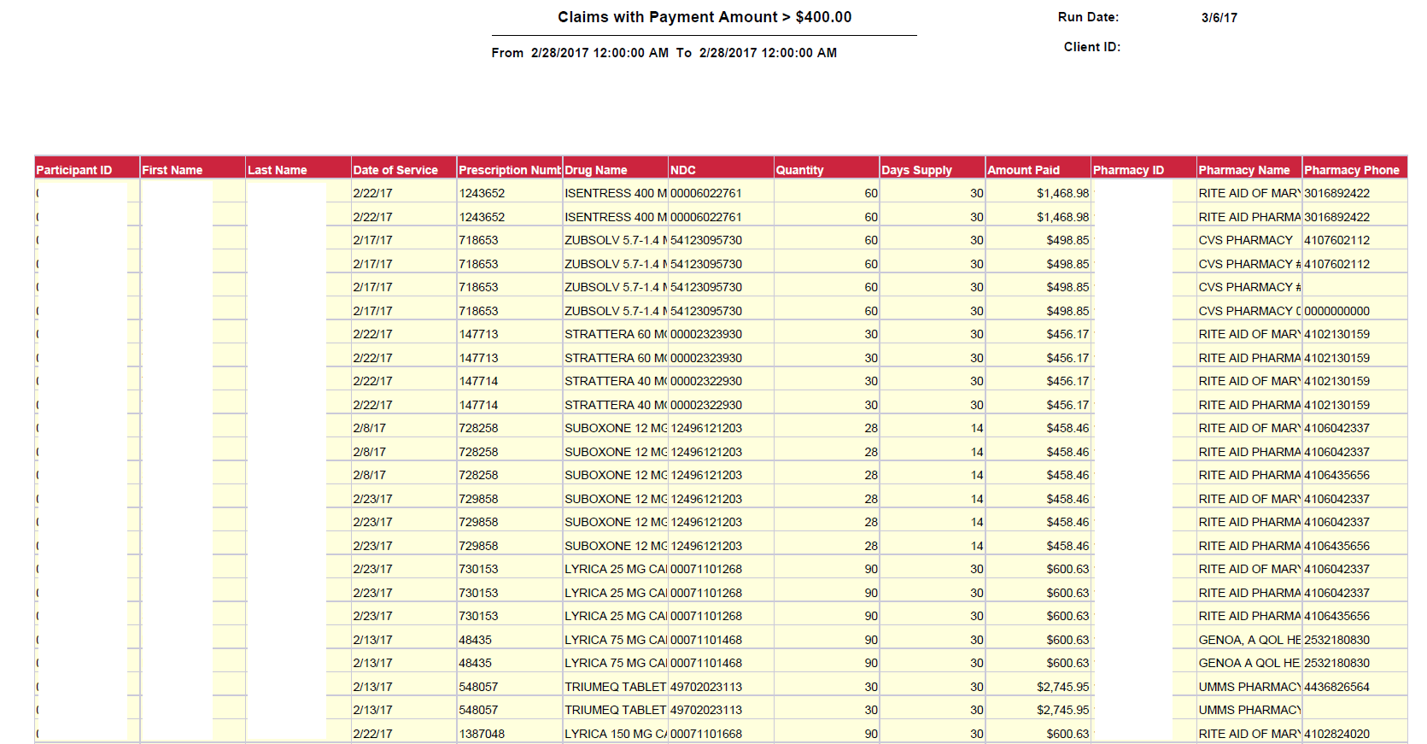

Maryland Medicaid Pharmacies Ranked By Total Payment for Health Choice MCO-AIDS Drugs

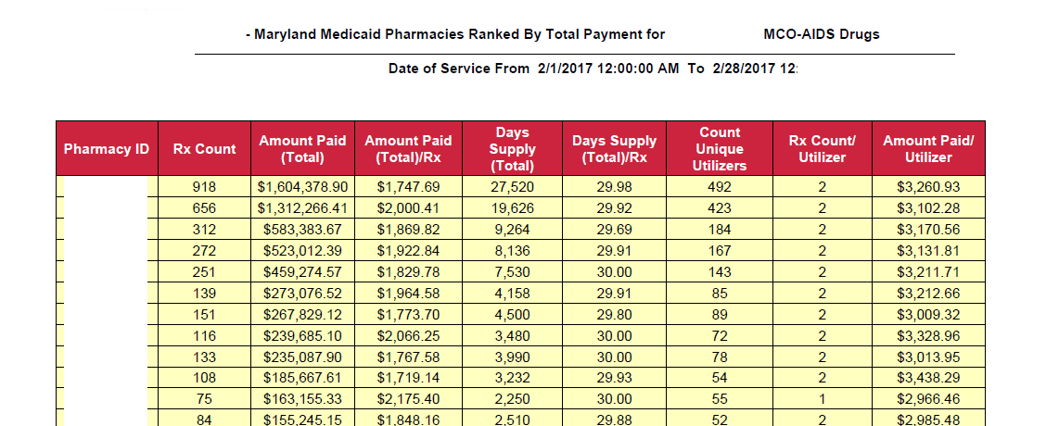

Top Pharmacies Ranked by Amount Paid
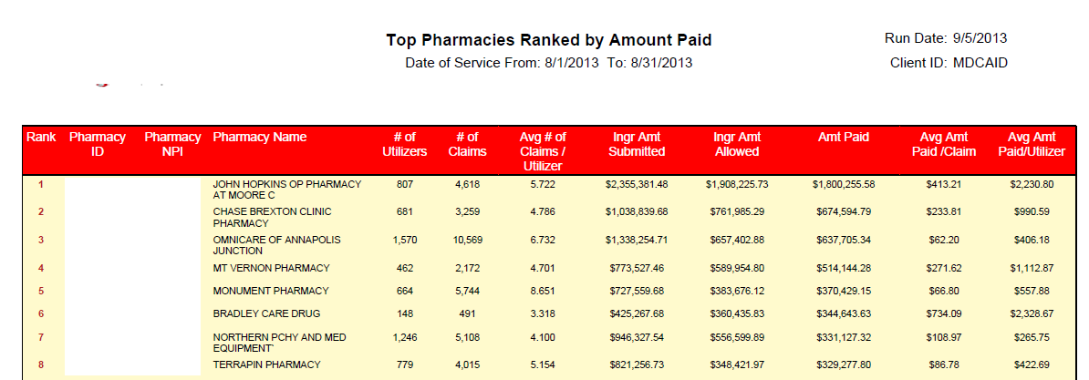

Top Pharmacies Ranked by Number of Prescriptions
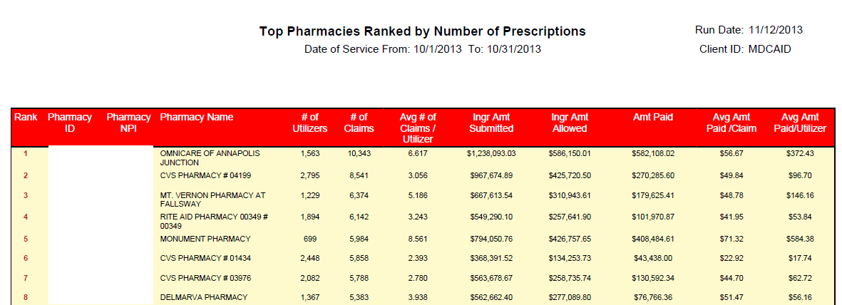

Top Pharmacies Ranked by BWGA Number of Prescriptions
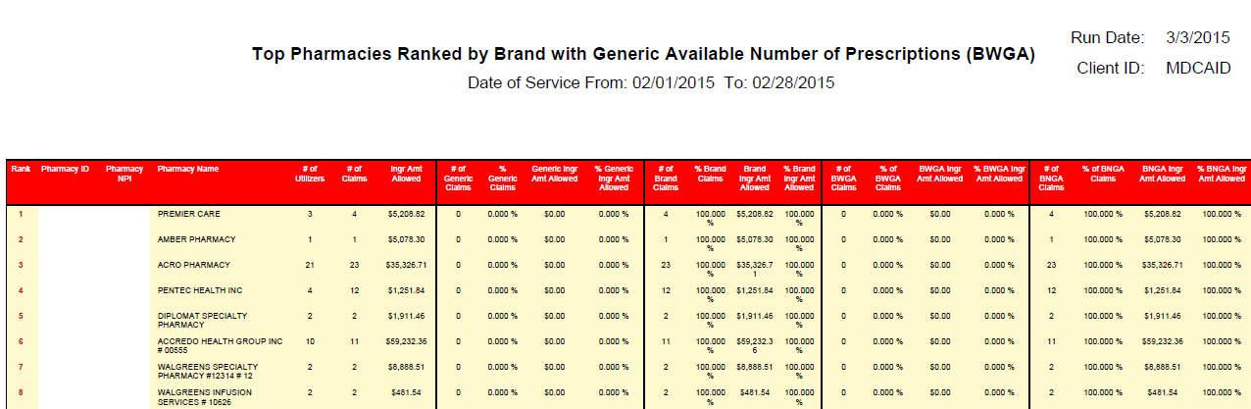

Top Prescribers of Controlled Substances Ranked by Amount Paid
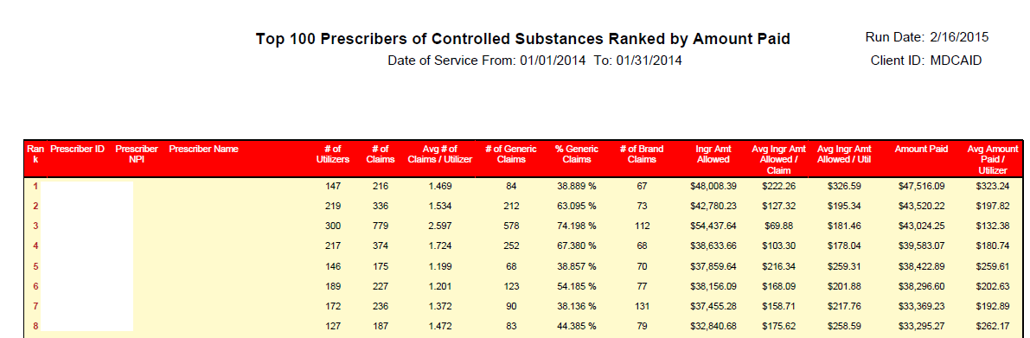

Top Prescribers of Controlled Substances Ranked by Number of Prescriptions
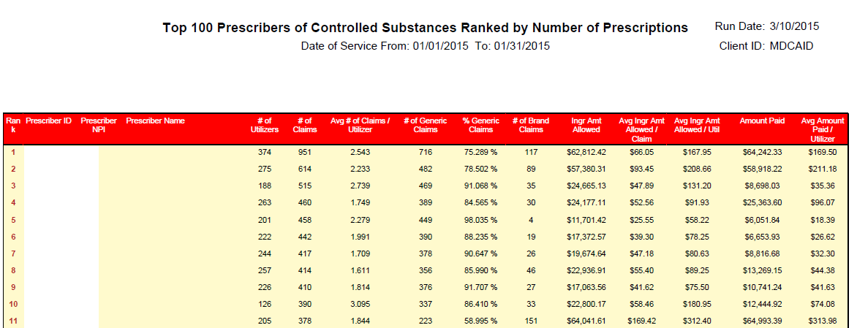

Top Prescribers Ranked by Amount Paid
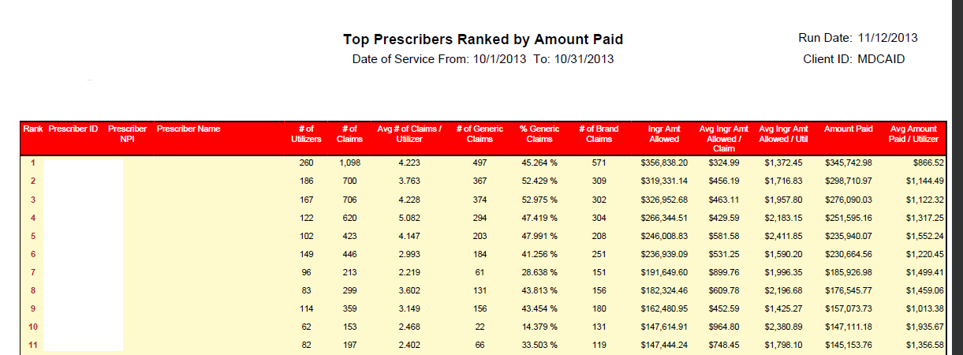

Top Prescribers Ranked by Number of Prescriptions
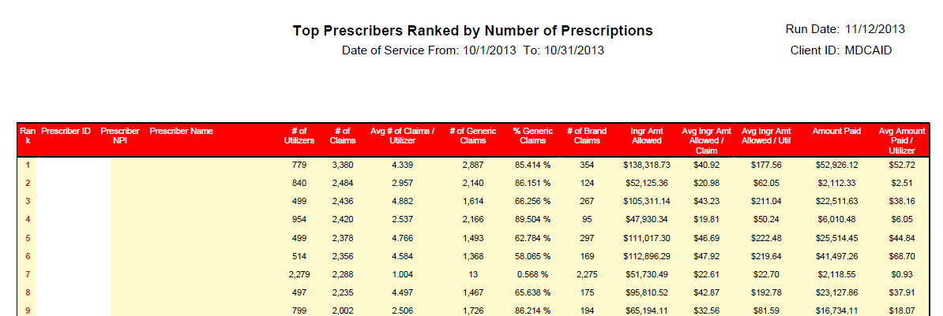

Top Prescribers Ranked by Average Prescription Cost
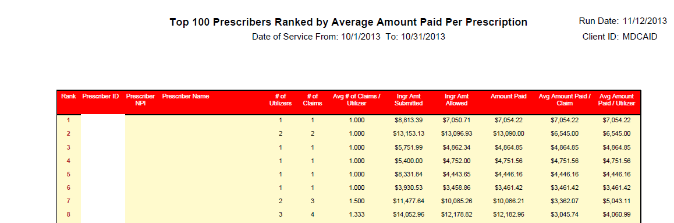

Top Prescribers Ranked by Brand with Generic Available Number of Prescriptions
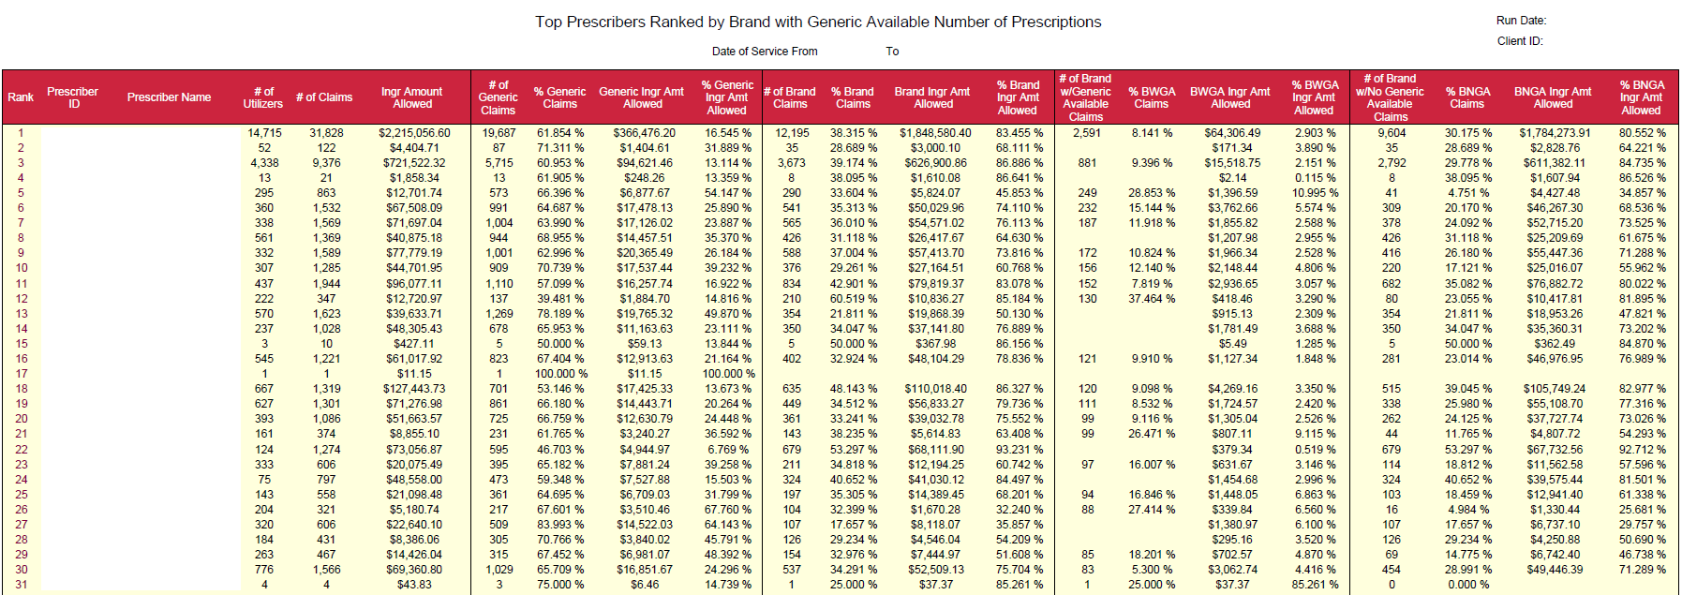

Top Prescribed Drugs Ranked by Amount Paid
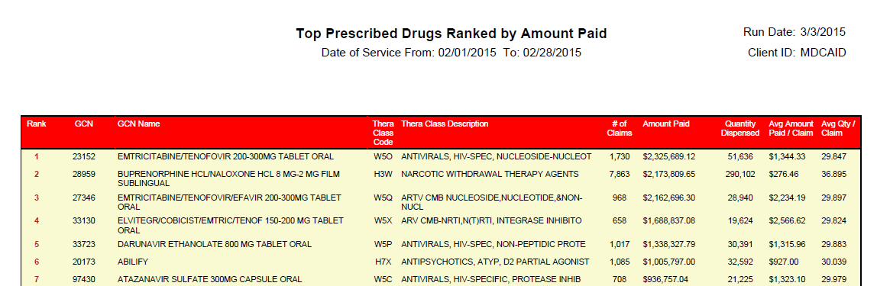

Top Prescribed Drugs Ranked by Number of Prescriptions
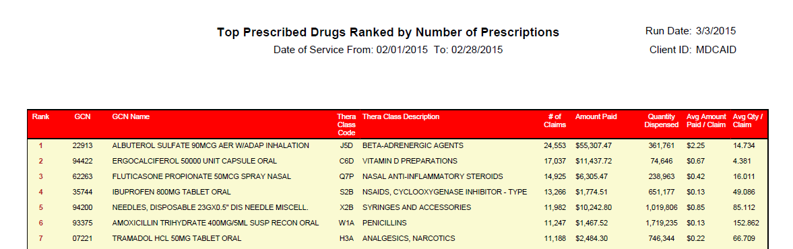

Top Prescribed Injectable Ranked by Amount Paid
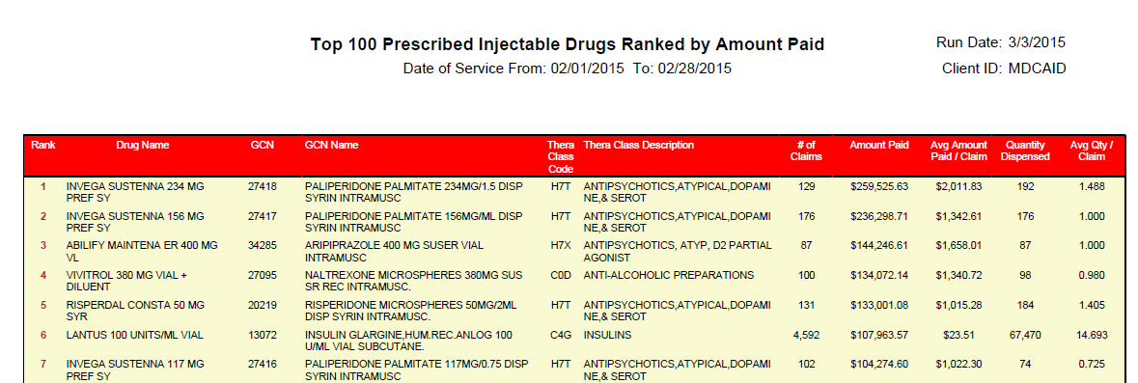

Top Prescribed OTC Drugs Ranked by Amount Paid
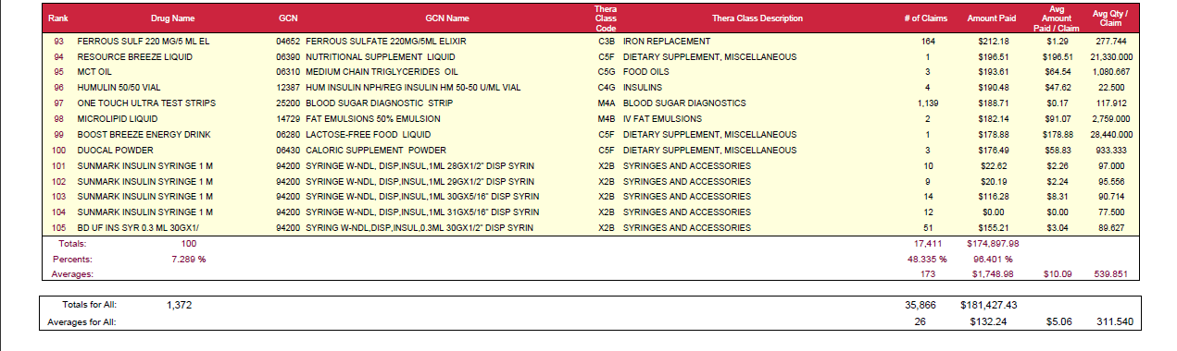

Top Therapeutic Classes Ranked by Amount Paid
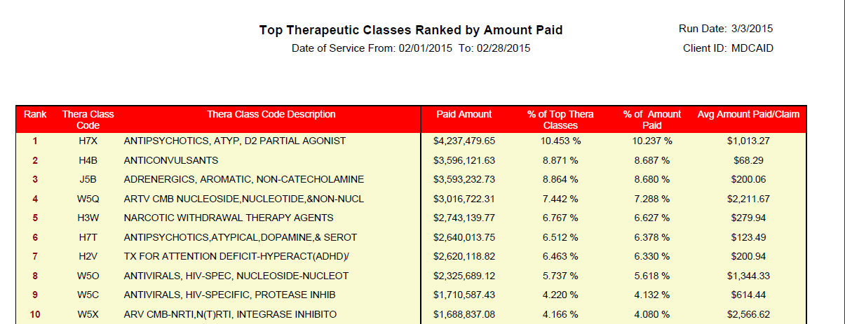

Top Therapeutic Classes Ranked by Number of Prescriptions
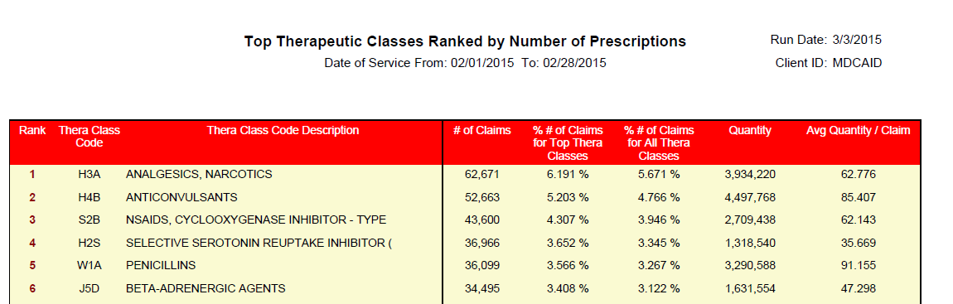

Claims Payment Summary
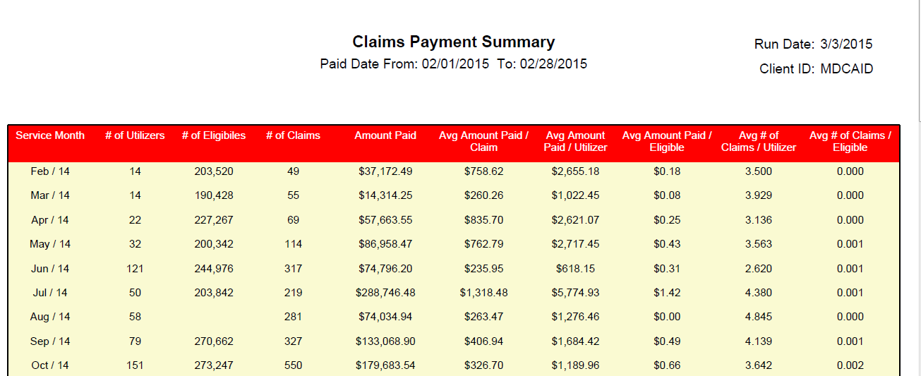

Top Utilizers Ranked by Amount Paid
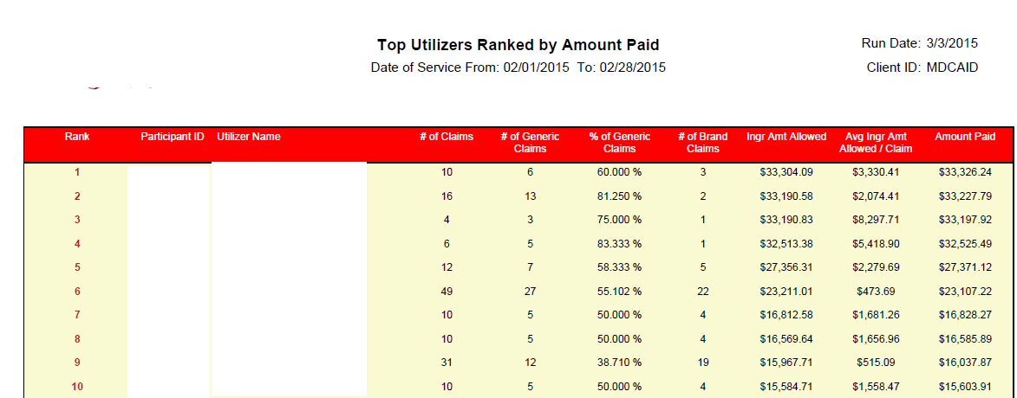

Top Utilizers Ranked by Number of Prescriptions

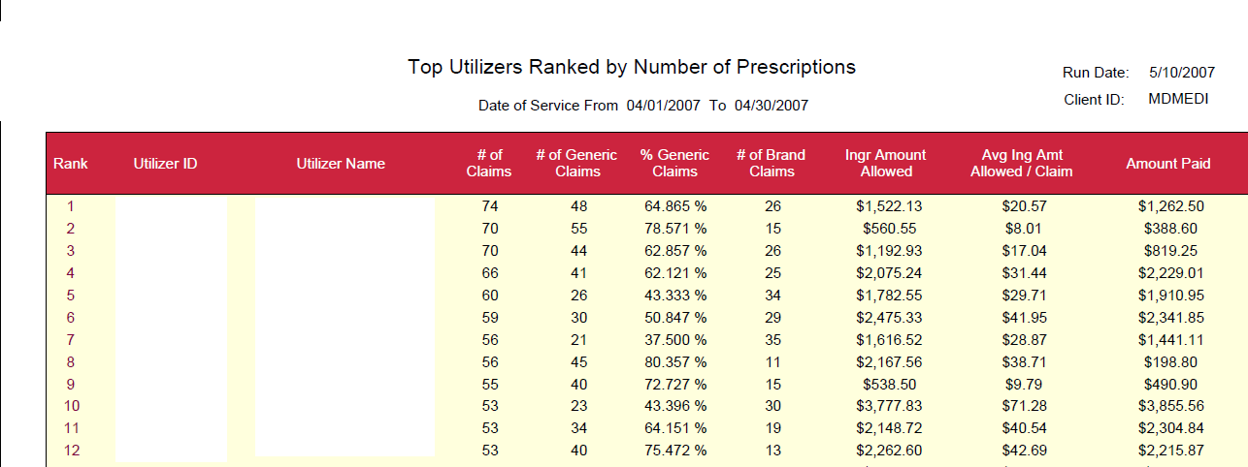

Top Utilizers of Controlled Substances Ranked by Amount Paid

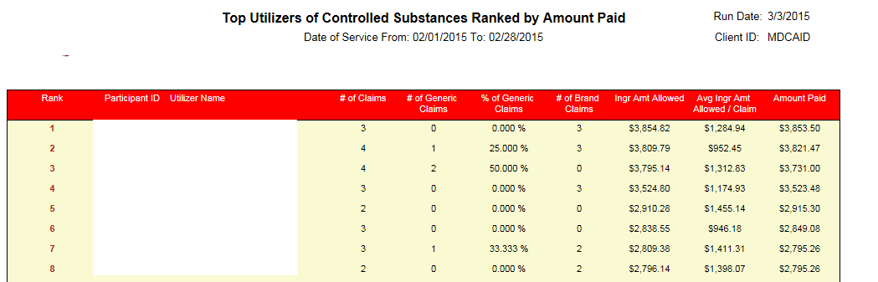

Top Utilizers of Controlled Substances Ranked by Number of Prescriptions
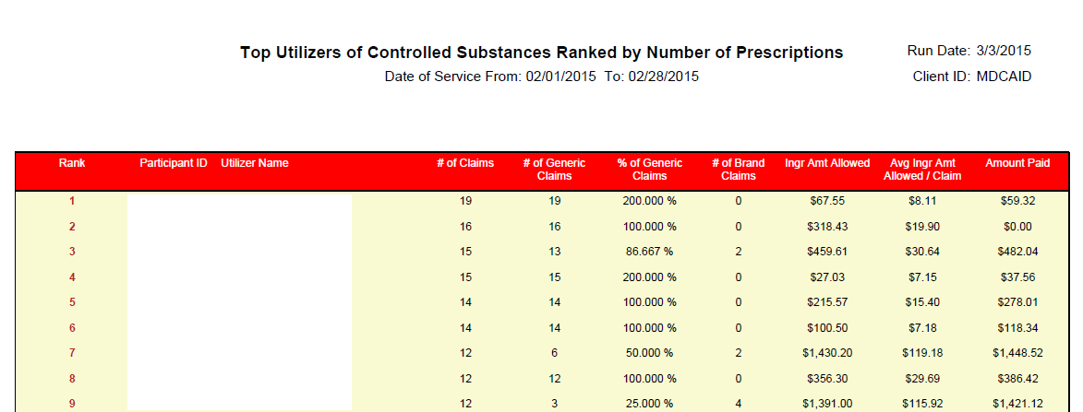

Age-Sex Utilization Summary
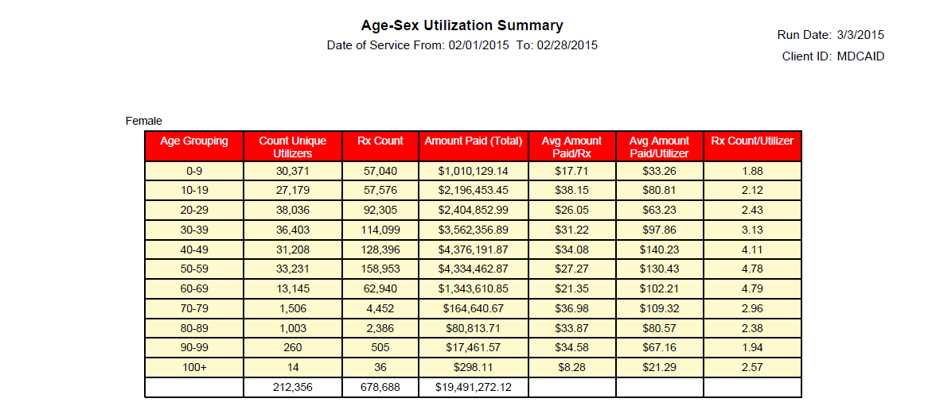
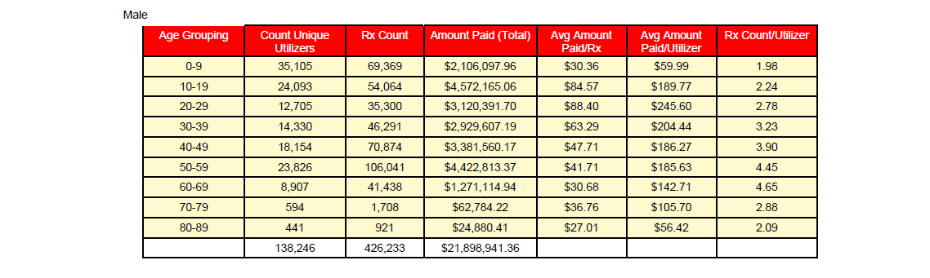
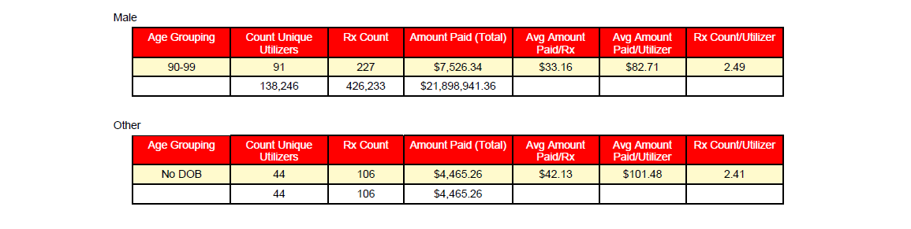

Monthly Prior Authorization Status
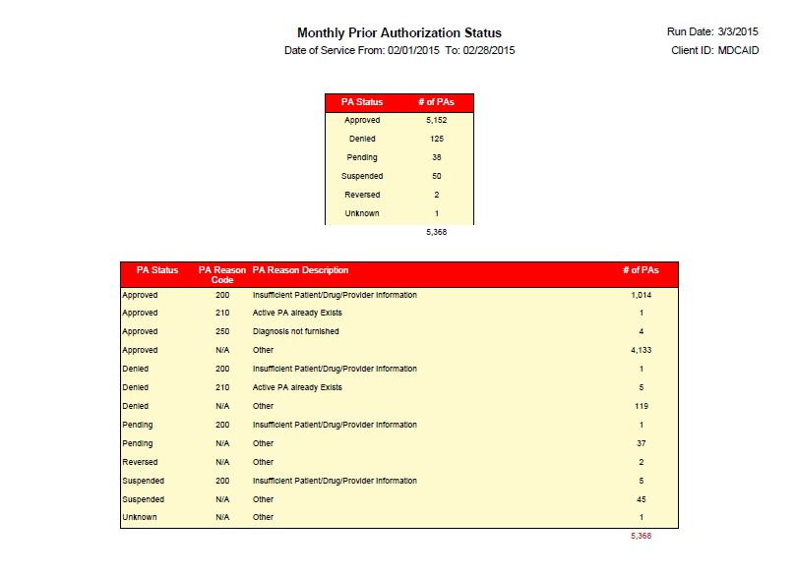
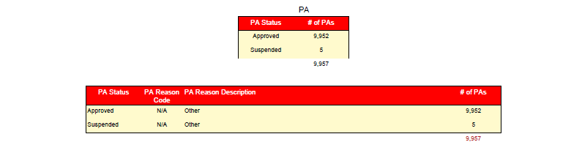

Top Prescribers Ranked by Ingredient Cost Allowed
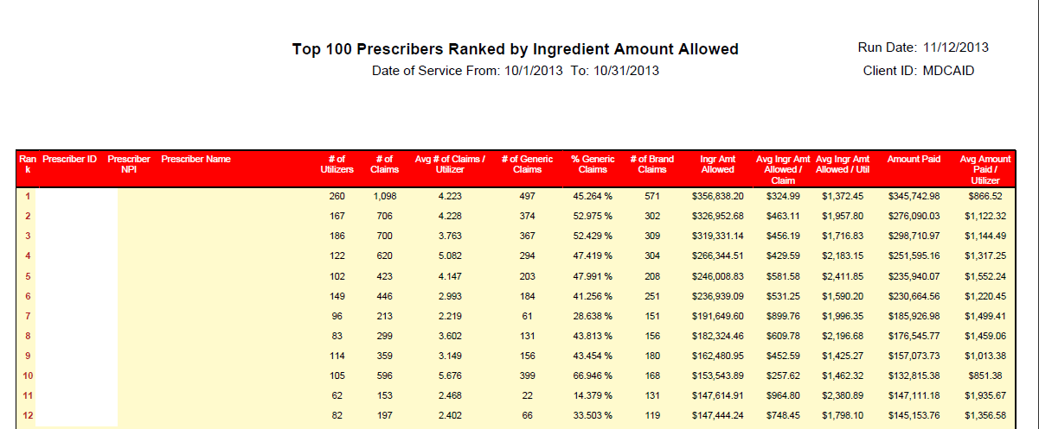

Denied Exceptions Ranked by Number of Edits Posted
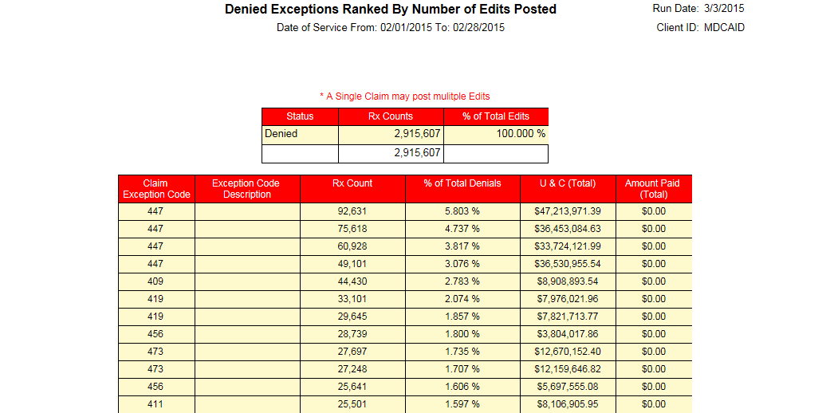

Paper Claims Summary
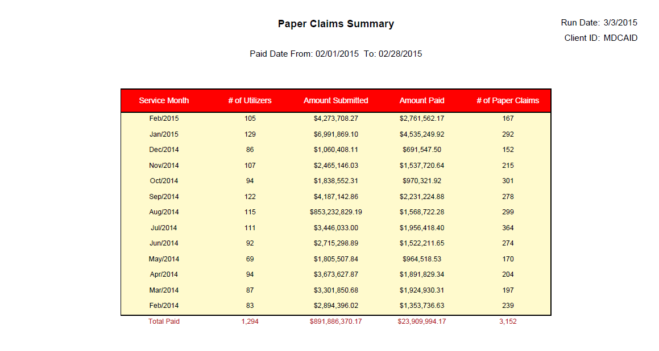

Paper Claims Submissions
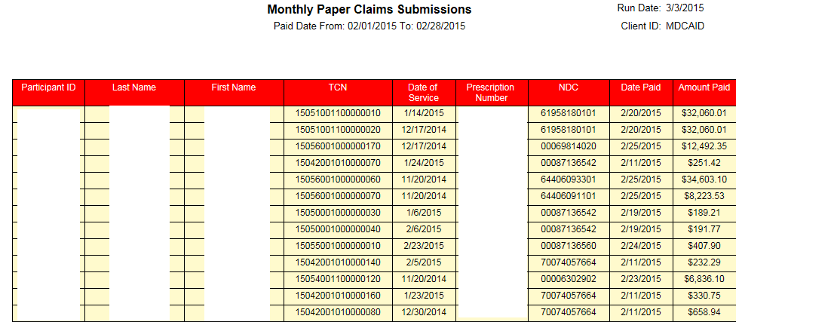

Monthly Payment Summary
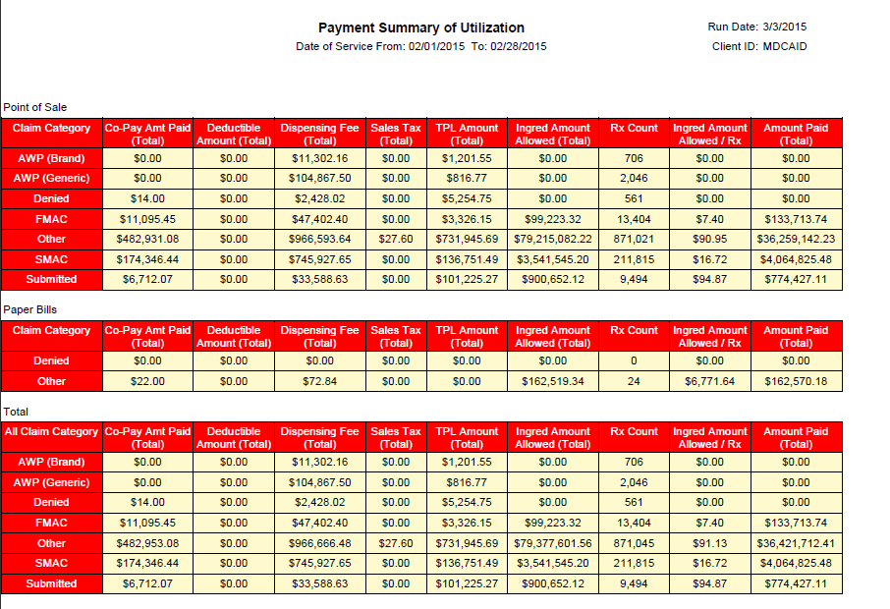

Cost Sharing Savings
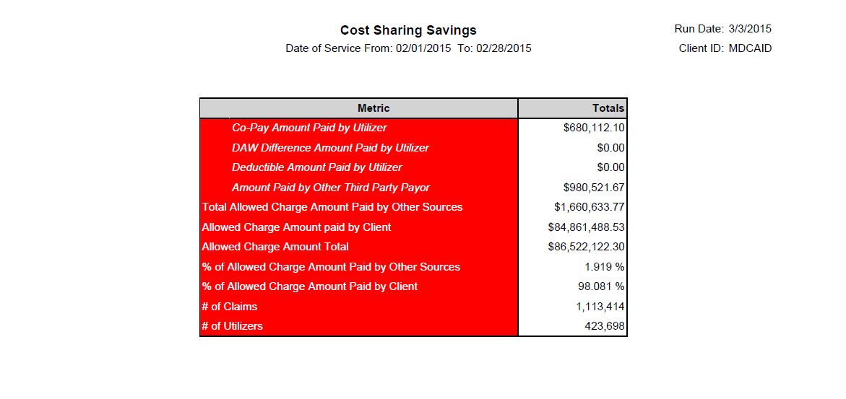

Plan Sponsor Cost Summary
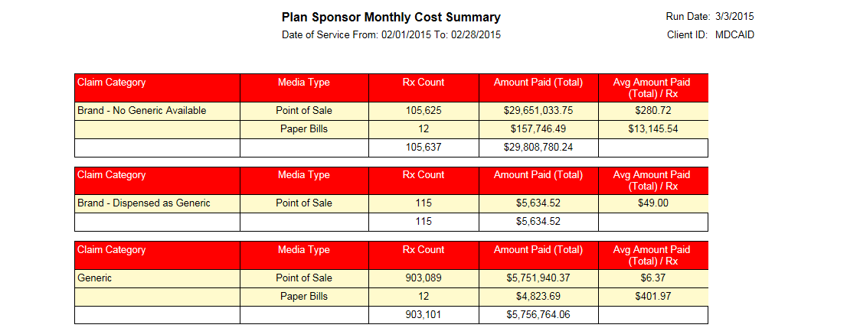

Executive summary
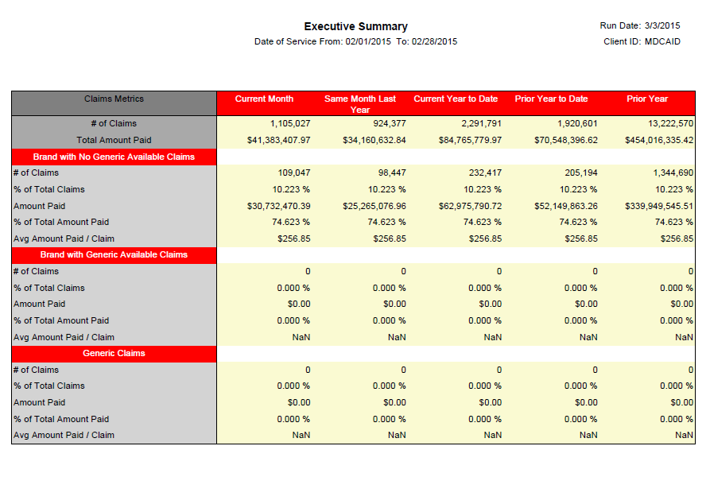

Denied Claims Analysis
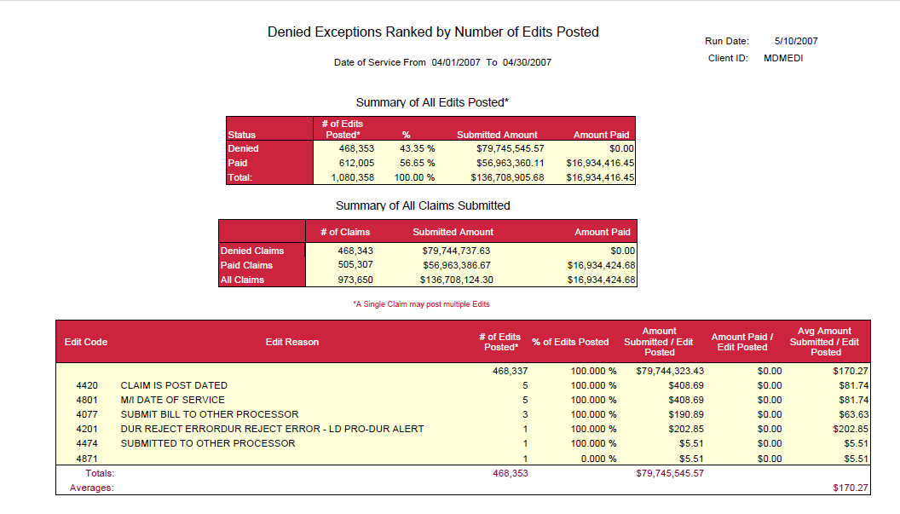
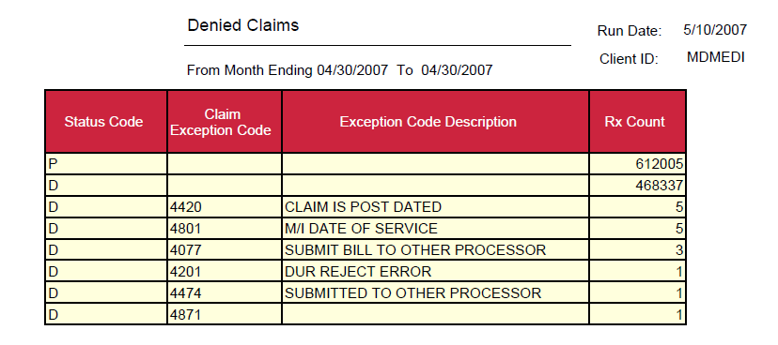

Monthly Denied claims
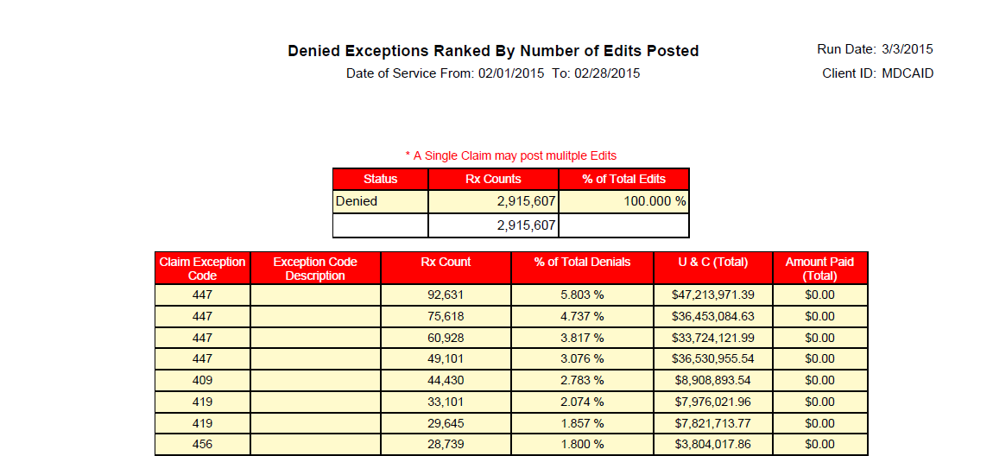

Prescriber Reports

Prescriber Activity Reports
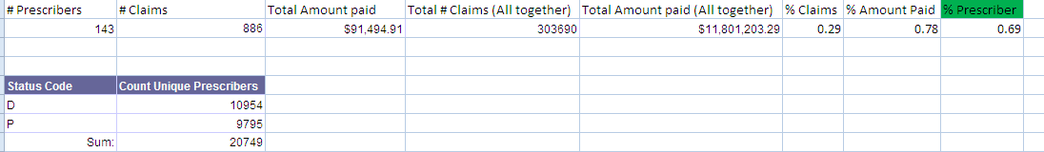
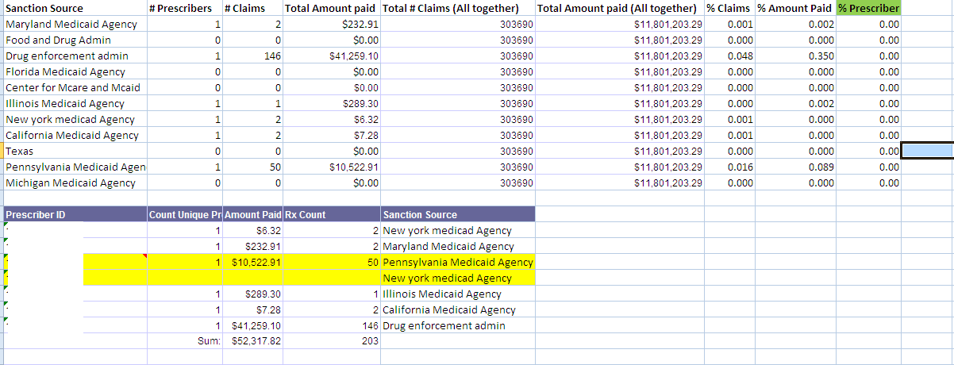

Prescriber sanction Report

Invalid Prescribers as per Source data (Pass Check digit logic only)

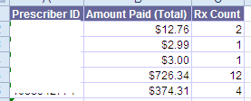

FDB Report

POS NDC MDSPAN UPDT RPRT - MediSpan Price change
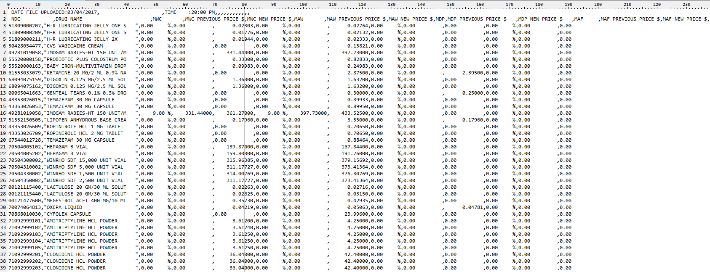

POS NDC UPDT RPRT - FDB Price change report
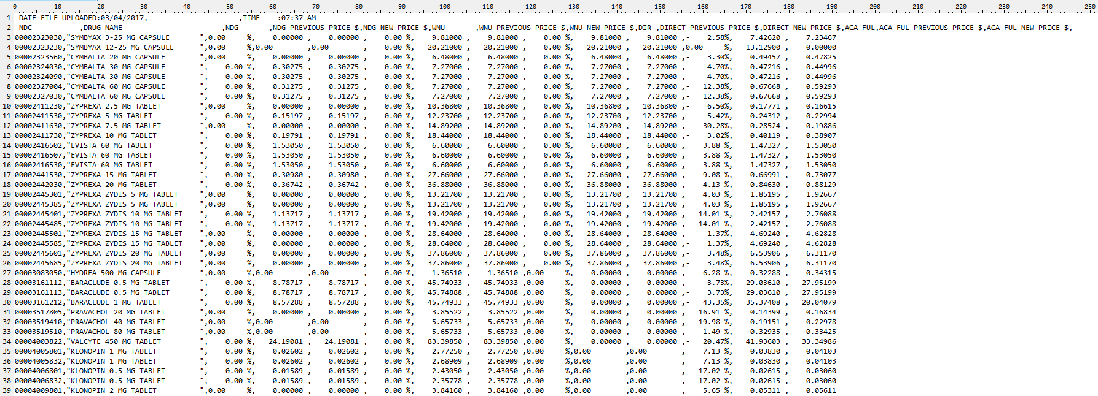

Interface file load/update/Reconciliation Reports

Eligibility Update report
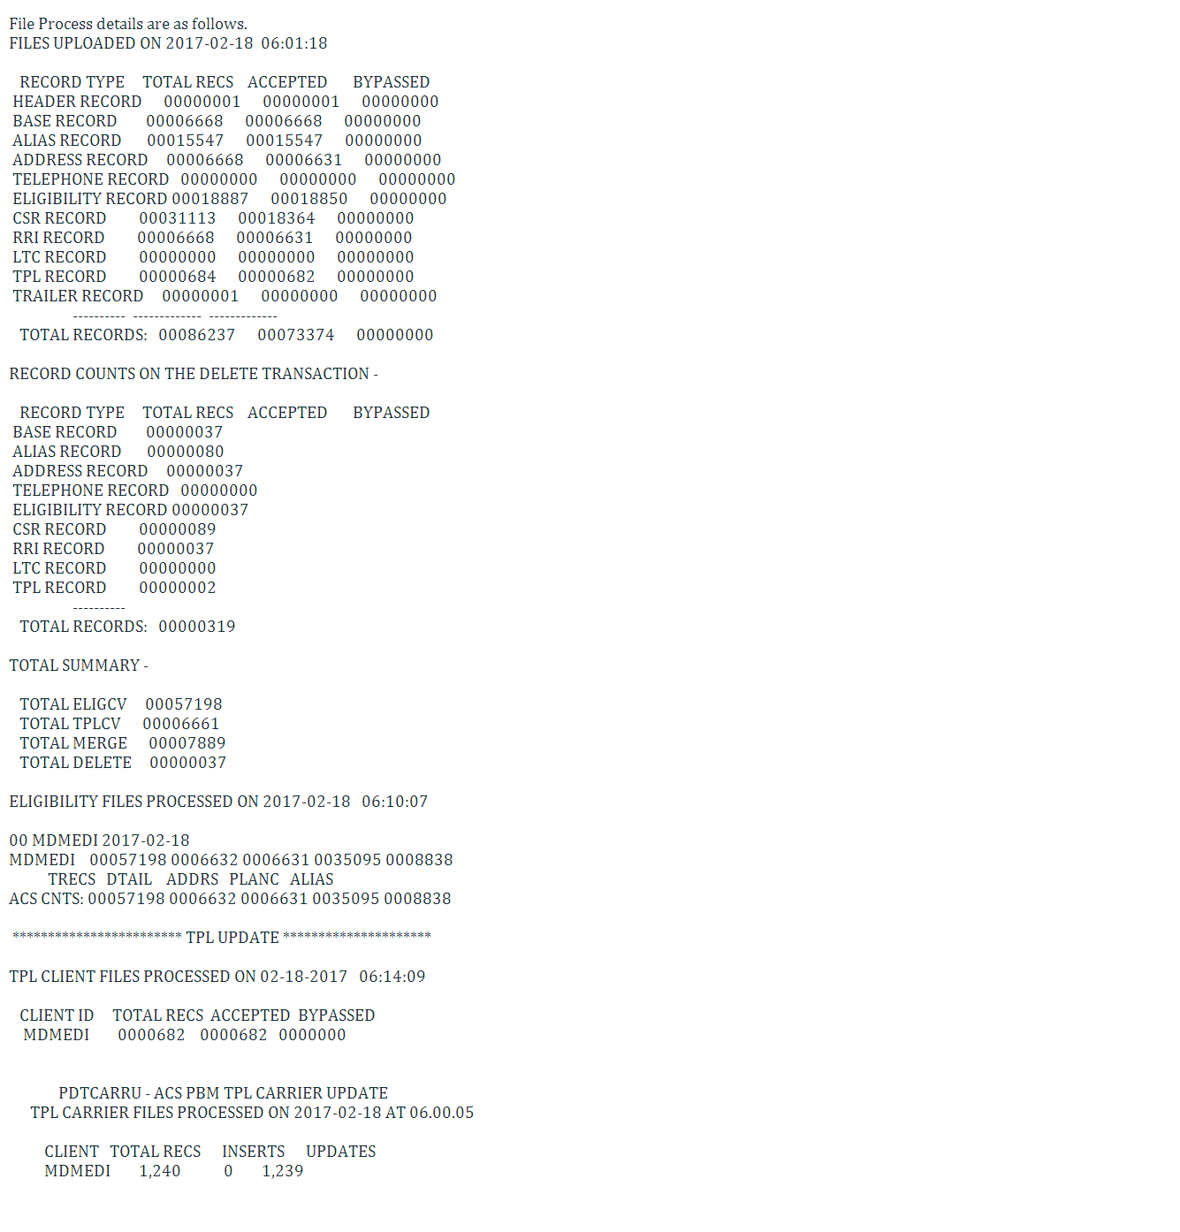

Eligibility Update report – Deletes
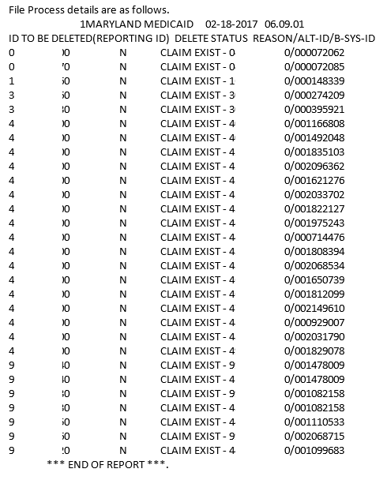

- Provider eligibility update report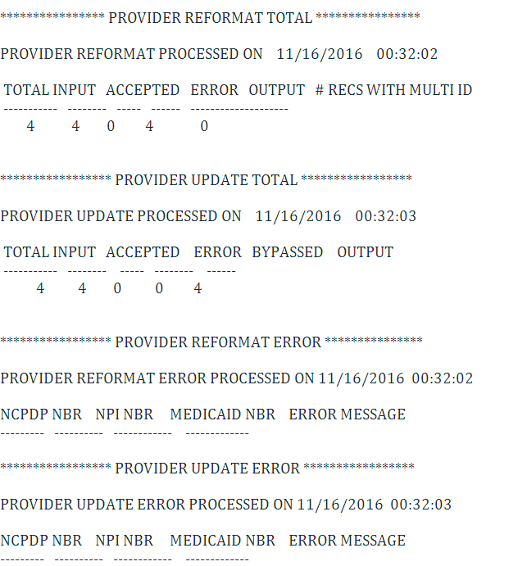

Reject Analysis Report

MDMEDI
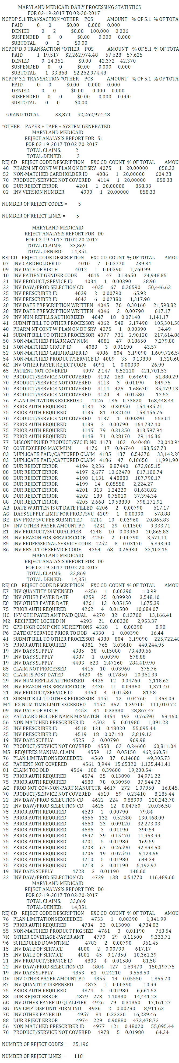

OOEP/Encounter Claims Extract Reconciliation Report

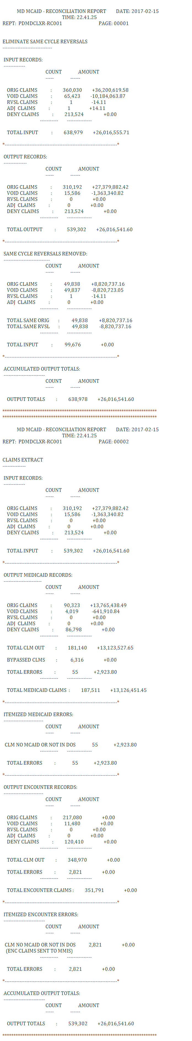

OOEP/Encounter Claims Extract Produced Errors
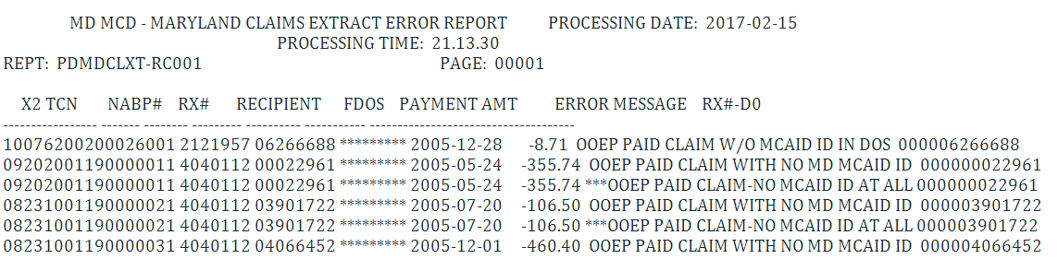

OOEP/Encounter Claims Error Reconciliation Report
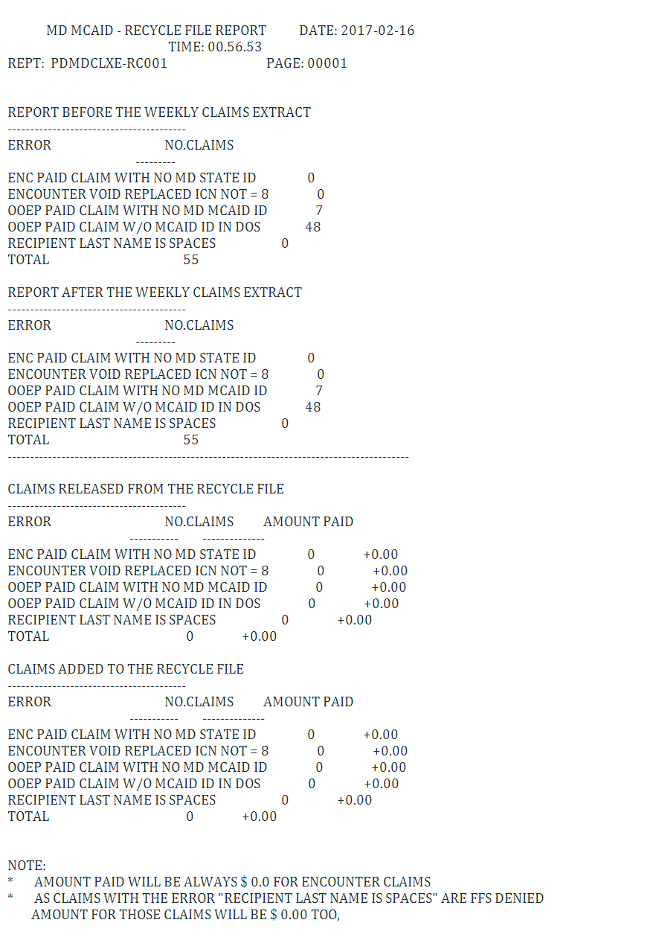

STATE PRESCRIBER SANCTIONS LOG Report

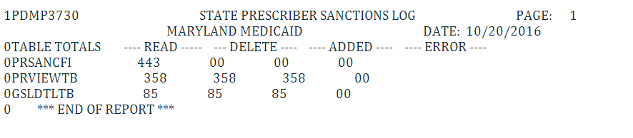

STATE PRESCRIBER SANCTIONS LOG Error Report
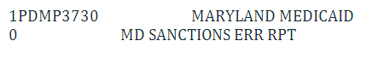

Miscellaneous Reports

Operational Performance Report

Provide the POS system performance report for claims processing against the contractual SLAs and Outages. The report should include, Claims details (Paid, Denied, etc), Average time for processing by day for each day of the month.

MONTHLY INJECTABLE FFS TOTAL REPORT

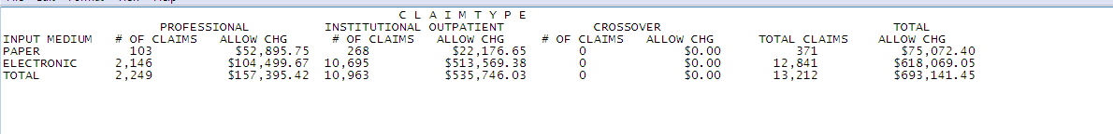

MONTHLY INJECTABLE ENCOUNTERS TOTAL REPORT

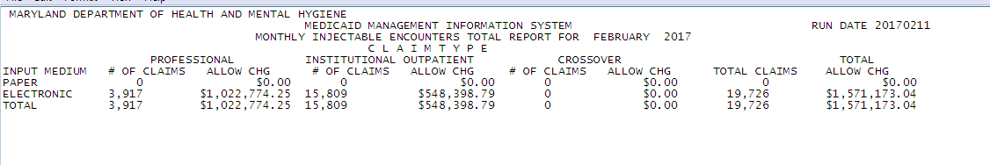

J-Code Claims load report
FFS
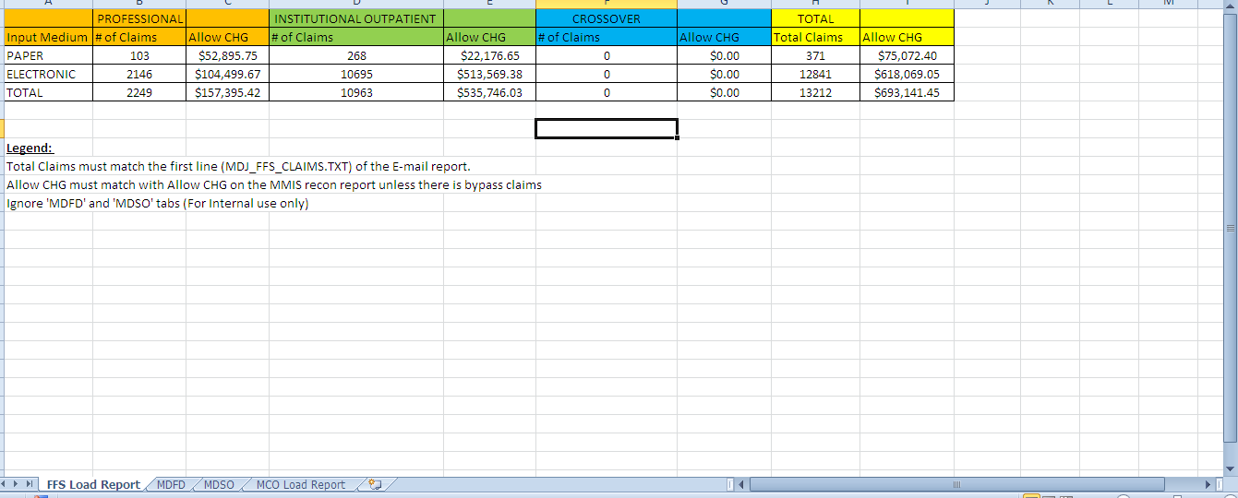

MCO
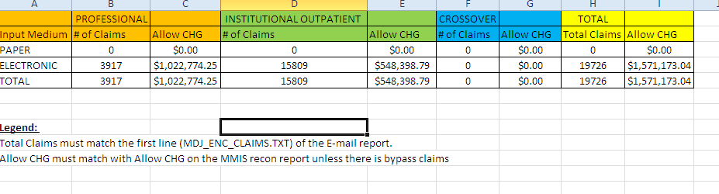

J-Code Claims Error report

- NDC Units/HCPC Units Missing for Maryland REBATE Claims
Create a report with the details when there is an error loading the specific claim due to missing/invalid units for the NDC or HCPC in Input file.
- NDC Code missing for Maryland REBATE Claims
Create a report with the details when there is an error loading the specific claim due to missing/invalid NDC in input file.
- HCPC/Revenue code missing for Maryland REBATE Claims
Create a report with the details when there is an error loading the specific claim due to missing/invalid (UB92) or HCPC Code (HCFA) in Input file.
- Unit of measure missing for Maryland REBATE Claims
Create a report with the details when there is an error loading the specific claim due to missing/invalid Unit of measure for the NDC in Input file.

DUR Board Meeting Quarterly Reports

Top 20 Drugs by DUR Conflict
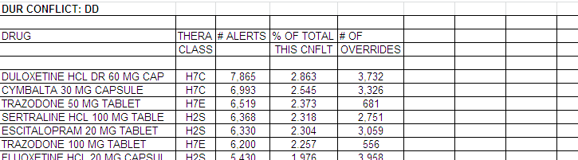

Prospective DUR Cost Avoidance by Amount Paid
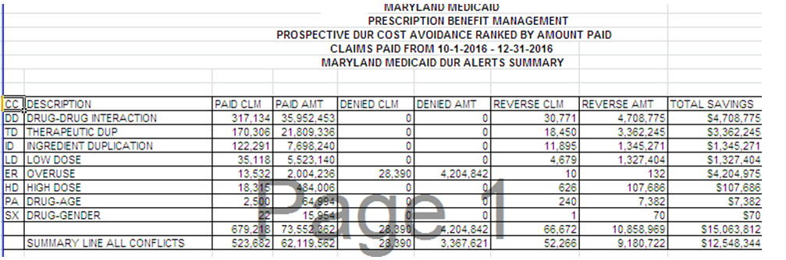

Summary Report by DUR Conflict, Intervention, and Outcome Codes
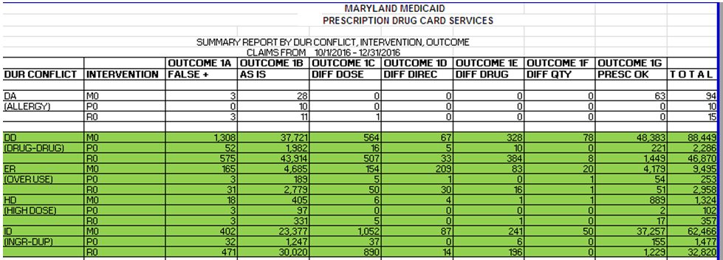

Preferred Drug List (PDL) Prior Authorization (PA) Report
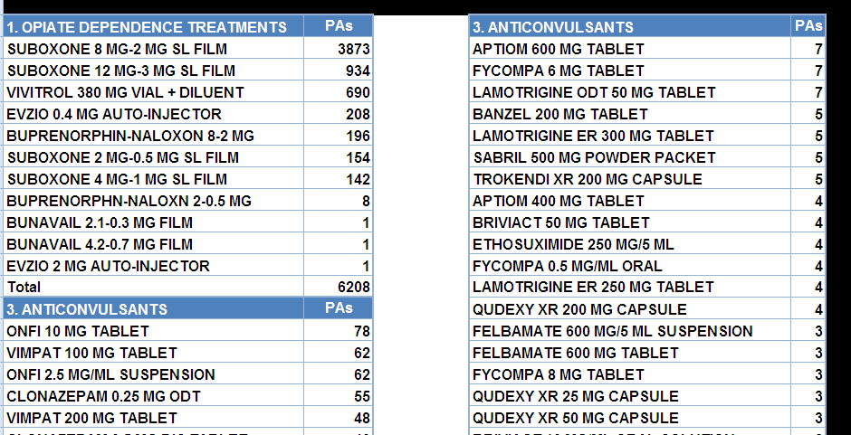

Call Center Report
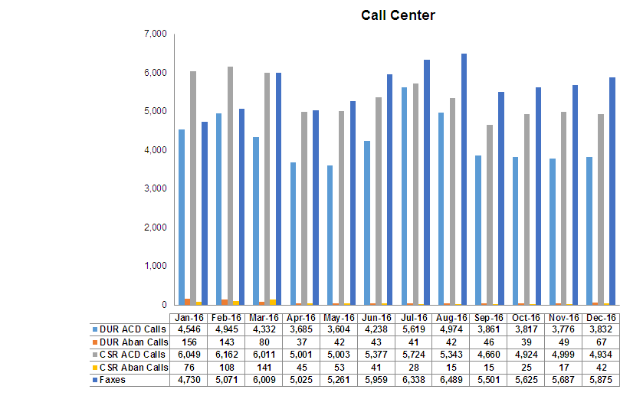

Annual CMS Reports

Top 20 Drugs by DUR Conflict
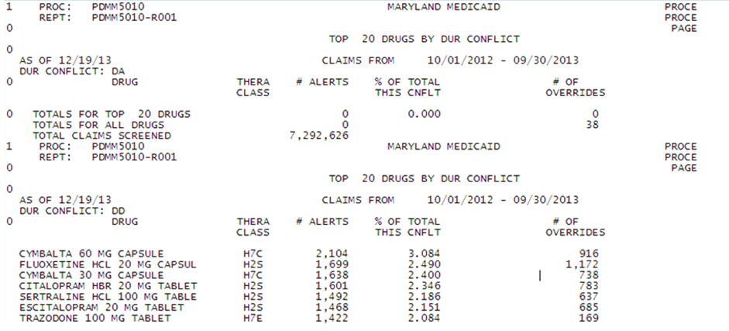

Prospective DUR Cost Avoidance by Amount Paid
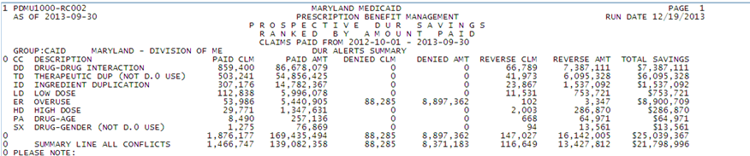

Summary Report by DUR Conflict, Intervention, and Outcome Codes
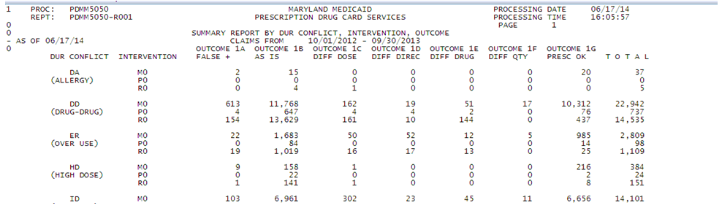

Summary report which includes, top 10 PA Requests by Drug Name, top 10 PA Requests by Drug Class, top 5 Denial Reasons, top 10 Drug Names by Amount Paid and % of Total Spent by Amount Paid, top 10 Drug Names By Claim Count and % of Total Claims.
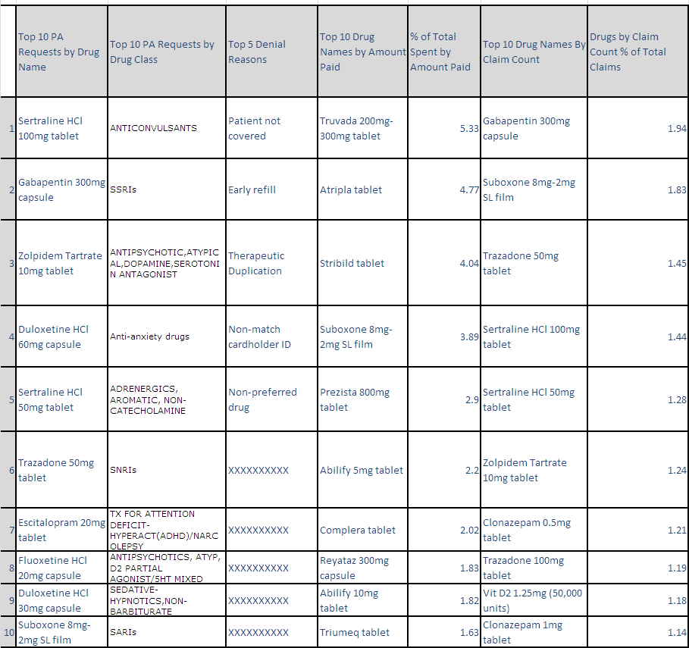

P&T Committee Quarterly Report

Preferred Drug List (PDL) Prior Authorization (PA) Report
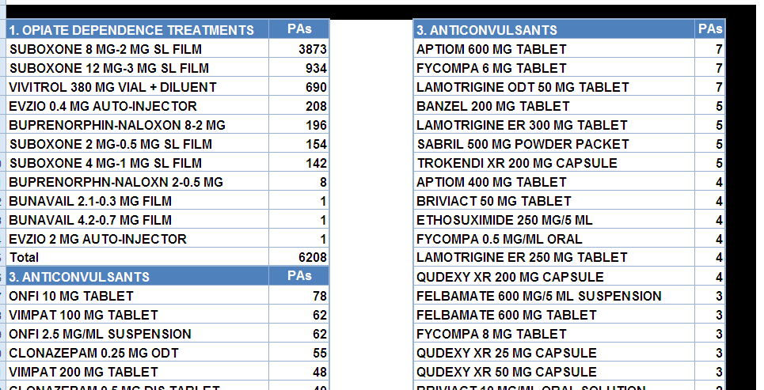

Top 10 PDL PAs by Therapeutic Classes
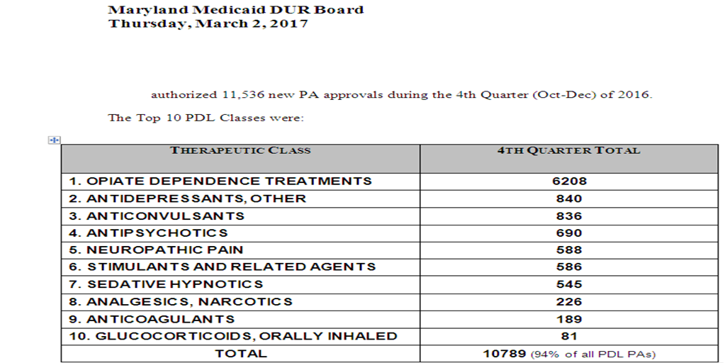

MDBCCDT

MDBCCDT Weekly Reports

Weekly PA Drug Detail by Status Code
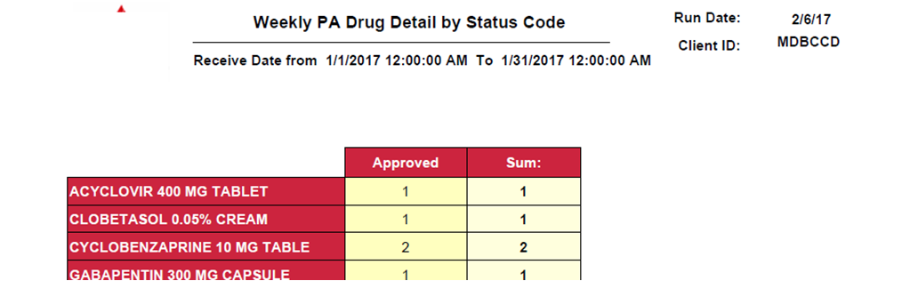

Weekly Prior Authorization Requests

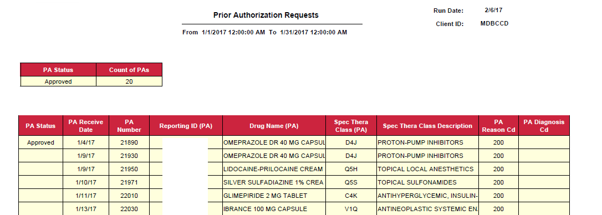

Weekly Claims Data Entry Summary

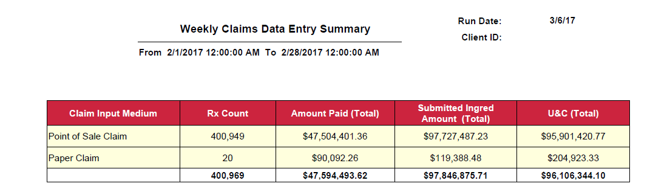

MDBCCDT Monthly Reports

Drug Audit Report Refill Too Soon Overrides
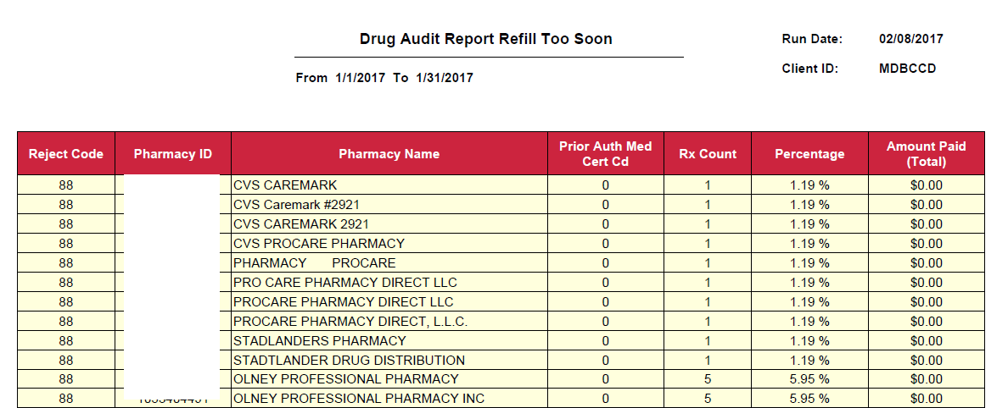

Drug Audit Report Duplicate Claim Overrides

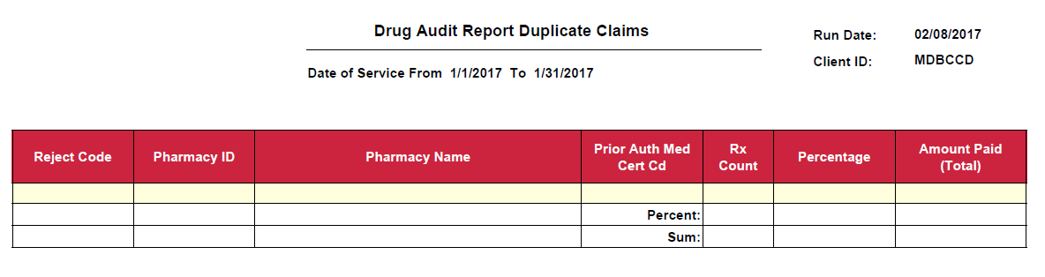

COB Claims Where Other Amount Paid is <$3

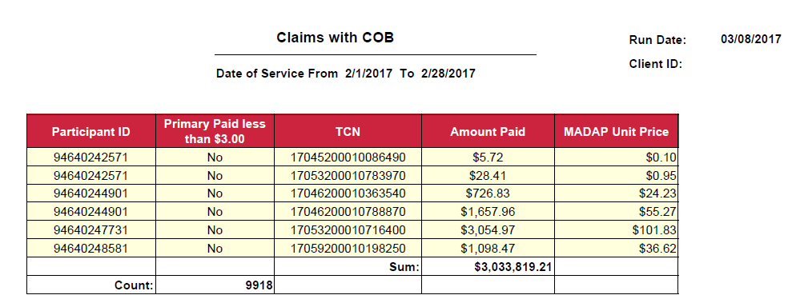

Adjudicated Claims Analysis
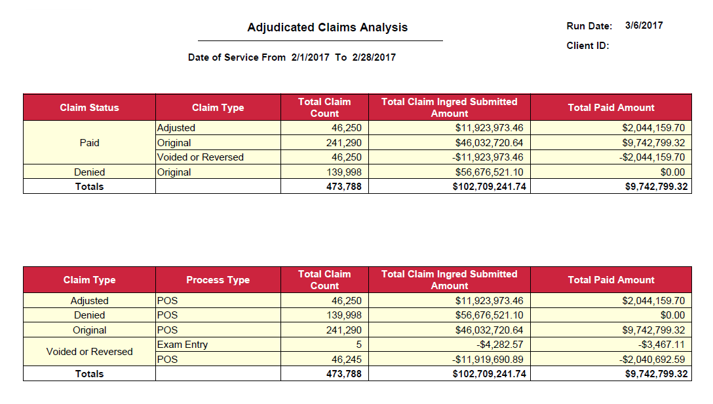

Claims with payment Amount >$400

BCCDT Active Insurance Report
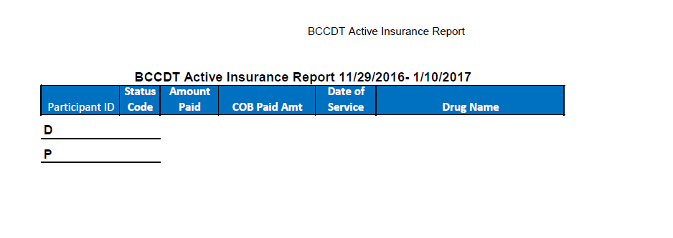

BCCDT Monthly Drug Costs Report
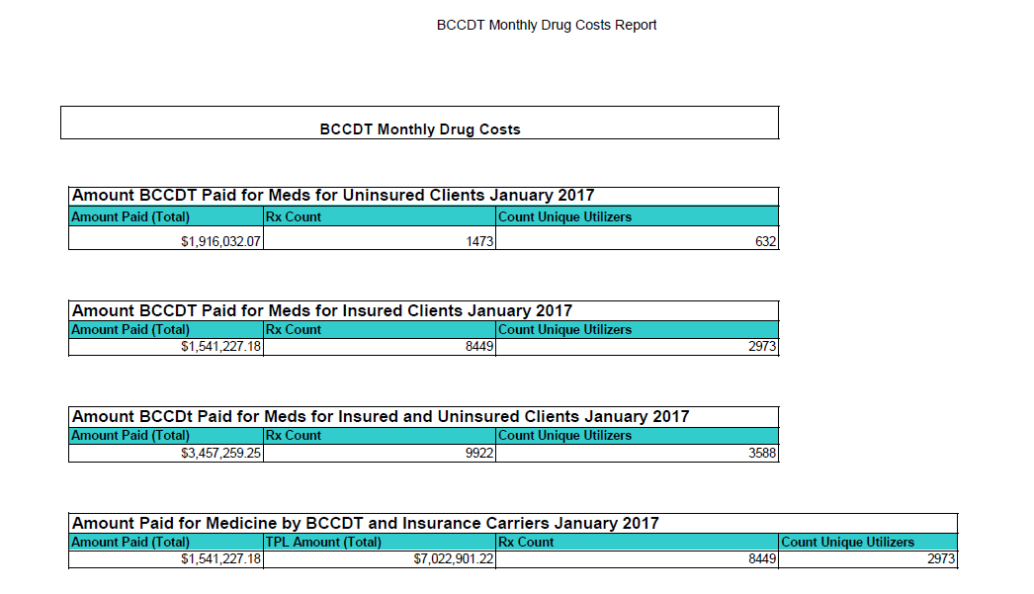

BCCDT Override Report
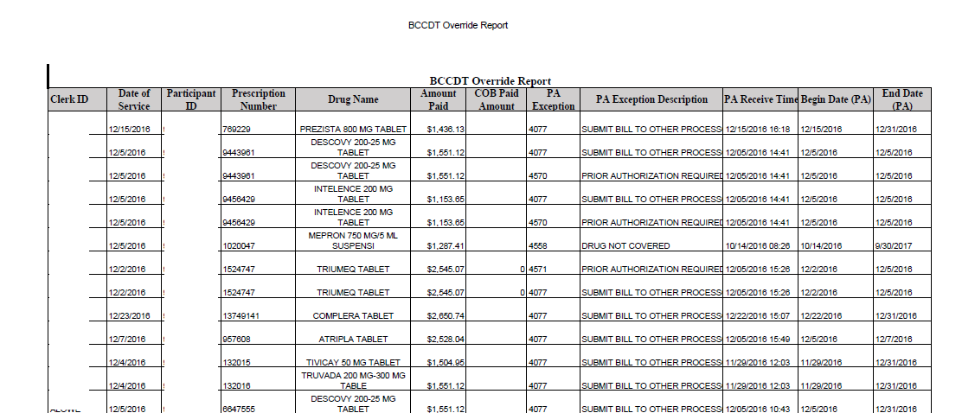

BCCDT PBM Override Report

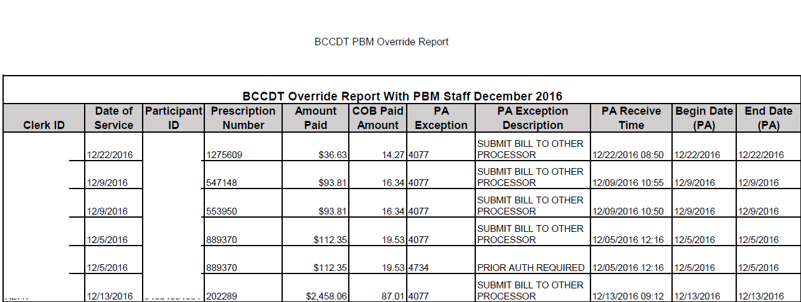

Top Pharmacies Ranked by Amount Paid
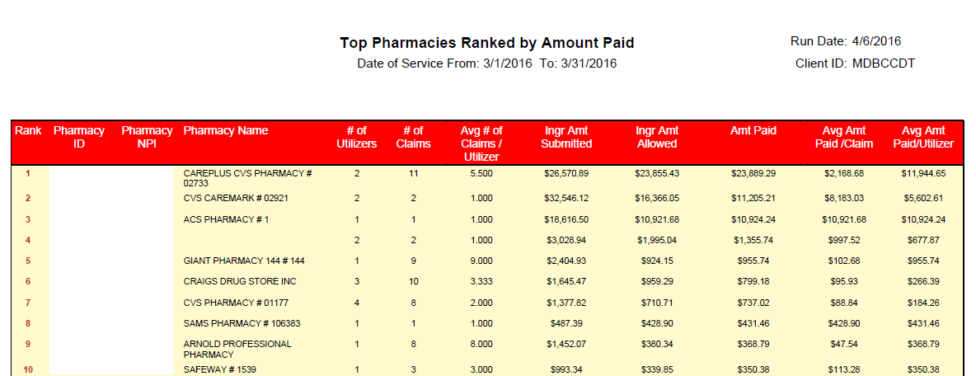

Top Pharmacies Ranked by Number of prescriptions
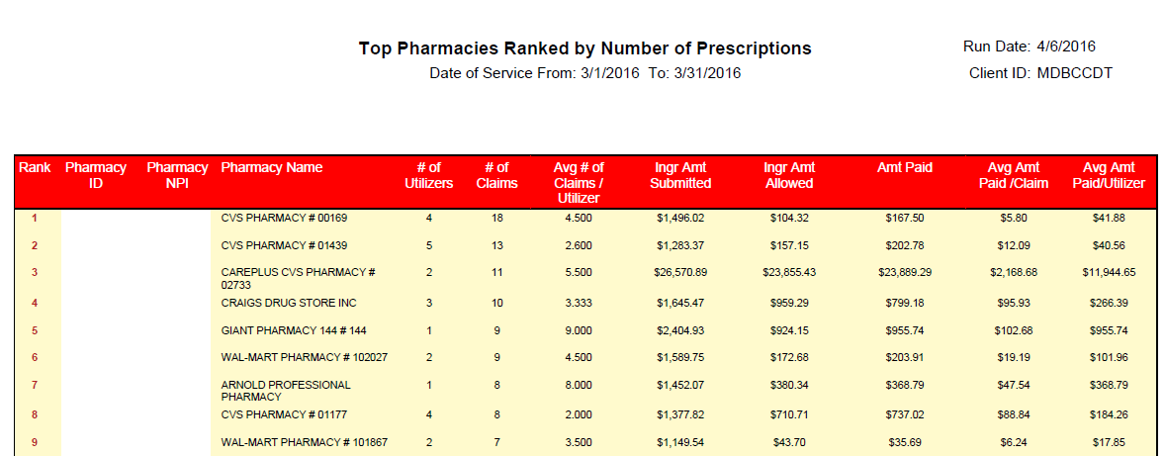

Top Prescribers of Controlled Substances Ranked by Number of Prescriptions
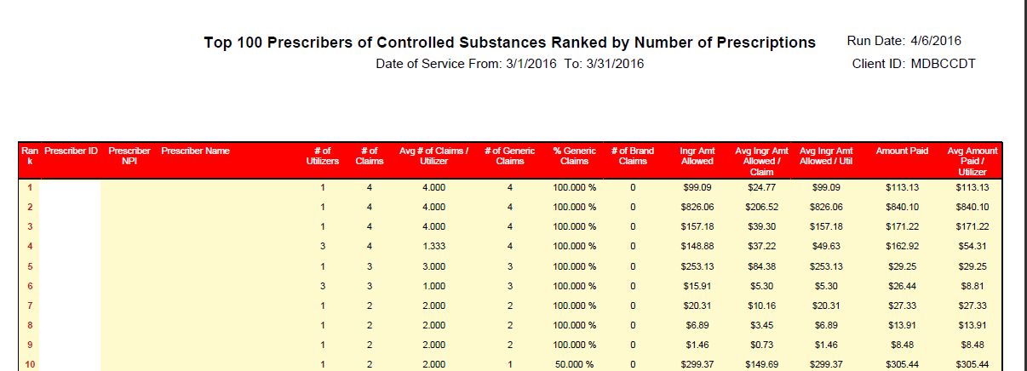

Top Utilizers Ranked by Amount Paid
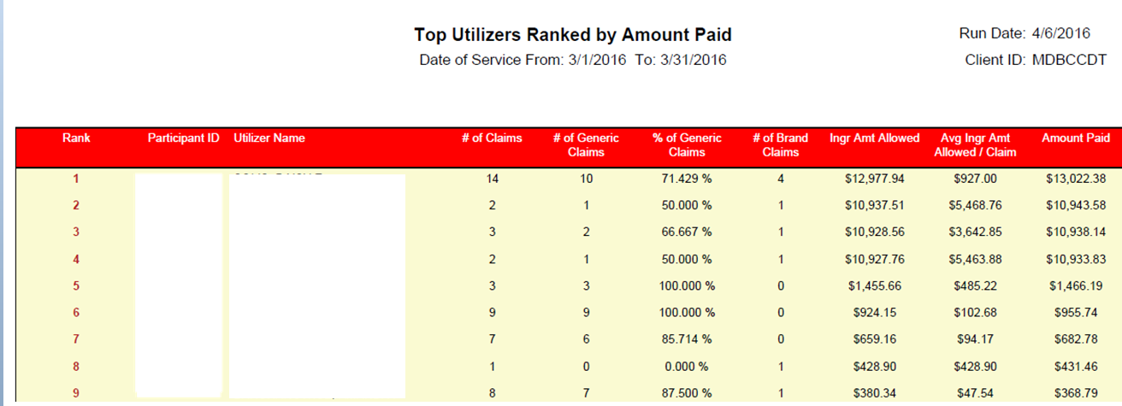

Top Utilizers Ranked by Number of Prescriptions
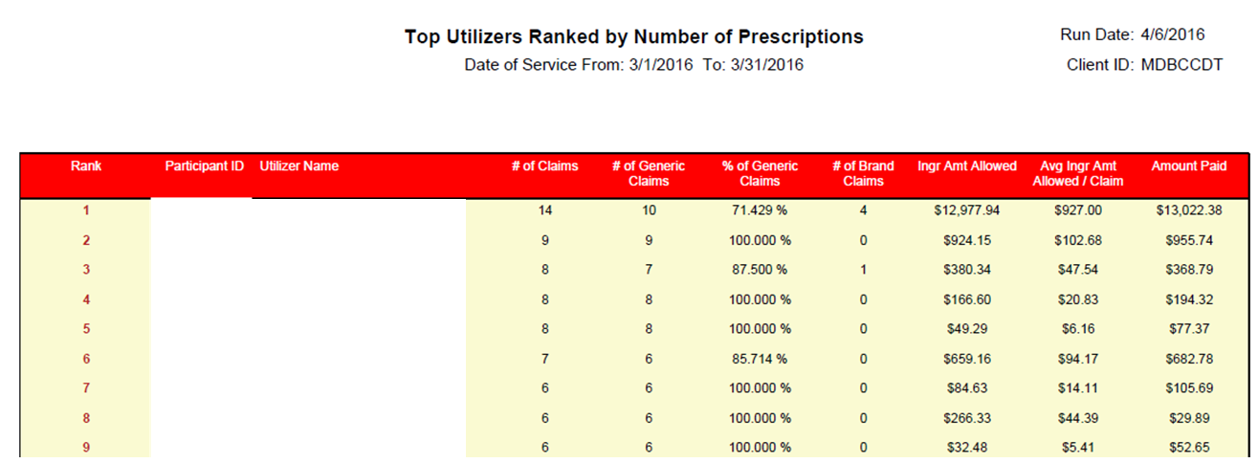

Top Utilizers of Controlled Substances Ranked by Number of Prescriptions
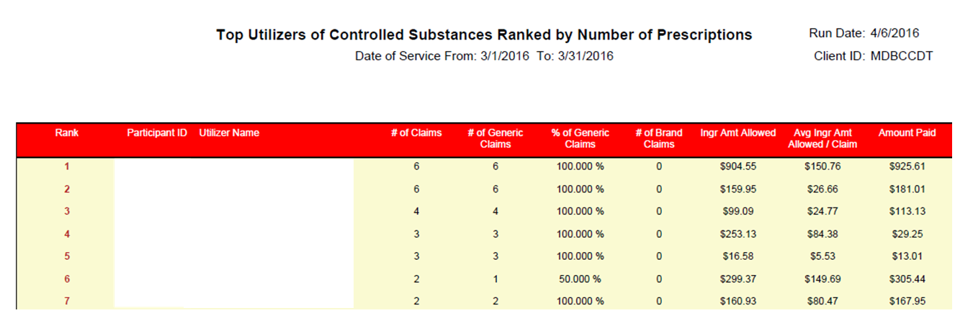

Top Prescribed Drugs Ranked by Amount Paid
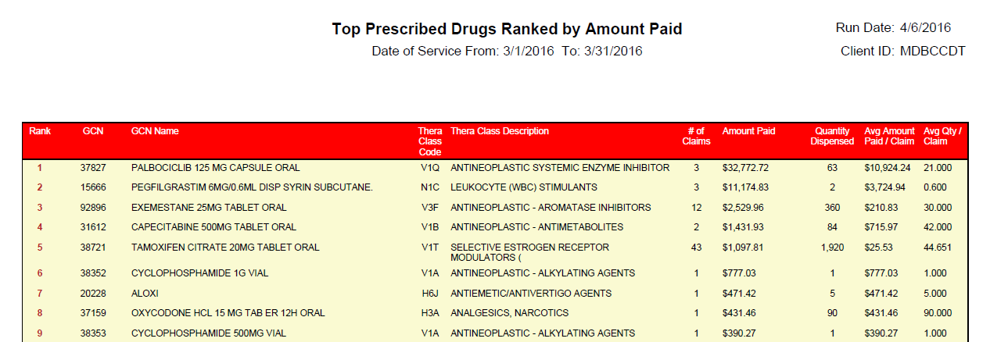

Top Prescribed Drugs Ranked by Number of Prescriptions
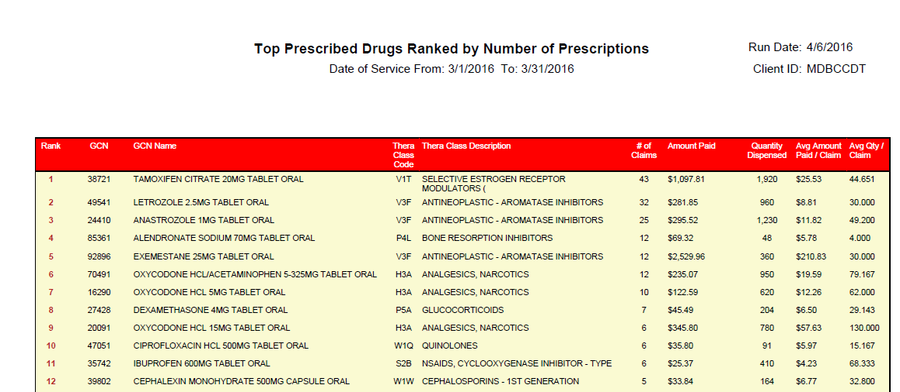

Top Prescribed Injectable Drugs Ranked by Amount Paid
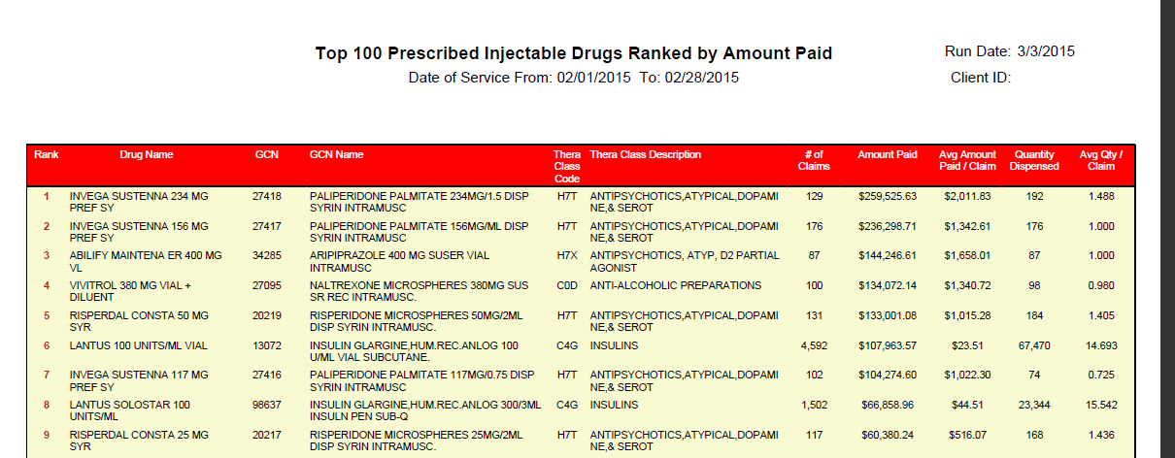

Top Therapeutic Classes Ranked by Amount Paid
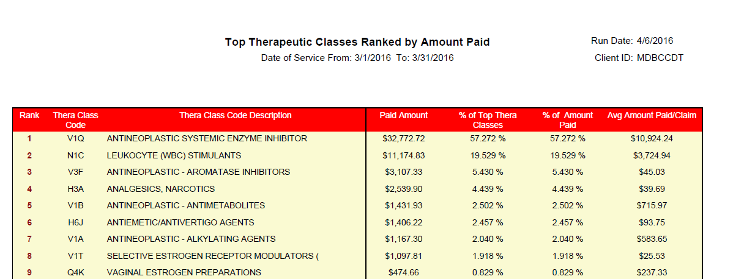

Top Therapeutic Classes Ranked by Number of Prescriptions
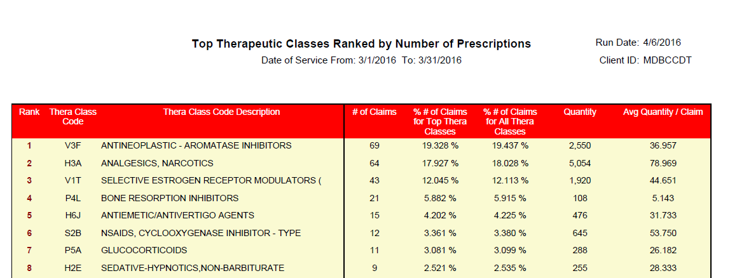

Claims Payment Summary
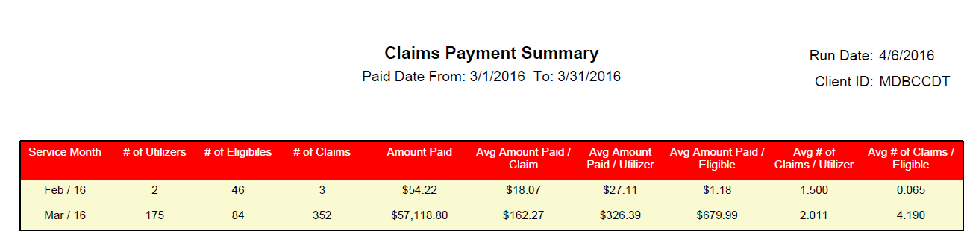

Monthly Prior Authorization Status
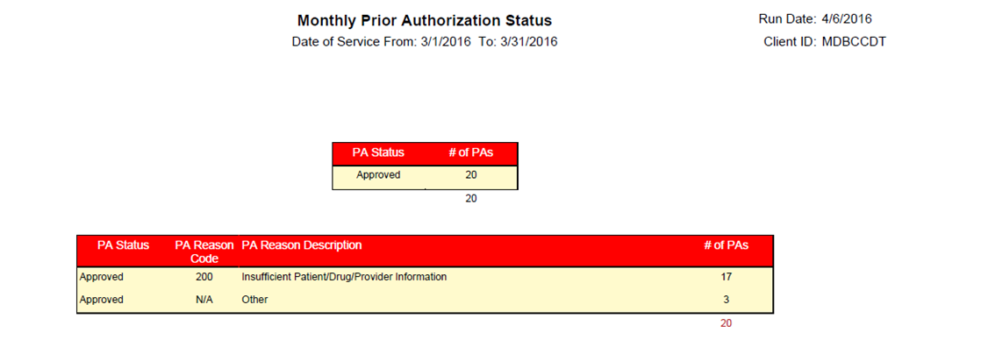

MDBCCDT Interface file load/update/Reconciliation Reports

Eligibility update report
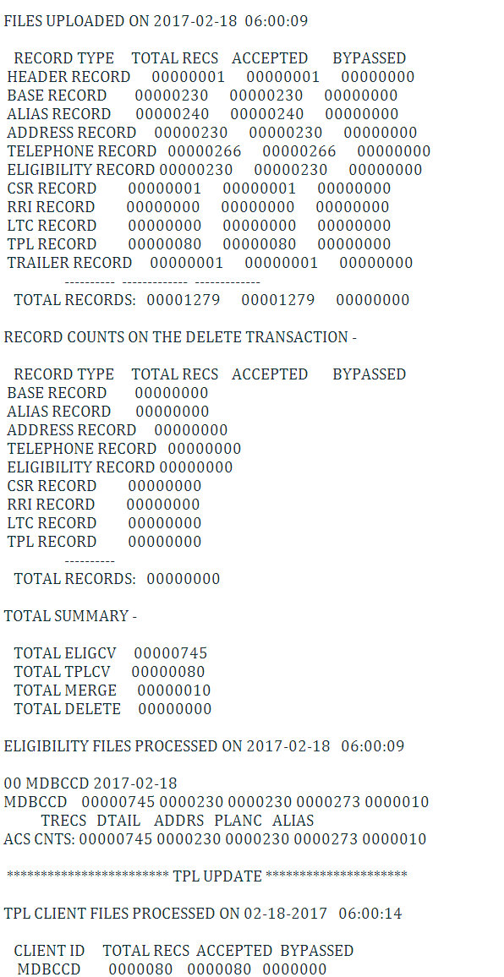

BCCDT Claims Extract Reconciliation Report
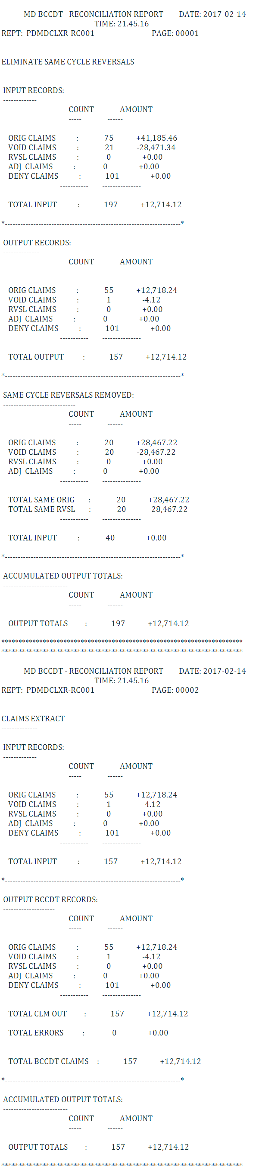

BCCDT Claims Error Reconciliation Report
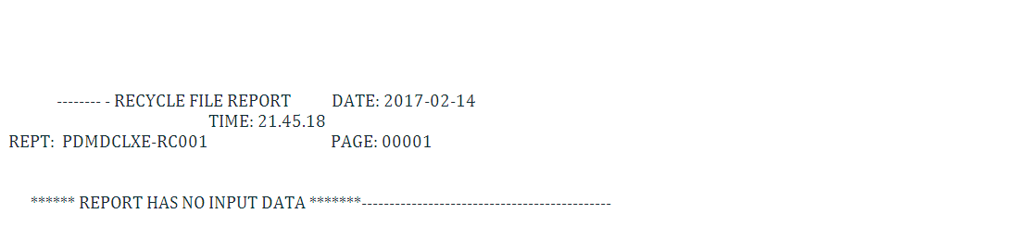

Reject Analysis Report
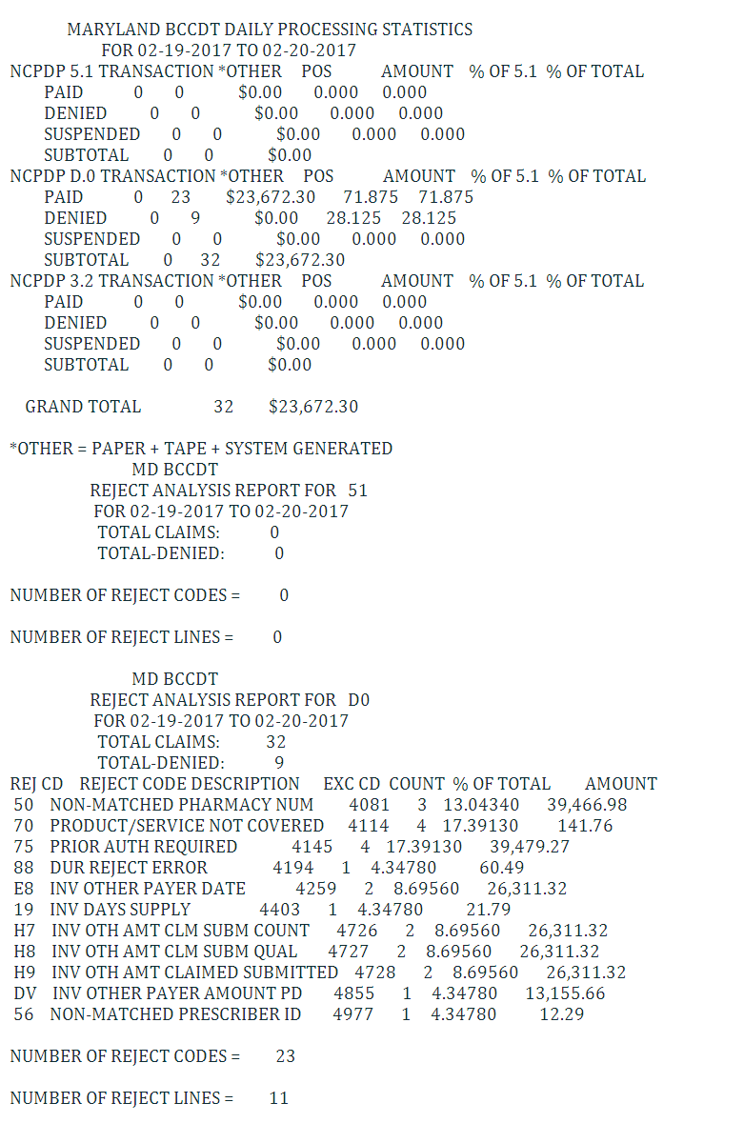

MDKDP

MDKDP Weekly Reports

Weekly Claims Data Entry Summary
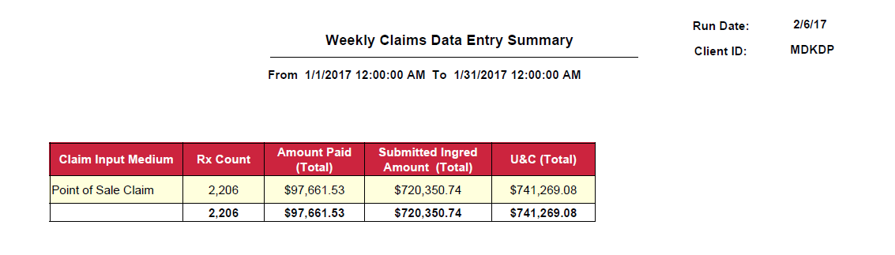

Weekly PA Drug Detail by Status Code
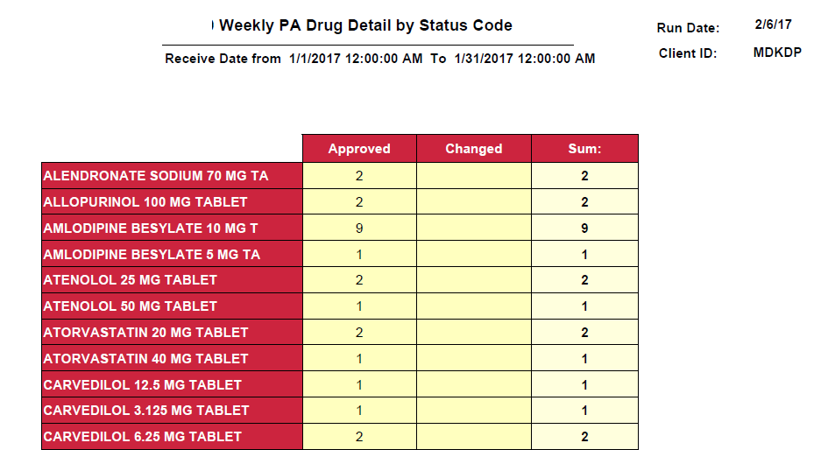

MDKDP Monthly Reports

Drug Audit Report Refill Too Soon Overrides
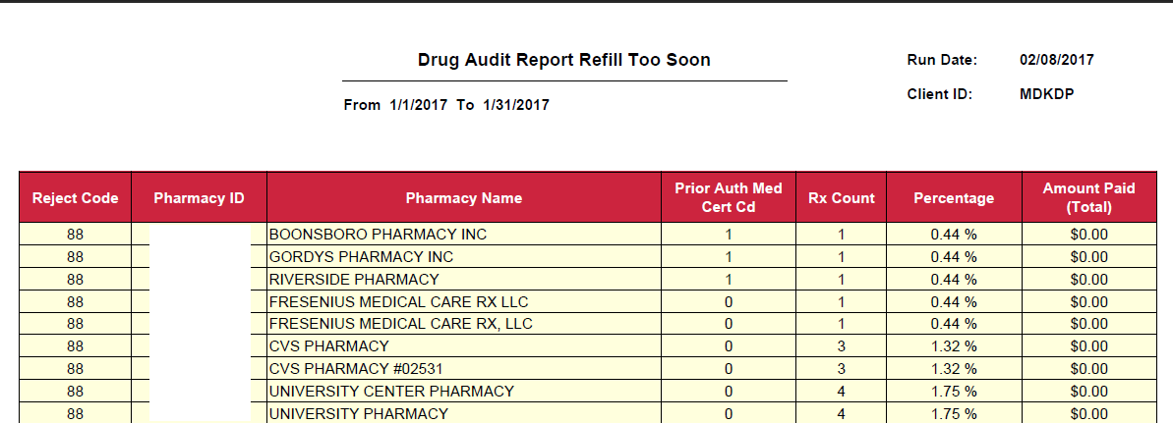

Drug Audit Report Duplicate Claim Overrides
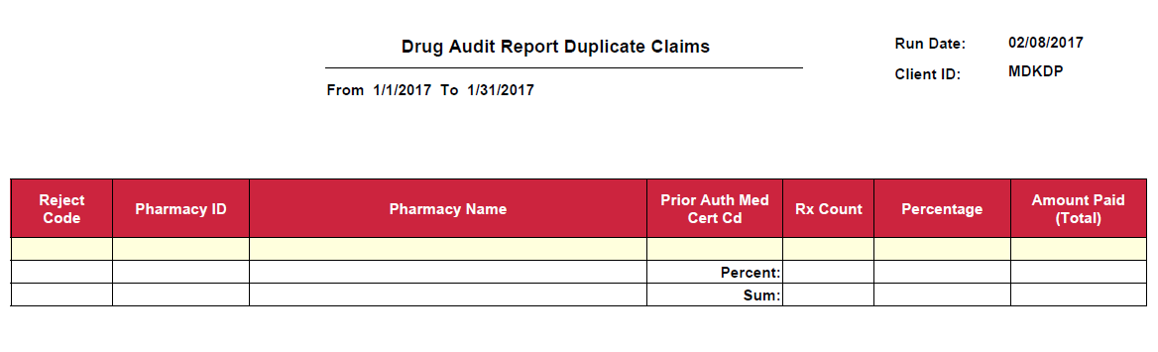

Drug Audit Report Maintenance Drugs with Less Than 10 Days Supply

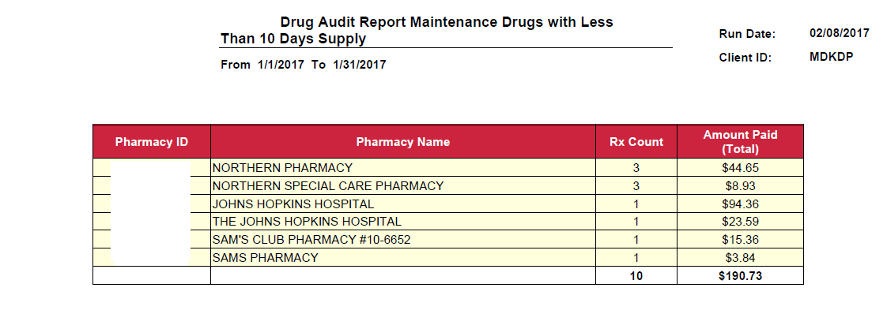

Drug Audit Report DAW 1 and DAW 4 Utilization
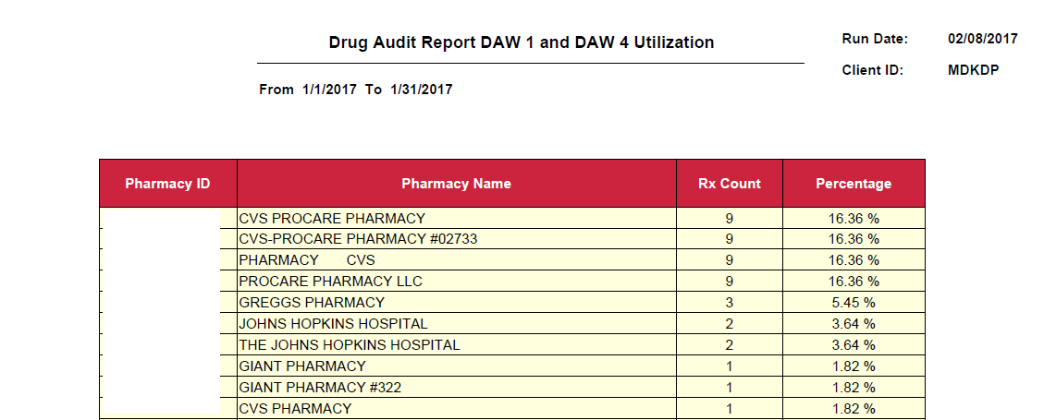

Claims Level Detail
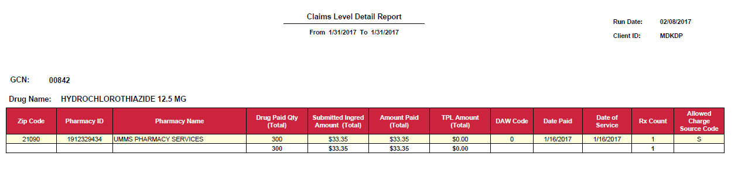

Controlled Substance (Provider)
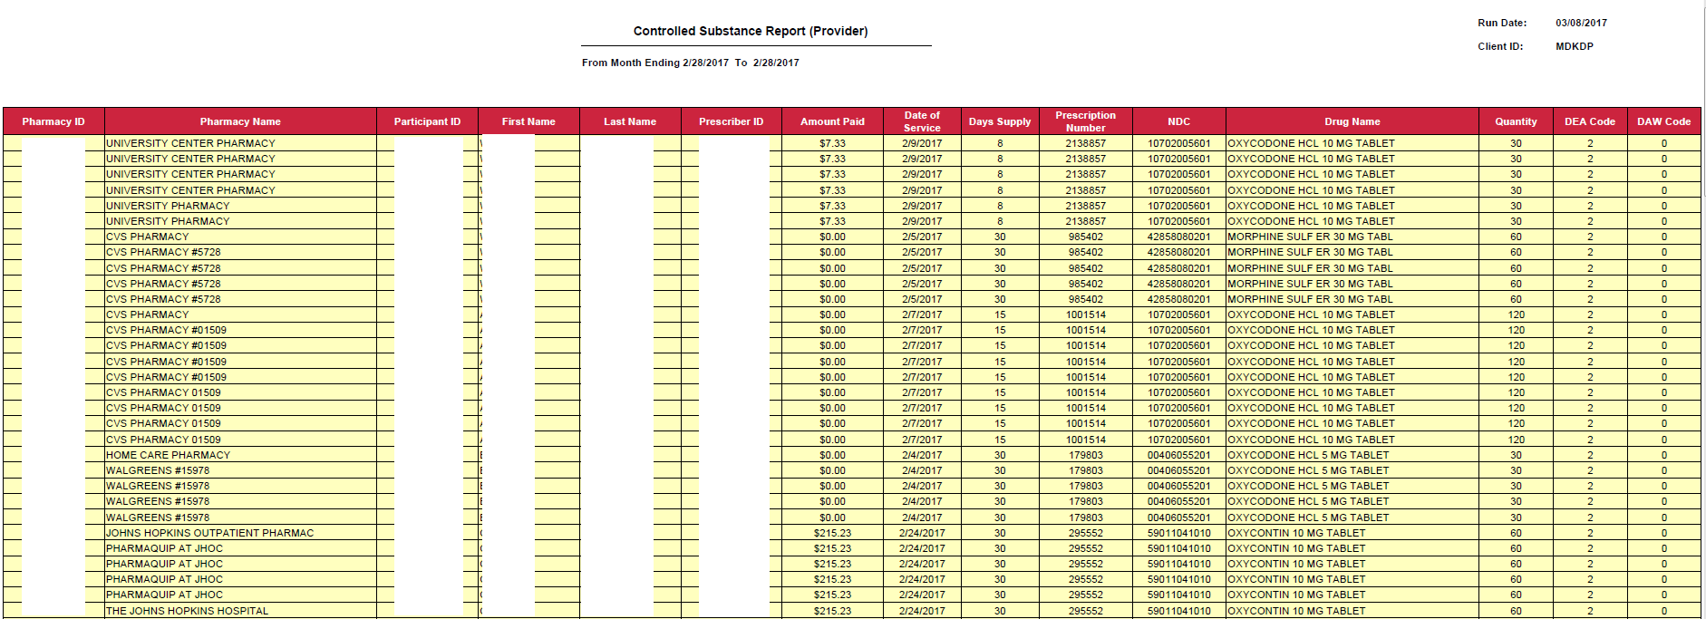

MDKDP COB Quarterly Report

COB_2_3_4_KDP Monthly

MDKDP Interface file load/update/Reconciliation Reports

Eligibility update report
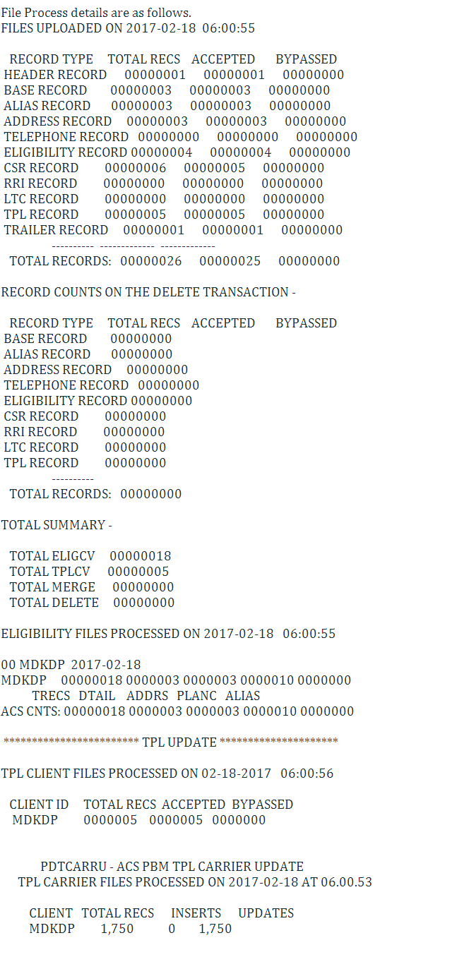

KDP Claims Extract Reconciliation Report
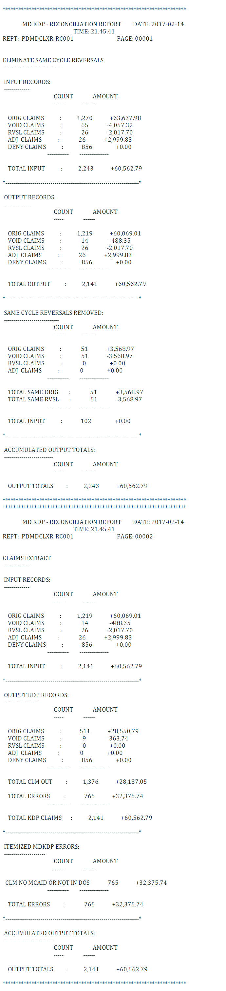

KDP Claims Extract Produced Errors
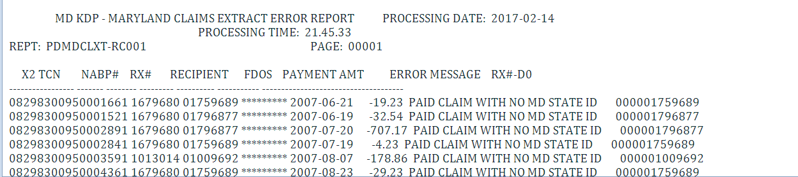

KDP Claims Error Reconciliation Report
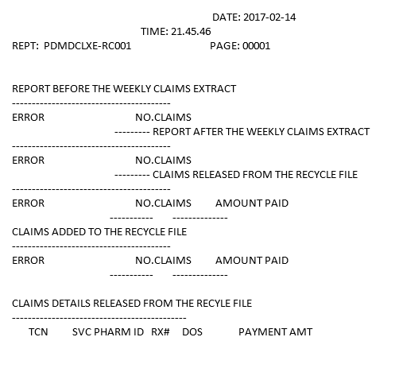

Reject Analysis Report
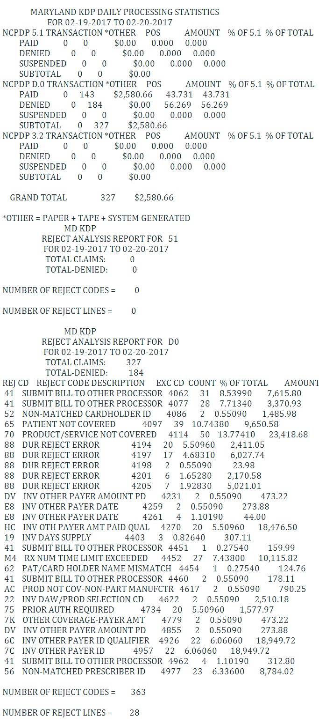

MADAP

MADAP Monthly Reports

MADAP MEDICAID Eligible Report
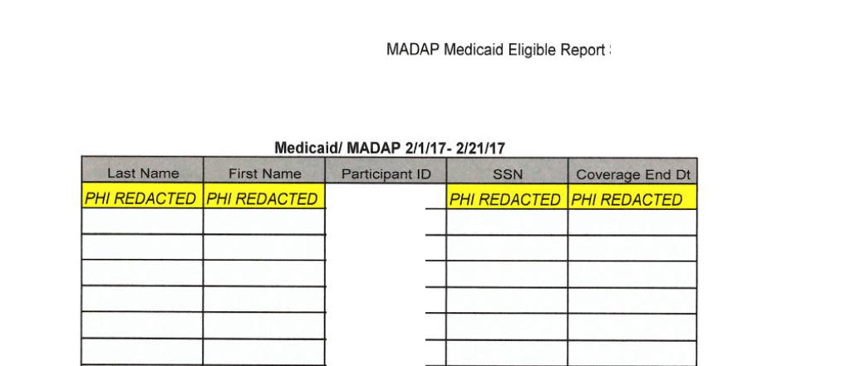

MADAP Active Insurance Report
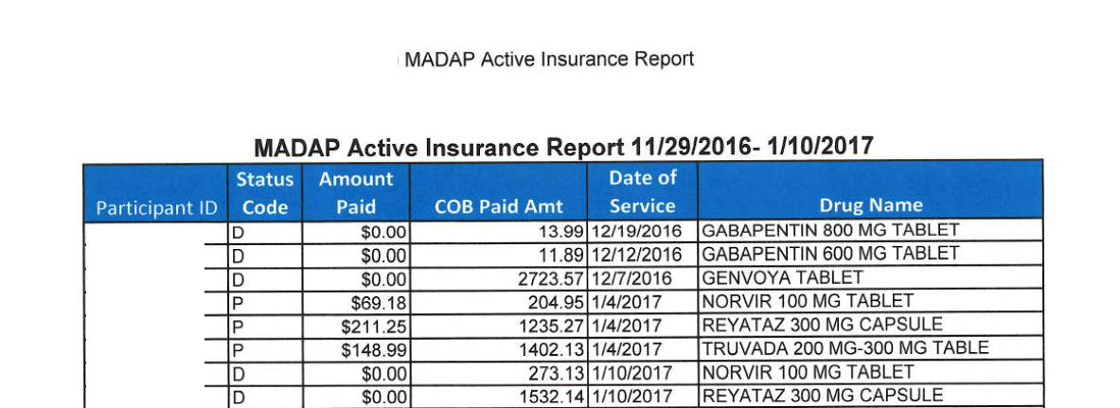

MADAP Override Report
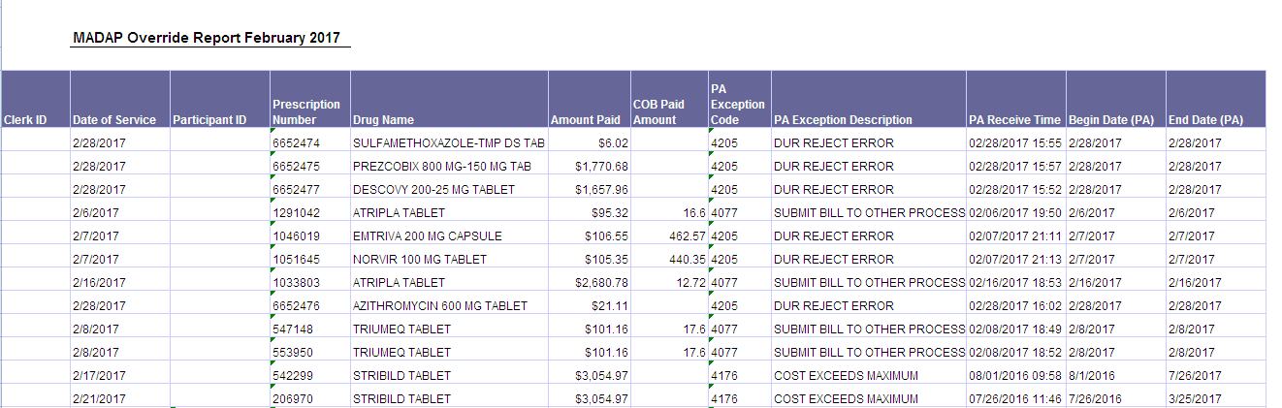

MADAP PBM Override Report
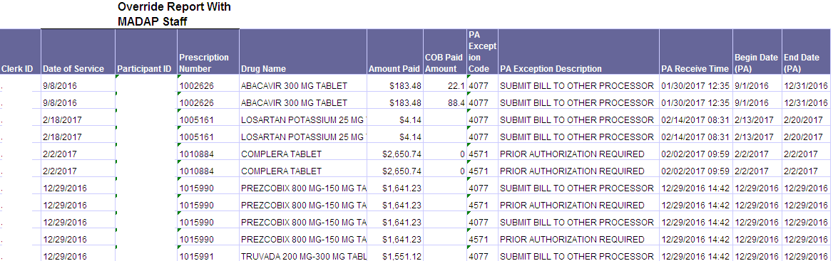

MADAP Insurance Problem Report
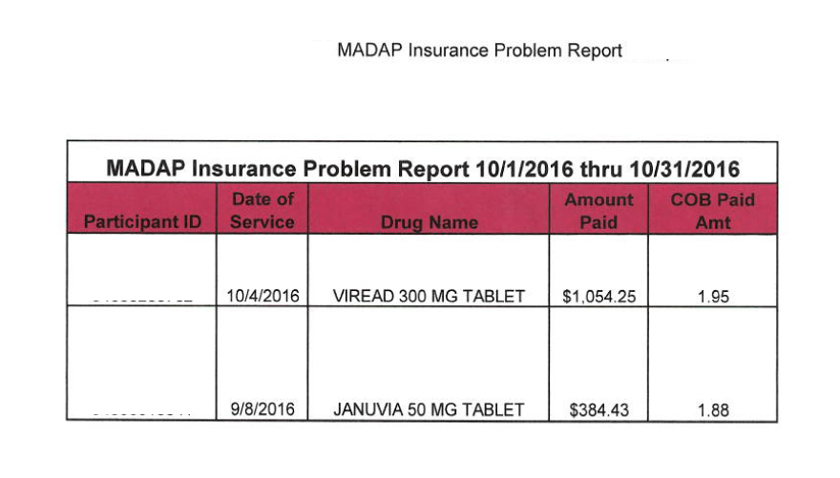

MADAP Monthly Drug Costs Report

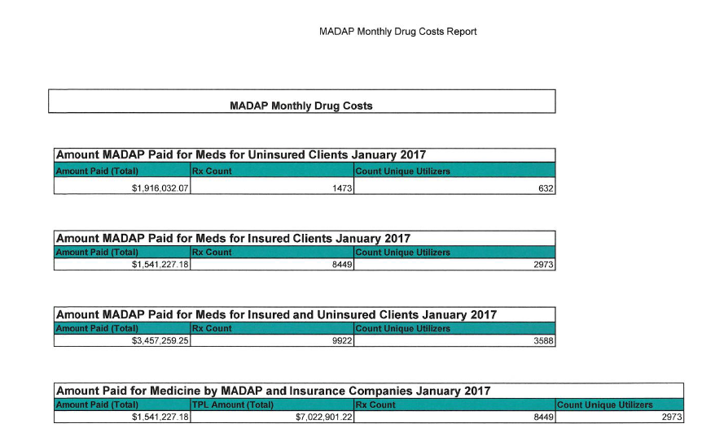

MADAP Interface file load/update/Reconciliation Reports

Eligibility update report
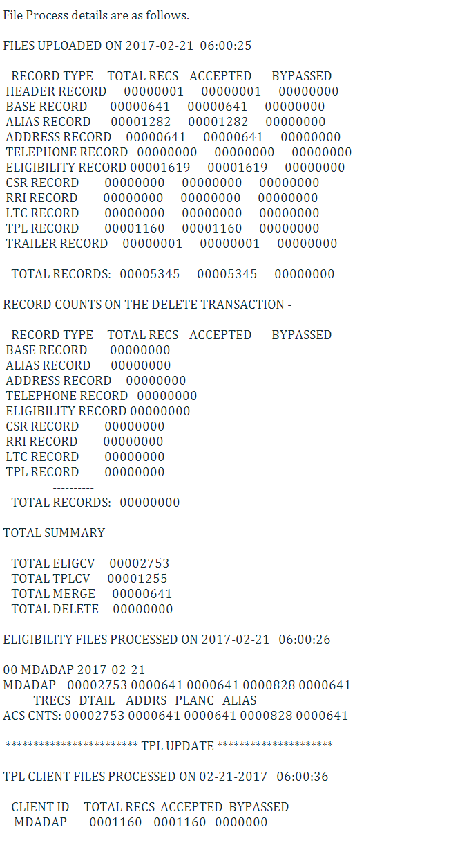

MDADAP Claims Extract Reconciliation Report
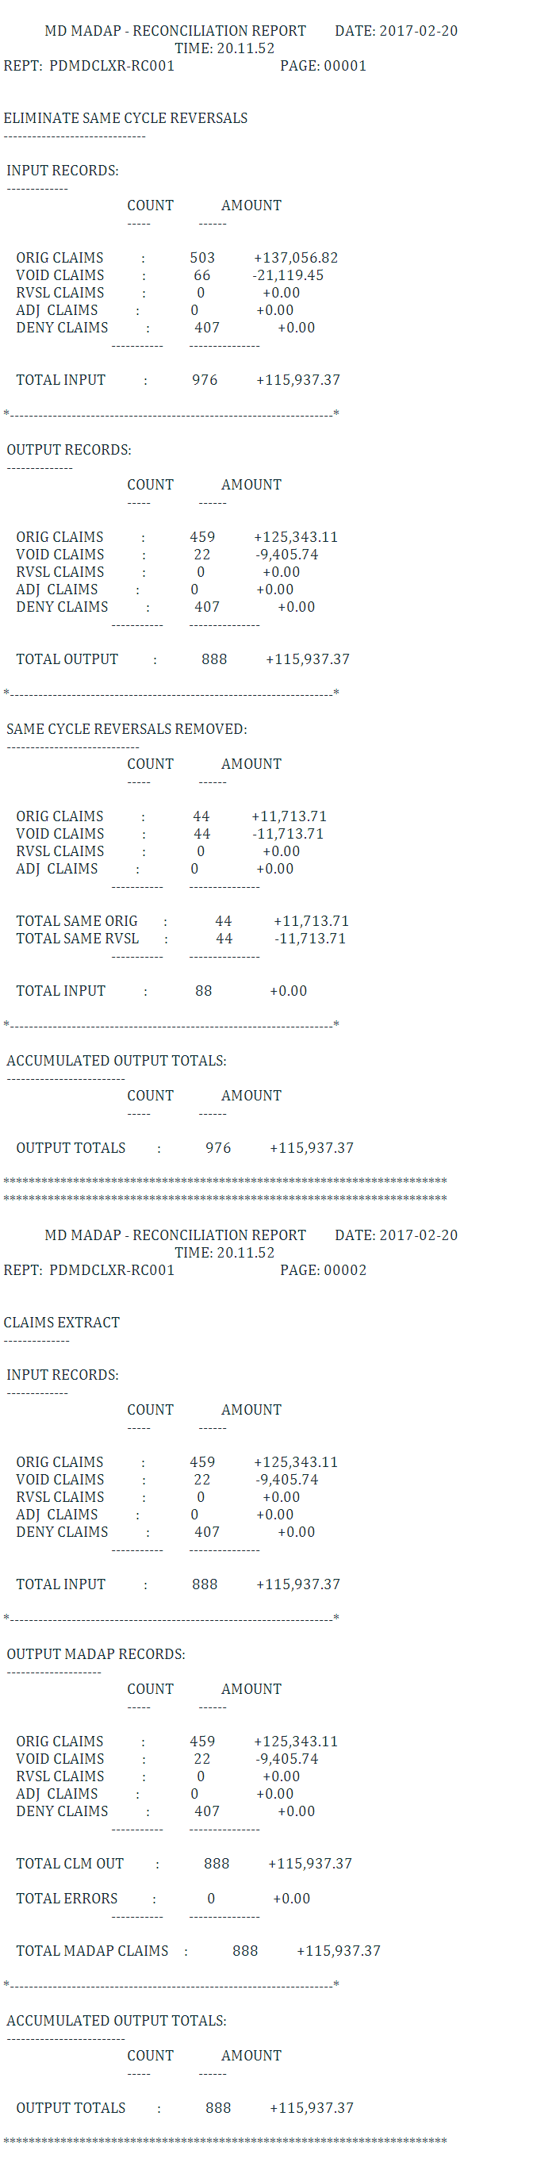

MDADAP Claims Error Reconciliation Report
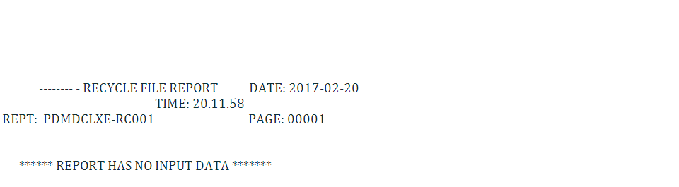

Reject analysis

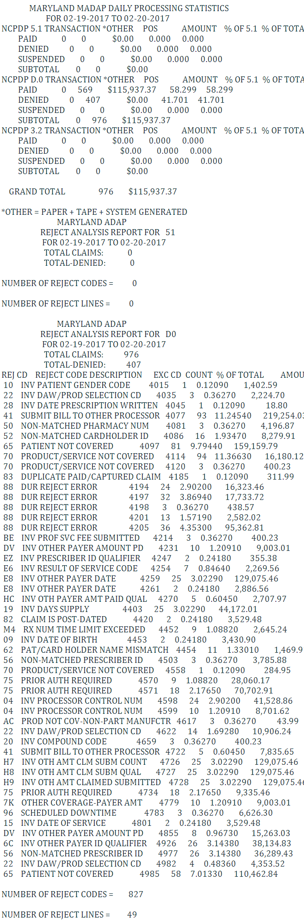

Call Center Reports

Call Center Monthly Reports

Call Center Stats
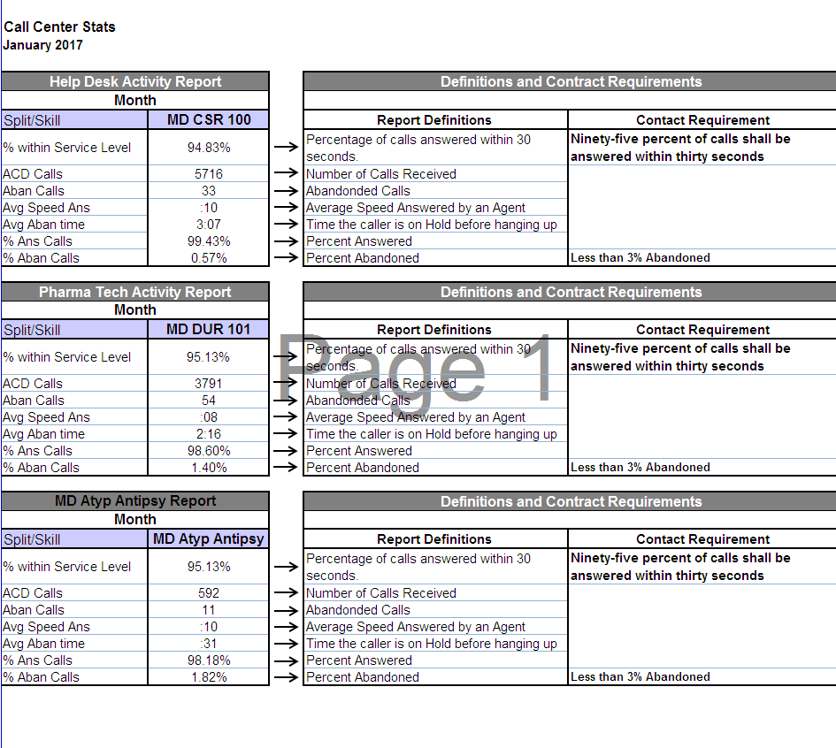

Busy Hour Report
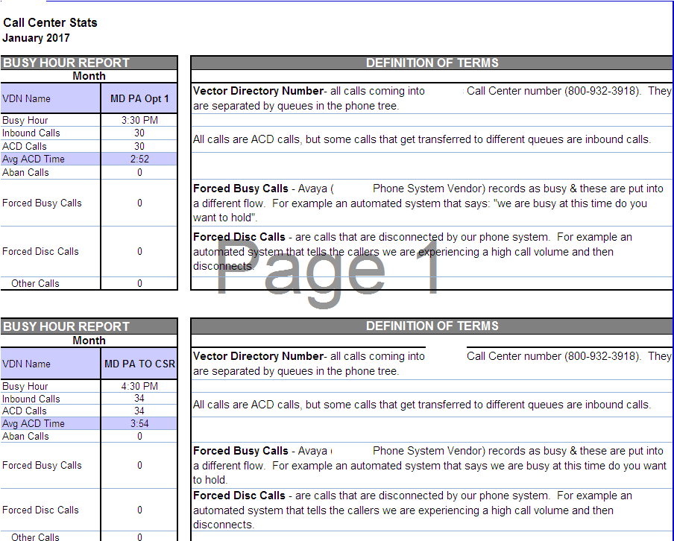

Fax SLA Report
