TO: DDA Providers

FROM: Developmental Disabilities Administration
Maryland Medicaid Administration

CC: DDA Regional Offices
DDA Provider Relations Directors

DATE: June 18, 2019

SUBJECT: ePREP Application Updates

This correspondence is to provide further clarification and guidance in reference to the ePREP application process. The DDA is aware that providers are in various stages of this process. Some providers are waiting for their Base Medical Assistance (MA) numbers. Some are awaiting instructions to proceed with entering their site-based applications.

The DDA and Medicaid will be hosting a webinar on July 8, 2019 at 2:00 pm, for providers to ask specific questions related to ePREP provider application process. We will also be able to clarify DDA's role and Medicaid's role related to the review process, communication, site visit, approval and next steps. Please see the provider Training and Webinar Calendar on the DDA website for registration. https://dda.health.maryland.gov/Pages/training.aspx

Please see the instructions and follow those that apply to your agency:

If you need to submit an Application:

- Contact your regional Provider Relations representative, via email, in your region. Email your PR representative your documents for review, prior to submittal, to ensure accuracy.
- Enter your application in the ePREP system and submit it, using the instructions from the DDA ePREP training session.

If you need to check your application status:

- Check your ePREP account for messages from ePREP and updates on your application status. We recommend checking twice a week during this enrollment process. Note: Communications do not come from Medicaid or the DDA. Review all ePREP communications via the ePREP messaging center to see whether corrections are needed.
- If corrections are needed, you will see them detailed in a Deficiency Notice. Make sure to address all items within the Deficiency Notice before resubmission.
- Respond to any ePREP requests for information or corrections as soon as possible. To avoid a rejection, providers must respond to all items within the Deficiency Notice within 60 days.

If your application is rejected or denied:

- Complete a new ePREP application immediately upon denial communication. You do not need to wait.
- Contact Teara Winmond, via email at teara.winmond1@maryland.gov to alert her that you have submitted a new application.

If you have received your Base Medical Assistance (MA) Number:

- Once you have received your Base MA number from ePREP, enter your site applications within two (2) weeks of receiving your Base MA number.
- Log in to ePREP and open your existing business profile.
- Go to the applications tab.
- Click New Application. Select “I’m new to Maryland Medicaid, and I want to create a new application.” Click Continue. (Do NOT select the option that says “I’m enrolled in Maryland Medicaid.”)
- Follow the same instructions used for the Base MA but use your site address as the service address:
- Select “I’m a facility, Clinic, Health Care Organization, or Waiver Provider. Click Continue.
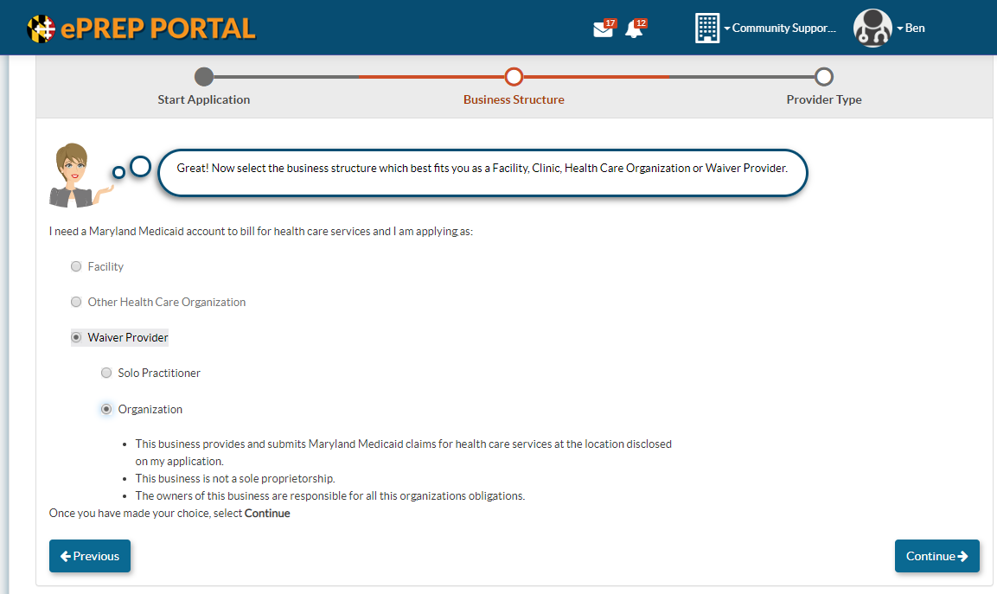
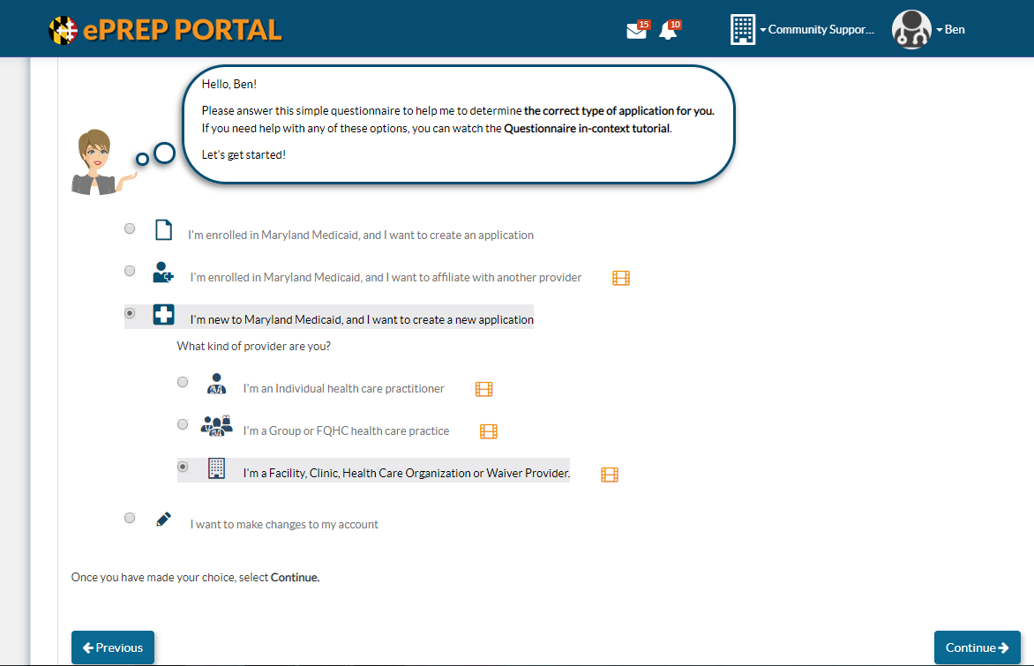
- Select “Waiver Provider” and “Organization.” Click Continue.

- From the dropdown menu, select “DDA Services Provider.” Click Continue. This will generate the application.

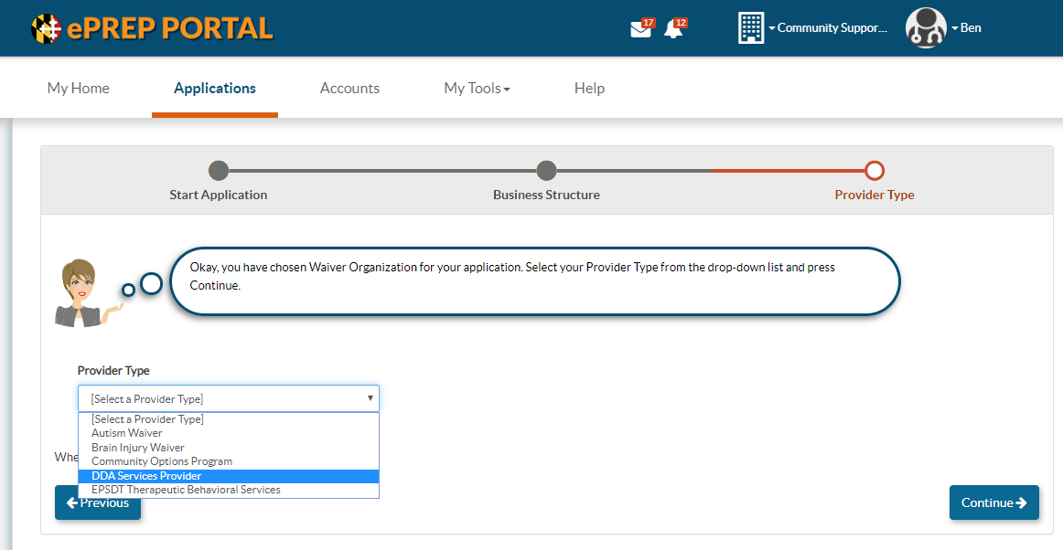

- Complete and attach the DDA Addendum for the site application:
  - On Page 2 of the Addendum select option 2 "DDA Licensed Site MA Application"
  - Select ONLY the Office of Health Care Quality (OHCQ) licensed services for that site (beginning on Page 5); no unlicensed services should be selected on this Addendum
  - ONLY select "Yes" for children's services if you have an OHCQ license for CHILDREN'S RESIDENTIAL services at this site.
  - Be sure that ALL services selected match the DDA licensed services on your DDA approval letter and OHCQ license for this specific site location ONLY.

- Include a copy of your DDA approval letter and OHCQ license that lists this specific site address and the selected services.
- Continue to check your ePREP application status in the ePREP system and promptly respond to any requests for information.

When will Medicaid visit my provider location?

- The site visits are unannounced. Therefore, ePREP and the DDA cannot provide you with an appointment for your site visit or tell you when it will be scheduled.
- Once the DDA reviews your ePREP application, it is referred to Medicaid's Site Visit Team for a visit to your corporate office.
- Once referred to the Site Visit Team, visits usually occur within three weeks.
- Once your visit is complete, you may receive a Deficiency Notice via ePREP Message Center if any additional information is needed.
- If you receive a Deficiency Notice, see notes on Page 1. Please check your ePREP application status within the ePREP system at least twice a week to check for communications.
- It may take a few weeks to complete application processing before Medicaid issues an MA number.
- If you are concerned that there is an issue, please contact Teara Winmond via email at teara.winmond1@maryland.gov to ensure that your application is awaiting a site visit.

Calling the ePREP Helpdesk 1-844-463-7768

- When you contact the ePREP helpdesk, please note that you will be asked for an NPI number. This is standard practice.
- Please say, I am a DDA "atypical" provider and I do not have an NPI.
- They will then ask for an alternate type of identification. Be prepared with you Tax ID Number for identification purposes.
- If just need general information, not specifics about an application, you can say, "I have a general question" and skip the account verification step.

Helpful links:

- ePREP Helpful Information: health.maryland.gov/eprep
- State Department of Assessments and Taxation (SDAT): https://egov.maryland.gov/BusinessExpress/EntitySearch

Provider Relations Contact information:

Contact your regional Provider Relations representative in your region to have your documents reviewed for accuracy. Additionally, if you need an ePREP training, contact your representative below.

SMRO- Bianca Renwick Bianca.Renwick@maryland.gov

CMRO- Renellda Moore Renellda.moore@maryland.gov

ESRO- Andrea Jones Andrea.Jones@maryland.gov

WMRO- Timothy Jenkins Timothy.Jenkins@maryland.gov

