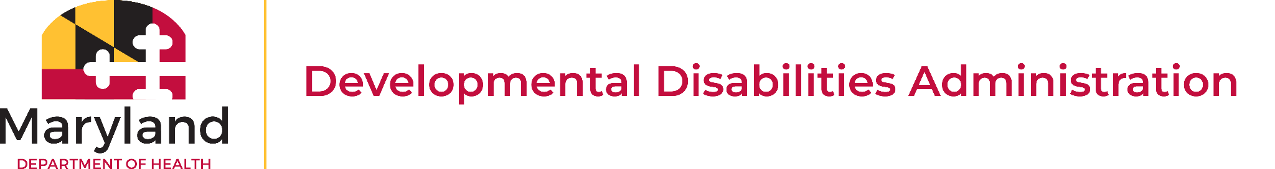

Technology First Initiative Overview

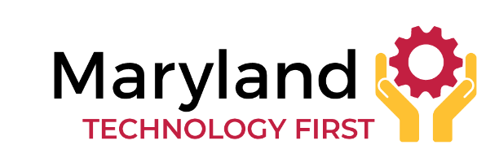
On Aug. 15, 2022, the Governor of Maryland issued a proclamation declaring Maryland a Technology First State. The Technology First initiative promotes the idea that assistive technology and enabling technology should be considered first when supporting people with disabilities, helping them live, work, learn, and participate in their communities with greater independence.
The proclamation reflects Maryland's commitment to ensuring that people with disabilities access technology that enhances their ability to pursue their own vision of a good life, including opportunities to:
- Live as independently as possible;
- Make informed choices about their lives;
- Participate fully in education, employment, and community activities; and
- Increase independence, communication, mobility, and self-determination through technology.
Rather than viewing technology as an optional add-on, the Technology First approach encourages service providers, policymakers, educators, and support professionals to consider technology as a primary support whenever appropriate, alongside other services and supports.

DDA Waiver Services:
- Assistive Technology Services: “Assistive Technology” or “AT” is an item, computer application, software, piece of equipment, or product system that maintains or improves a person’s functional ability and promotes their ability to live independently and meaningfully participate in their community.
  - (Examples: Assistive technology assessments, iPads, weighted spoons, screen readers, apps, social stories, GPS maps, scheduling).

- Remote Support Services: Remote Supports provide oversight and monitoring within a person’s home through an off-site electronic support system to reduce or replace the staffing a person needs while ensuring their health, safety, and welfare.
  - (Examples: Emergency alert sensors, two-way communication, remote monitoring, voice-activated appliances).

MD Resources:
- Access Maryland works closely with project engineers, architects, and construction managers to ensure that individuals with a range of physical disabilities can fully interact and engage with buildings, parks, universities, and other state-owned facilities across the state.
  - https://mdod.maryland.gov/accessmd/Pages/Access-Maryland-Home.aspx

- Arc Tech Toolbox is a place to find, share, rate, and review technology for people with intellectual or developmental disabilities (I/DD).
  - https://toolbox.thearc.org/

- Maryland Division of Rehabilitation Services (DORS) - If enrolled in DORS services, funding can be provided for work-related technology based on need (e.g., desktop or portable video magnifiers, note-taking devices, specialized software, etc.)
  - https://dors.maryland.gov/consumers/WTC/RTS/Pages/AT.aspx

- Kennedy Krieger Assistive Technology Clinic - Kennedy Krieger's Assistive Technology Clinic, innovative technologies, and the expertise of its specialists allow children and adults with I/DD to enjoy many of the same activities as their peers.
  - https://www.kennedykrieger.org/patient-care/centers-and-programs/assistive-technology-clinic

- Maryland Access Point (MAP) - MAP is Maryland’s No Wrong Door Aging and Disability Resource Center, established as the single entry point for older adults and people with disabilities who need community resources for long-term care planning and independent living. Trained MAP specialists work with individuals, caregivers, and professionals to plan and assist with identifying and accessing both private and public-sector supports on available health, transportation, financial aid, nutrition, medication, housing, and other programs and services.
  - https://aging.maryland.gov/programs-and-services/maryland-access-point

- Maryland Assistive Technology Program (MDTAP) offers AT libraries across the state, AT demonstrations, consultations, short-term device loans, a high-tech AT Reuse Center, training, webinars, and a low-interest financial loan program.
  - https://mdod.maryland.gov/mdtap/Pages/MDTAP-Home.aspx
- Mobility Link All Access – Maryland Transit Administration Mobility has expanded its service to customers with Mobility All Access, an online desktop and mobile phone software application that significantly enhances online services like ride bookings, lookups, and trip cancellations. Mobility All Access replaces PassWeb, the previous application used to book mobility trips, and expands its capabilities to smartphones as well.
  - https://www.mta.maryland.gov/mobility-all-access

Additional Resources:
- Assistive Technology Industry Association (ATIA) is a resource that gathers research information on assistive technology products.
  - https://www.atia.org/home/at-resources/

- Assistive Technology Resource Roundup - This resource provides websites, blog posts, articles, and videos that highlight personal experiences of people who use various AT products.
  - https://www.edutopia.org/article/assistive-technology-resources/

- Home Modification Self-Help Guide - This is a state guide to home modification providers and resources.
  - https://www.peoples-law.org/home-modification-self-help-guide

- National Organization of Home Modifications - Information on home modifications, what to look for, vendors, and funding resources.
  - https://homemods.org/national-directory/

- Partnership on Employment and Accessible Technology (PEAT) - Information on combining technology with services to create inclusive workspaces.
  - https://www.peatworks.org/

