MENTAL HEALTH ADDICTIONS ADVISORY COUNCIL

FY 2018-2020 Strategic Plan

Vision

The Mental Health and Addictions Advisory Council of Harford County envisions a comprehensive, culturally-sensitive and recovery-oriented substance use disorder and mental health system in Harford County.

Mission

The Mission of the Council is to expand, strengthen, and sustain an integrated and comprehensive prevention, intervention, and treatment services system to reduce the incidence and consequences of substance abuse and mental health problems in Harford County.

Overview

Strong partnerships and positive collaboration are the foundation for developing the substance use disorder and mental health systems in Harford County. This collaboration occurs with multiple systems, agencies, and people. To develop and improve the overall delivery of behavioral health services in Harford County, the Harford County Health Department, Harford County Department of Community Services/Office of Drug Control Policy, and Office on Mental Health/Core Service Agency work with strategic partners such as consumers of substance use disorder/mental health services, family members, providers, the Maryland Department of Health’s (MDH) Behavioral Health Administration, Harford County Mental Health and Addictions Advisory Council, Harford County District & Circuit Courts, Local Law Enforcement Departments, Harford County Detention Center, Harford County Board of Education, Department of Social Services, Department of Juvenile Services, Harford County Public Library, Harford County Local Management Board, and faith-based agencies.

As the foundation, the Harford County FY18-20 Strategic Plan is based on principles set forth by the Substance Abuse Mental Health Services Administration (SAMHSA) and mirrored by the State of Maryland MDH. SAMHSA states that behavioral health is essential to the Nation’s health – for individuals, families, and communities, as well as for the Nation’s health delivery systems. Further, our country and within each community, can make a difference in its health, justice, social services, educational, and economic systems by addressing the prevention and treatment of mental and substance use disorders and related problems. To guide the country, SAMHSA has identified six strategic initiatives (http://www.samhsa.gov/about/strategyExt.aspx).

SAMSHA’s Strategic Initiatives

- Prevention of Substance Abuse and Mental Illness: Through this initiative, SAMHSA promotes and implements prevention and early intervention strategies to reduce the impact of mental and substance use disorders in America’s communities. This initiative includes a focus on several high-risk populations, including:
- Transition-age youth
- College students
- American Indian/Alaska Natives
- Ethnic minorities experiencing health and behavioral health disparities
- Service members, veterans, and their families
- Lesbian, gay, bisexual, and transgender (LGBT) individuals
- Health Care and Health Systems Integration: Health care and health systems integration aims to ensure that behavioral health care services are more accessible and connected to the broader health care system. This initiative focuses on:
- Increasing access to appropriate high quality prevention, treatment, recovery, and wellness services and supports
- Reducing disparities between the availability of services for mental illness (including serious mental illness) and substance use disorders compared with the availability of services for other medical conditions, including those for people from minority populations who experience significant health disparities
- Supporting coordinated care and services across systems
- Trauma and Justice: This initiative addresses the behavioral health needs of people involved in - or at risk of involvement in - the criminal and juvenile justice systems. Additionally, it provides a comprehensive public health approach to addressing trauma and establishing a trauma-informed approach in health, behavioral health, human services, and related systems. The intent is to reduce both the observable and less visible harmful effects of trauma and violence on:
- Children and youth
- Adults
- Families
- Communities

- Recovery Support: This initiative will promote partnering with people in recovery from mental and substance use disorders and their family members to guide the behavioral health system in:
- Promoting individual, program, and system-level approaches that foster health and resilience
- Increasing housing to support recovery
- Reduce barriers to employment, education, and other life goals
- Securing social supports in their chosen communities
- Health Information Technology: This initiative advances the use of health information technologies to support integrated behavioral health care and its potential to transform the health care system. It encourages the general health care delivery system in the adoption of Health Information Technology (HIT) and interoperable Electronic Health Records (EHR) by states, community providers. This will help practitioners across the spectrum provide:
- High-quality integrated health care
- Appropriate specialty care
- Improved patient and consumer engagement
- Effective prevention and wellness strategies

Workforce Development: This initiative will support active strategies to increase the supply of trained and culturally aware preventionists, health care practitioners, paraprofessionals and peers to address the behavioral health needs of the nation. It will also improve the behavioral health knowledge and skills of those health care workers not considered behavioral health specialists. To help meet behavioral health needs within America’s transforming health promotion and health care delivery systems, this initiative will monitor and assess the needs of:
- Youth
- Young adults
- Young adult and adult peers
- Communities
- Health professionals

Analysis of Jurisdictional Needs

Demographics
Harford County is comprised of 440 square miles, is bordered by Pennsylvania, the Chesapeake Bay, and Cecil and Baltimore Counties. Harford County has the seventh largest population in the State of Maryland, which is 4.4% of the state population. The Harford Planning and Zoning Department reports the 2015 estimated population is 250,025 with an estimated 2020 population to be 258,670. The average age of a Harford County citizen is 40.5 years of age which is a little higher than the state average of 38.3 years of age.

Demographics of Harford County’s population is 79.5% white, 14% black or African-American, 4% Hispanic, 3% Asian, and 3.5% of more than two races.

Wealth of the county population is a major consideration for substance use disorder/mental health planning. Harford County has 92,662 households and the average median household income is $78,050, slightly higher than the average for the State. According to the Department of Health and Mental Hygiene (FY2012), 30,050 Harford County residents were enrolled in Medical Assistance. The number of children living in single parent homes has increased steadily, which will increase the chances that a child will live in poverty. In addition, the number of families in need of public assistance has increased. Those individuals living below the poverty line in Harford County is estimated at 7.4%.

Treatment data/needs:

Based on the most recent data available through the Maryland Behavioral Health Administration (BHA):

- Based on current treatment data , it is estimated that about 7,500 Harford County residents have a substance abuse problem requiring treatment.

- Through May 30, 2015 (FY 15), 1,312 residents received treatment in State-supported facilities; 483 in non-state-supported facilities. These numbers are unduplicated counts meaning that if a person was admitted two or more times, they were only counted one time.
  - The demographics of these residents include:
    - 40% women
    - 5% adolescents
    - 23% African-Americans, Hispanic, or individuals of other minority groups
    - 43% with co-occurring mental health problems
    - 56% without employment or disabled

Mental Health data/needs:

In FY 2016, the public mental health system served 8,205 people; 2,679 children/adolescents, 510 transitional aged youth, and 5,016 adults. Of these, 873 were new to the public mental health system, for an increase of 11.9% from FY15. The Office on Mental Health monitored $28.7 million through the PBHS and provided $3.3 million in grant funds for services and programs in the County. One of the key components of the Mental Health system in Harford County is the Mobile Crisis Team which handled 1,497 crisis calls and responded to 899 persons in crisis, and provided 196 medical evaluations with OIC Counseling.

In January, 2017, the Harford County Department of Community Services conducted a point in time study to capture data on people who are homeless in Harford County. 189 people were identified as being homeless, many of which reported behavioral health issues.

DATA CHARTS:

The Mental Health and Addictions Advisory Council is comprised of representatives from the consumers of addiction/mental health services, family members, substance use disorder/mental health providers, Harford County Health Department, Office on Mental Health/Core Service Agency, Judicial and Criminal Justice, etc. A workgroup has been selected to review the bylaws and discuss changing the group’s name.

The Harford County Health Department is the Local Addictions Authority for the county and is responsible for planning, managing, and monitoring publicly funded substance use disorder services.

A review of the following data was used to help gain an overall understanding of the addiction problems. As shown below, in 2016, Harford County is 7th highest in the state for total drug and alcohol related intoxication overdose deaths and 7th in the state for heroin related intoxication deaths. This continues to be a concern. Thus far in 2017, Harford County has lost 46 people to overdose deaths but potentially saved 233 persons through Harford County Health Department’s Narcan initiative, and this number does not include those lives saved from other entities such as EMS, hospital, etc.

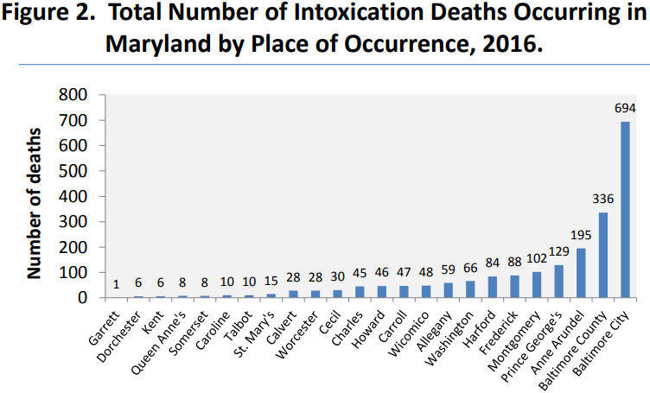
Figure 1
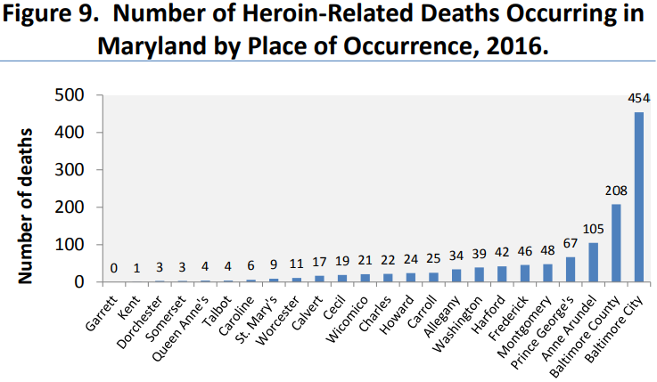
Source: DHMH

Figure 2
Source: DHMH

Figure 7
Figure 8

Where one death is too many, clearly heroin and prescription opioids continue to be a major concern for Harford County.

Figure 9

Patient Residence for Admissions to State-Supported
Alcohol and Drug Abuse Treatment Programs Reporting Data
Harford County Drug and Alcohol Treatment FY 13 - 17 |  |  |  |  |  |  |  |  | Total
 | FY13 | FY14 | FY15 |  | FY16 |  | FY17 |  | Total
Number of Admissions to State Funded  Treatment Centers | 12,114 | 12,180 |  | 9,293 |  | 9,520 | 9,223 |  | 52,330
Source

Figure 10- Narcan Training Initiative FY 17

Total Individuals Trained | Total Certificates Issued | Total Prescriptions Issued | Total Naloxone Dispensed | Total Naloxone Administered from HCHD Training | Total Sheriff Office Overdose Incidents (1/1/17 – 7/21/17)
725 | 725 | 114 | 767 | 69 | 233

Figure 11 -Persons served in the Harford County Public Mental Health System

Age | FY 2012 | FY 2013 | FY 2014 | FY 2015 | FY 2016
0 – 5 | 272 | 183 | 270 | 254 | 240
6 – 12 | 1119 | 965 | 1253 | 1386 | `1416
13 -17 | 770 | 691 | 929 | 1020 | 1023
18 – 21 | 364 | 288 | 358 | 411 | 510
22 – 64 | 2775 | 2444 | 3436 | 4219 | 4974
65 + | 33 | 39 | 42 | 42 | 42
Total | 5333 | 4610 | 6288 | 7332 | 8205

The Harford County Office on Mental Health/Core Service Agency monitors the number of people who receive public mental health services in the county. As illustrated above, the overall number of people served in the public mental health system continues to increase each year.

5,134 Pounds | 2015
7,075 Pounds | 2016
Figure 12 -Take Back Events

Figure 13-
Sources: Maryland Adolescent Survey; Maryland Youth Risk Behavior Survey

Figure 14-
Data from the 2015 Maryland Youth Risk Behavior Survey

Figure 15-
Source: 2015 Maryland Youth Risk Survey

Figure 16-
Data from the 2015 Maryland Youth Risk Behavior Survey

Figure 17-
Data from the 2015 Maryland Youth Risk Behavior Survey

Analysis of the Local Continuum of Care

The Harford County Health Department’s Division of Behavioral Health oversees and administers a comprehensive continuum of care that includes the following:

- ASAM Level 0.5 Early Intervention services to adults and adolescents at Health Department site
- ASAM Level I services to adults and adolescents at Health Department site with opioid medication treatment vended out (OTP)
- Level 2.1 Intensive Outpatient Program (IOP) for adults at Health Department site
- Level 3.7 care through insurance authorized facilities, which provide detoxification and inpatient services to adults.
- Continuing Care – offered to those clients who successfully complete treatment and volunteer to stay involved via phone contact
- Peer Recovery – offered to any interested client at any time throughout treatment and continues as long as client is interested
- Halfway House or Recovery housing through a local navigation program, ACR
- Family Support Group
- Women’s Support Group

The Harford County Government also provides funding for two halfway houses in the County:

- ASAM Level 3.1 care for 12 men provided by the Mann House, located in Bel Air, Maryland
- ASAM Level 3.1 care for 8 women provided by Homecoming Project, Inc, located in Bel Air, Maryland

Harford County still continues with system barriers, gaps and challenges such as:

- Lack of adequate affordable housing, particularly for people with criminal histories and poor credit histories
- Lack of comprehensive transportation system
- Lack of residential treatment for adolescents
- Lack of immediate access to services
- Insufficient number of halfway and recovery houses
- Halfway housing for opioid-dependent individuals on medication such as methadone or suboxone

Goal 1: Reduce the number of overdose deaths by 10% by the year 2020

Objective 1: Review and monitor overdoses via Overdose Fatality Review Team and make recommendations for system change

Objective 2: Place peer counselors/recovery coaches within the hospital to meet with patients who have behavioral health needs

Objective 3: Train residents and Harford County Detention Center inmates in the use of Narcan

Objective 4: Promote behavioral health screenings within primary care and urgent care practices

Objective 5: Utilize Opioid Operation Command Center to reduce gaps in prevention, treatment, and law enforcement efforts

Objectives | Performance Measures/Targets | Target Date
Review and monitor overdoses via Overdose Fatality Review Team and make recommendations for system change | - Meet monthly or at least quarterly to review every overdose death | October, 2017
Place peer counselors/recovery coaches within the hospital to meet with patients who have behavioral health needs | 1. Place a peer within each hospital (Upper Chesapeake and Harford Memorial) to work with the behavioral health patients to link them to appropriate care to begin recovery | ongoing

Train community in the use of Narcan | 1. Hold Narcan trainings monthly to accommodate community need and monthly at the Harford County Detention Center to train inmates | July, 2017
Promote behavioral health screenings within primary care and urgent care practices | 1. Meet with docs and urgent care practices quarterly to make them aware of behavioral health needs and resources | ongoing
Utilize Opioid Operation Command Center to reduce gaps in prevention, treatment, and law enforcement efforts | Meet weekly to monthly with County Opioid Intervention Team members to develop plan for Opioid Operation Command Center funding | August, 2017

Figure 18
Goal 2: Improve delivery and awareness of behavioral health services

Objective 1: Reduce hospital admissions from the Emergency Department due to behavioral health conditions.

Objective 2: Raise community awareness around drug use/misuse and treatment

Objective 3: Increase community education on suicide prevention, treatment options and promoting wellness

Objective 4: Refer clients who receive crisis counseling and identify as having a Substance Use Disorder from Mobile Crisis into treatment services

Objective 5: Educate obstetricians and substance use providers about treating pregnant women using substances

Objective 6: Increase education on drugs and behavioral health within schools

Objective 7: Promote recovery and support through peers, families, and faith based community

Objectives | Performance Measures/Targets | Target Date
Reduce hospital admissions from the Emergency Department for behavioral health conditions | 1. Implement peer specialists in the Emergency Rooms to meet with behavioral health patients to link them to appropriate care | Ongoing since October 2015
Raise community awareness around drug use/misuse and treatment | - Use social media, print media, billboards around community with signage to include places to call for help | Ongoing since August 2015
Increase community education on suicide prevention, treatment options, and promoting wellness | - Conduct mental health first aid trainings in the community.  - Conduct QPR (Question, Persuade and Refer) trainings in the community. | Ongoing
Refer clients who receive crisis counseling and identify as having a Substance Use Disorder from Mobile Crisis into treatment services | - Implement Mobile Crisis Counselor in the Emergency Rooms to meet with clients in crisis and also identify as having Substance Use Disorders to link them to appropriate care. | August 2017
Educate obstetricians and substance use providers about treating pregnant women using substances. | - Identify obstetricians and medication assisted treatment providers in the community.  - Provide education to physicians about treating pregnant women who use substances.  - Implement peer specialist in the hospital to provide support services to pregnant substance abusing women and mothers of substance exposed newborns. | Ongoing since June 2016
Increase education on drugs and behavioral health within schools. | 1. Provide prevention services to include behavioral health education in middle and elementary schools | Ongoing since October 2016
Promote recovery and support through peers, families, and faith based community | 1. Use existing certified peers to train interested community members in recovery coaching | ongoing

Figure 19

Goal 3: Enhance resources and programs to address the consumers in the behavioral health and criminal justice system.

Objective 1: Enhance the operations of the mental health and specialty court programs.

Objective 2: Provide a Vivitrol Program to the detention center population

Objective 3: Train inmates and their families on the use of Narcan

Objective 4: Develop a working partnership with community stakeholders utilizing local Sheriff’s Office as leadership (HOPE)

Objectives | Performance Measures/Targets | Target Date
Enhance the operations of the mental health and specialty court programs | - The Coordinator will work with the mental health court program to continue to develop the diversion program through Mental Health Diversion Program.  - Increase Adult Opiate Recovery Court enrollment to 40. | January 2018
Provide a Vivitrol Program to the detention center population | - Educate inmates on Vivitrol and offer Vivitrol before release date.  - Provide individual and group counseling treatment services to inmates. | Ongoing  July, 2017
Train inmates and their families on the use of Narcan | 1. Train every interested alcohol and opioid dependent inmate prior to release. | August 2017
Develop a working partnership with community stakeholders utilizing local Sheriff’s Office as leadership  Information sharing by the Sheriff’s Office of those residents who survived an overdose | 1. Meet bi-monthly with Hope Group at Sheriff’s Office in order to have a broader representation from community members  2. Distribute “Need Help” cards to every overdose survivor that outlines a number to call to speak with a peer specialist  1. HCHD receives monthly from the Sheriff’s Office, the names of those residents who overdosed but survived. HCHD calls every name on the list and tries to get the individual and/or family into treatment, or at least directed to appropriate resources. | Ongoing  Ongoing  Ongoing

