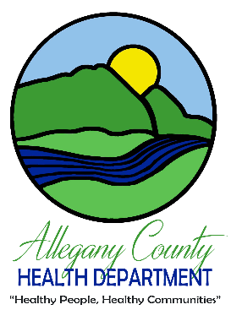
Application for Reimbursement for COVID-19 Health-Related Purchases
For agencies and organizations in Allegany County, Maryland
June 3, 2020

Application due date: June 24, 2020

The Allegany County Health Department is accepting applications from Allegany County organizations/agencies for reimbursement for COVID-19 health-related purchases. Funding is made available through the Coronavirus Aid, Relief, and Economic Security (CARES) Act.

The following entities are eligible to apply for reimbursement for COVID-19 health-related purchases: nonprofit organizations, government agencies, outpatient clinics conducting
COVID-19 testing, long-term care facilities, assisted living facilities, and home healthcare agencies. All applicants must be located in Allegany County, Maryland.

Eligible organizations/agencies may request reimbursement for COVID-19 health-related purchases made between March 1, 2020 and May 31, 2020. Examples of allowable purchases include: medical masks, face coverings, gloves, gowns, face shields, thermometers, partitions, disinfecting supplies, and hand sanitizer. Reimbursement is for the purchase of health-related items only. Staff salaries and teleworking equipment are not eligible for reimbursement.

COVID-19 health-related purchases submitted for reimbursement must be above and beyond normal expenses. Purchases must not have been reimbursed through any other funding source.

Organizations/agencies should complete the following application and submit it electronically to wendi.spiker@maryland.gov by June 24, 2020. Receipts or proofs of purchase for all purchases must be included with the application. Applications that do not include receipts or proofs of purchase will not be awarded.

Applications for reimbursement may be fully funded, partially funded, or not funded at all. As funding allows, additional reimbursement opportunities may be available in the future for health-related purchases made June-August 2020 and September-November 2020.

Organizations/agencies can direct any questions to wendi.spiker@maryland.gov.

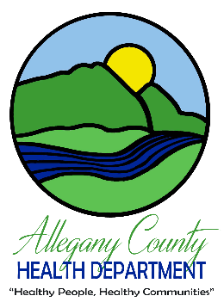
Application for Reimbursement for COVID-19 Health-Related Purchases
For agencies and organizations in Allegany County, Maryland
June 3, 2020

Name of organization/agency:

Type of organization/agency:
☐ Nonprofit organization
☐ Government agency
☐ Outpatient clinic conducting COVID-19 testing
☐ Long-term care facility
☐ Assisted living facility
☐ Home healthcare agency

Organization/agency address:

Contact name:

Contact phone number:

Contact email address:

Description of organization/agency (150 words max):

Description of COVID-19 health-related purchases. All purchases must have been made between March 1, 2020 and May 31, 2020 and must be above and beyond normal expenses (300 words max):

Total reimbursement requested: $

☐ Receipts or proofs of purchase are attached for all purchases.

I hereby certify that the above statements are true and correct to the best of my knowledge. I certify that all purchases submitted for reimbursement have not been reimbursed through any other funding source.

______________________________ ____________
Applicant signature Date

